Name:

**ure**

**ure**

**ure**

**ure**

**ure**

**booklet**

**My**

© 2020 Little Owls Resources

Circle the pictures that use the ure sound.

Name:

**Colour** the pictures that use the ure sound.

Name:

Name:

Circle the ure sound.

ure

air

x

ure

oi

z

y

ure

o

ure

b

**ure ure ure**

**ure ure ure**

ure ure ure

ure ure ure

ure ure ure

___­_ ____ ____

Practise writing ure.

Name:

Name:

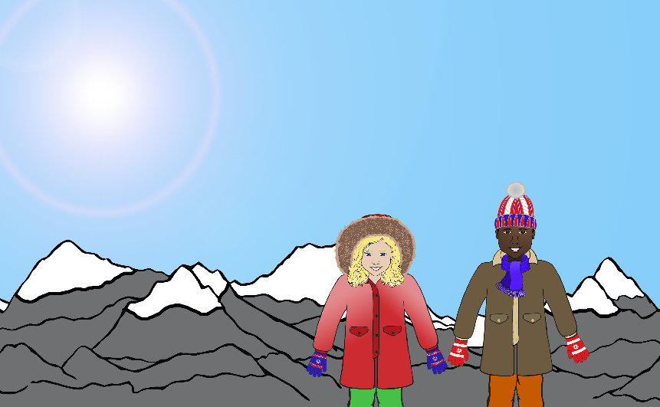

mixt

advent

pict

vult

Write ure and then read the word.

Name:

Read the words and **colour** the pictures.

vulture

mixture

picture

adventure

Name:

Match the word with the picture.

1

vulture

1

fox

1

mixture

1

can

1

box

1

picture

Name:

**✔**

Write the words for the pictures. Tick the ure words.

Name:

Write the words for the pictures. Tick the ure words.

1

1

1

1

1

1

**✔**

Name:

Read all the words. Tick the ones that are real.

**✔**

1

1

dure

1

1

manure

1

1

vure

1

1

pure

1

1

mature

1

1

gure

1

1

jure

1

1

sure

1

1

urez

1

1

cure

Name:

Read the words and draw pictures for them.

1

cure

1

picture