Name:

**ar**

**booklet**

**ar**

**ar**

**ar**

**ar**

**My**

© 2020 Little Owls Resources

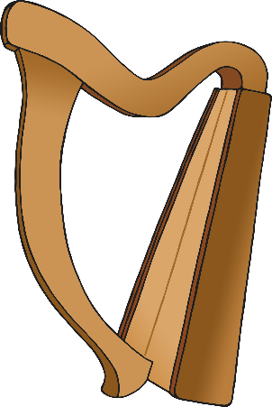

Circle the pictures that use the ar sound.

Name:

**Colour** the pictures that use the ar sound.

Name:



Name:

Circle the ar sound.

ar

ar

ar

k

oo

p

z

d

oo

ai

l

Practise writing ar.

Name:

**ar ar ar**

**ar ar ar**

ar ar ar

ar ar ar

ar ar ar

___ ___ ___

Name:

j

c

M s

h p



Write ar and then read the word.

Name:

Read the words and **colour** the pictures.

harp

car

Mars

jar



Name:

Match the word with the picture.

1

bat

1

car

1

bee

1

dog

1

jar

1

harp

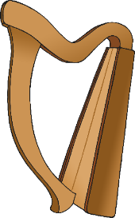

Name:



**✔**

Write the words for the pictures. Tick the ar words.



Name:

Write the words for the pictures. Tick the ar words.

1

1

1

1

1

1

**✔**

Name:

Read all the words. Tick the ones that are real.

**✔**

1

1

arf

1

1

bark

1

1

jar

1

1

shar

1

1

arb

1

1

arm

1

1

dar

1

1

art

1

1

farm

1

1

arp

Name:

Read the words and draw pictures for them.

1

1

card

park

1

1

farm

dark