|  |  |
| --- | --- |
| Animal | Tally |
|  |  |
|  |  |
|  |  |
|  |  |
|  |  |
|  |  |

Zoo Tally (1)

© 2019 Little Owls Resources

|  |  |
| --- | --- |
| Animal | Tally |
|  |  |
|  |  |
|  |  |
|  |  |
|  |  |
|  |  |

© 2019 Little Owls Resources

Zoo Tally (2)

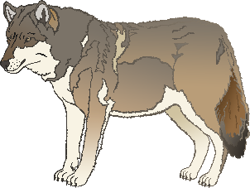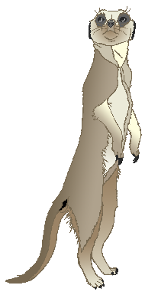

© 2021 Little Owls Resources

Zoo Checklist

What can you see on your zoo trip?

© 2019 Little Owls Resources

I see a _____

I see a _____

What can you see on your zoo trip?

© 2019 Little Owls Resources

I see a _____

_____________

What can you see on your zoo trip?

© 2019 Little Owls Resources

What can you see on your zoo trip?

© 2019 Little Owls Resources

__________________________

What can you see on your zoo trip?

© 2019 Little Owls Resources

I see a _____

I see a _____

I see a _____

I see _ _____

I ___ _ _____

I ___ _ _____

© 2019 Little Owls Resources

I see a _____

I see _ _____

I ___ _ _____

_ ___ _ _____

_ ___ _ _____

_ ___ _ _____

What can you see on your zoo trip?

© 2019 Little Owls Resources

______________________________________________________________________________

What can you see on your zoo trip?