lion

lion

lion

lion

tiger

tiger

tiger

tiger

elephant

elephant



elephant

elephant



chimpanzee

chimpanzee



chimpanzee

chimpanzee



giraffe

giraffe

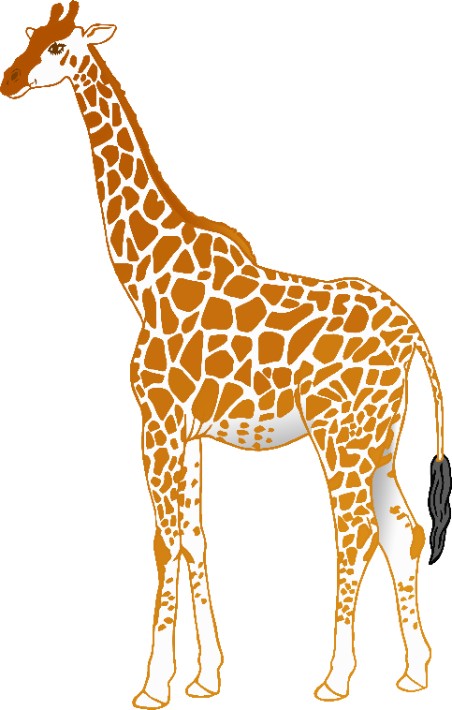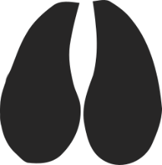

giraffe

giraffe



rhinoceros

rhinoceros

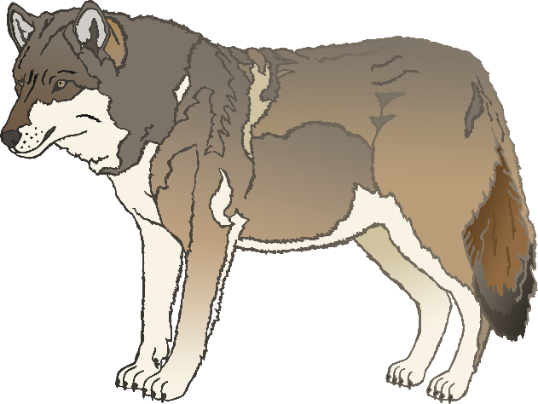

rhinoceros

rhinoceros

**w**olf

**w**olf

**w**olf

**w**olf

zebra

zebra



zebra

zebra



flamingo

flamingo

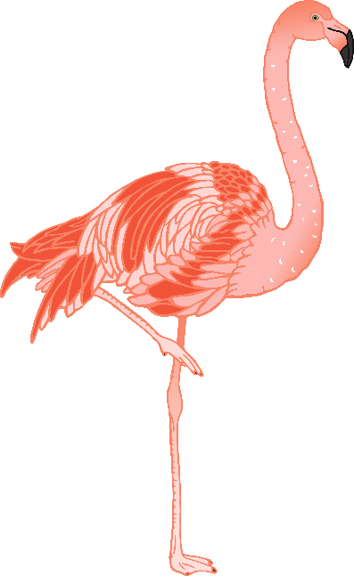

flamingo

flamingo



poison tree frog

poison tree frog



poison tree frog

poison tree frog

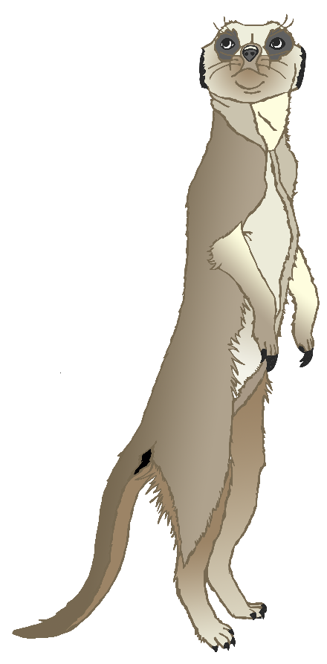

meerkat

meerkat

meerkat

meerkat