poison dart frog

chimpanzee

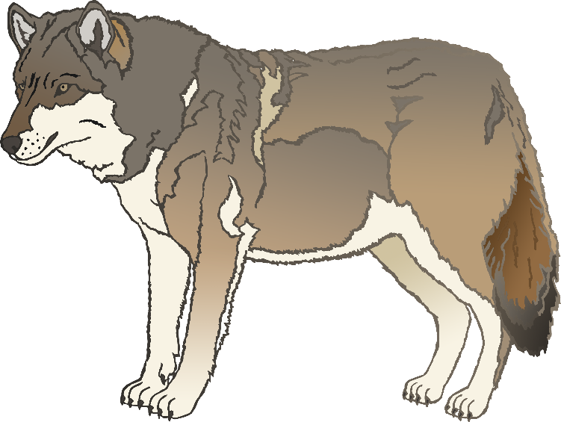

elephant

**w**olf

lion

flamingo

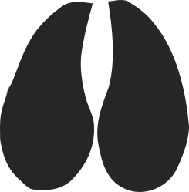

giraffe

rhinoceros

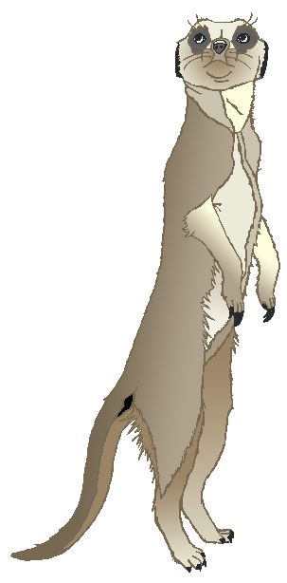

meerkat

komodo dragon