Feeding time is at **12** o’clock

© 2021 Little Owls Resources

© 2021 Little Owls Resources

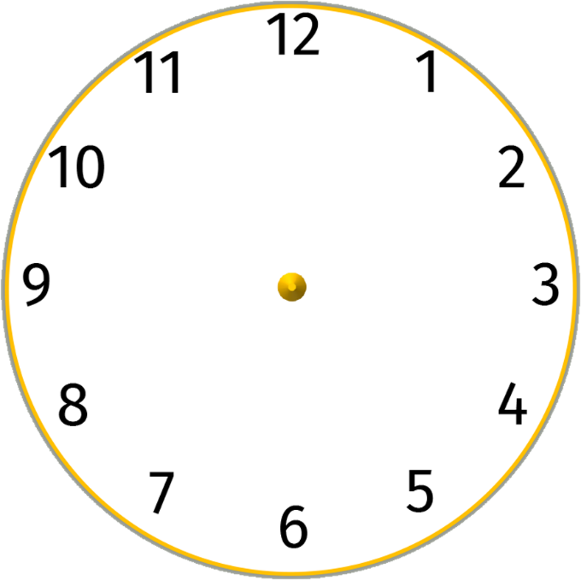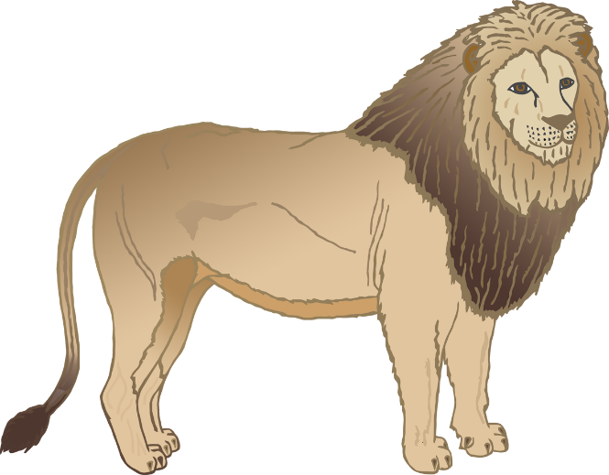

**Lion**

Feeding time is at **1** o’clock

**Elephant**

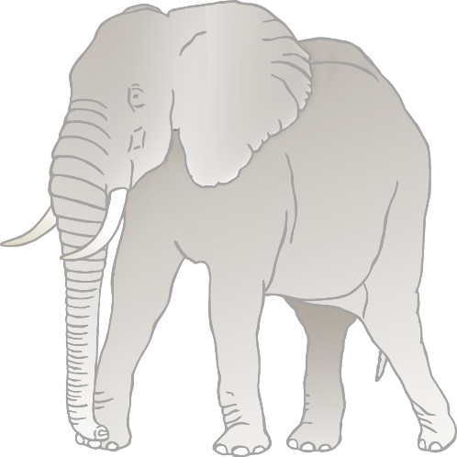

**Penguin**

Feeding time is at **2** o’clock

© 2021 Little Owls Resources

© 2021 Little Owls Resources

Feeding time is at **3** o’clock

**Chimpanzee**

Feeding time is at **4** o’clock

© 2021 Little Owls Resources

© 2021 Little Owls Resources



**Vulture**

Feeding time is at **5** o’clock

**Snake**

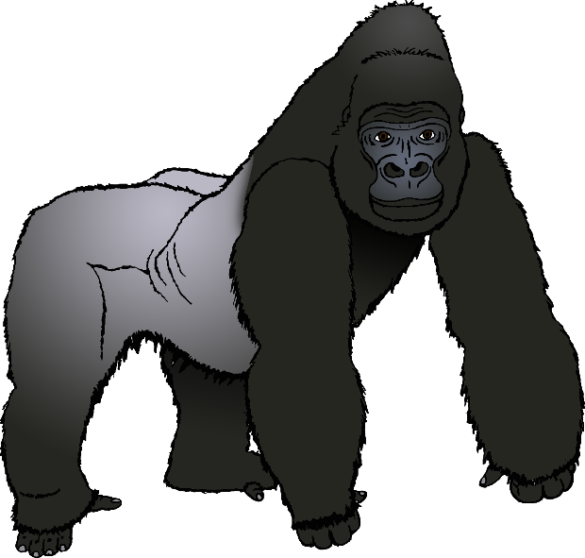

Feeding time is at **6** o’clock

© 2021 Little Owls Resources

© 2021 Little Owls Resources



**Gorilla**

Feeding time is at **7** o’clock

**Giraffe**

Feeding time is at **8** o’clock

© 2021 Little Owls Resources

© 2021 Little Owls Resources



**Tiger**

Feeding time is at **9** o’clock

**Sea Lion**

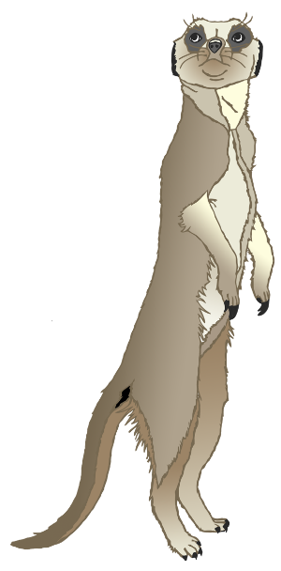

Feeding time is at **10** o’clock

© 2021 Little Owls Resources

© 2021 Little Owls Resources



**Meerkat**

Feeding time is at **11** o’clock

**Zebra**