* Eats meat.
* Baby is called a cub.
* Lives for 10-14 years.

Elephant

Tiger

Lion

* Eats meat.
* Baby is called a cub.
* Lives for 16-18 years.
* Eats plants.
* Baby is called a calf.
* Lives for 60-70 years.

* Eats plants, insects, meat.
* Baby is called an infant.
* Lives for 40 years.

Flamingo

Penguin

Chimpanzee

* Eats algae and shrimp.
* Baby is called a chick.
* Lives for 40 years.
* Eats fish.
* Baby is called a chick.
* Lives for 15-20 years.

Giraffe

* Eats plants.
* Baby is called a calf.
* Lives for 25 years.

Komodo Dragon

* Eats meat.
* Baby is called a hatchling.
* Lives for 30 years.

Poison Dart Frog

* Eats insects.
* Baby is called a tadpole.
* Lives for 4-8 years.

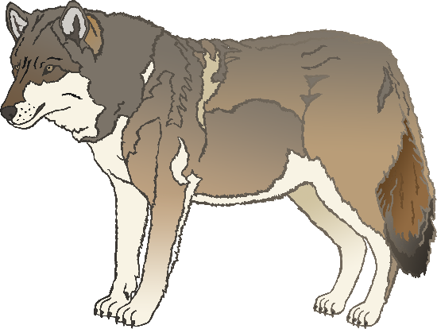

* Eats meat.
* Baby is called a pup.
* Lives for 6-8 years.

Wolf

* Eats penguin, krill and squid.
* Baby is called a pup.
* Lives for 20-30 years.

Sea Lion

* Eats plants.
* Baby is called a calf.
* Lives for 40-50 years.

Rhinoceros

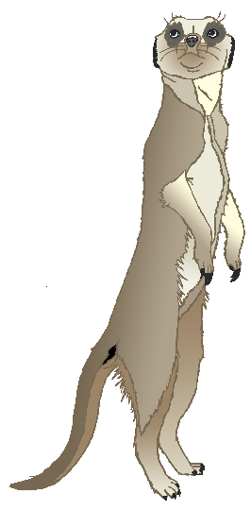

Zebra

* Eats grass.
* Baby is called a foal.
* Lives for 20-30 years.

Meerkat

* Eats insects.
* Baby is called a pup.
* Lives for 12-14 years.