**Zebra**

© 2021 Little Owls Resources

**Zebra**

**Tiger**

© 2021 Little Owls Resources

**Tiger**

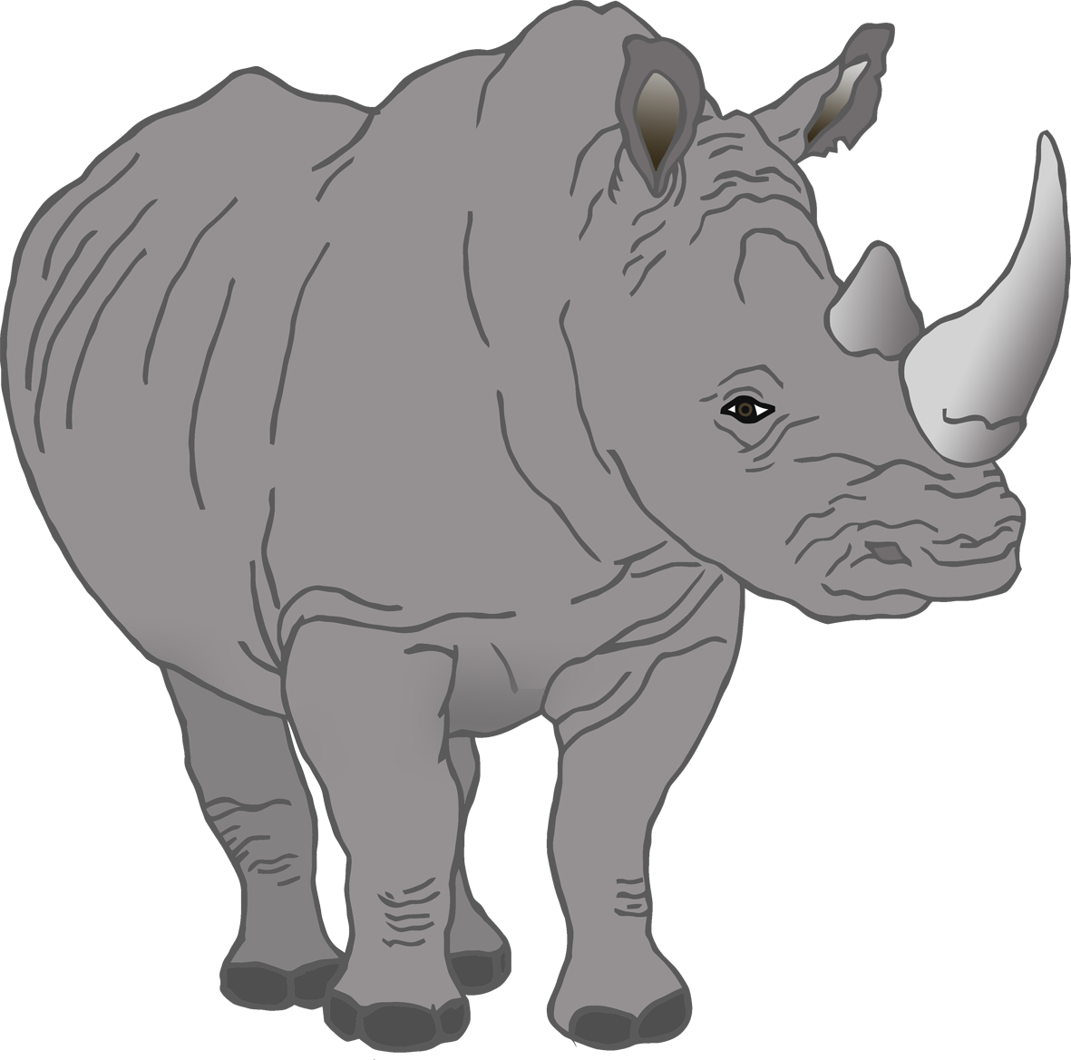

**Rhino**

© 2021 Little Owls Resources

**Rhino**

**Penguin**

**Penguin**

© 2021 Little Owls Resources

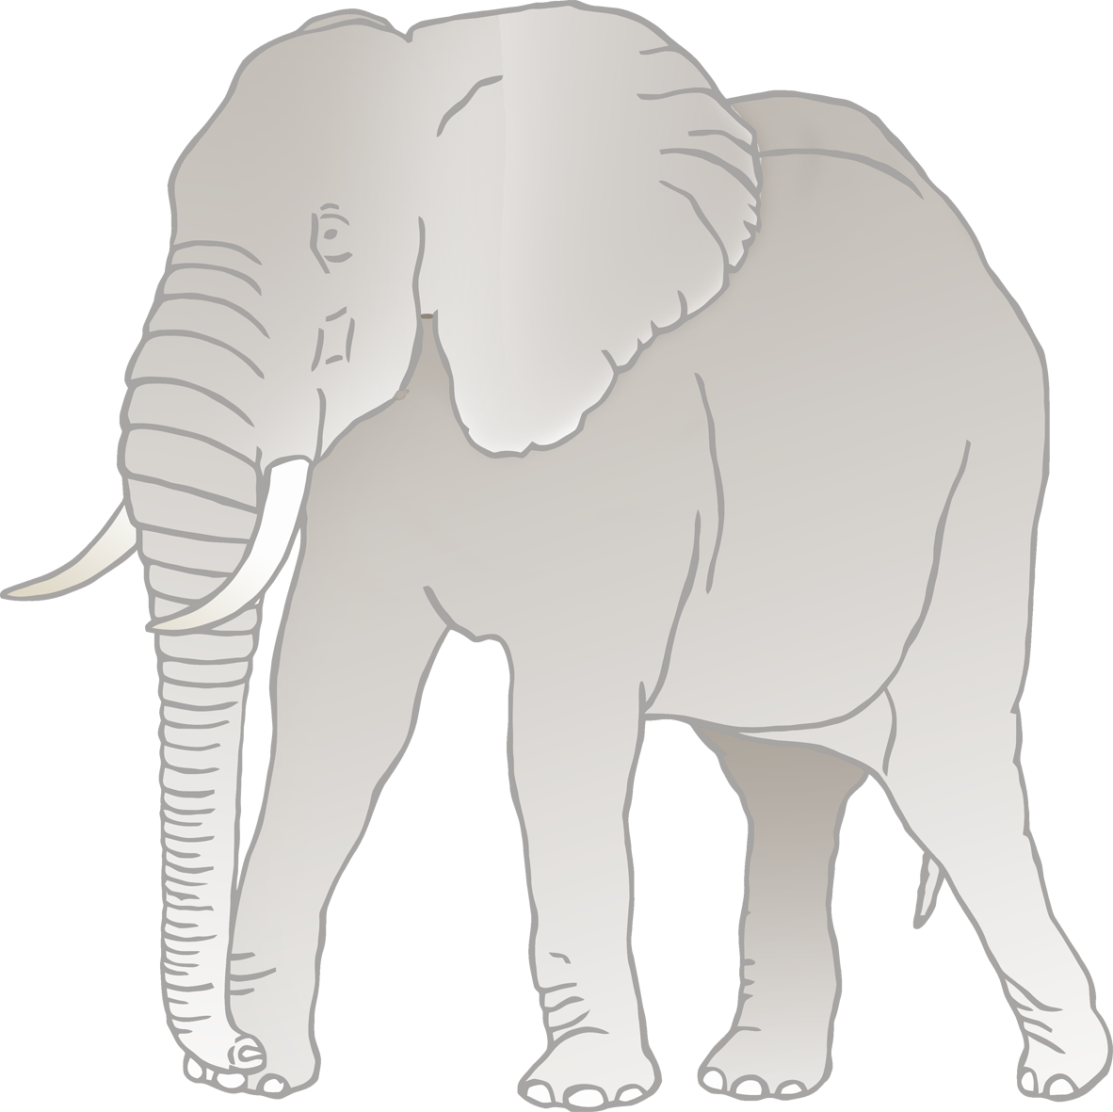

**Elephant**

© 2021 Little Owls Resources

**Elephant**

**Lion**

**Lion**

© 2021 Little Owls Resources

© 2021 Little Owls Resources

**Sea Lion**

**Sea Lion**

**Wolf**

**Wolf**

© 2021 Little Owls Resources

© 2021 Little Owls Resources

**Iguana**

**Iguana**

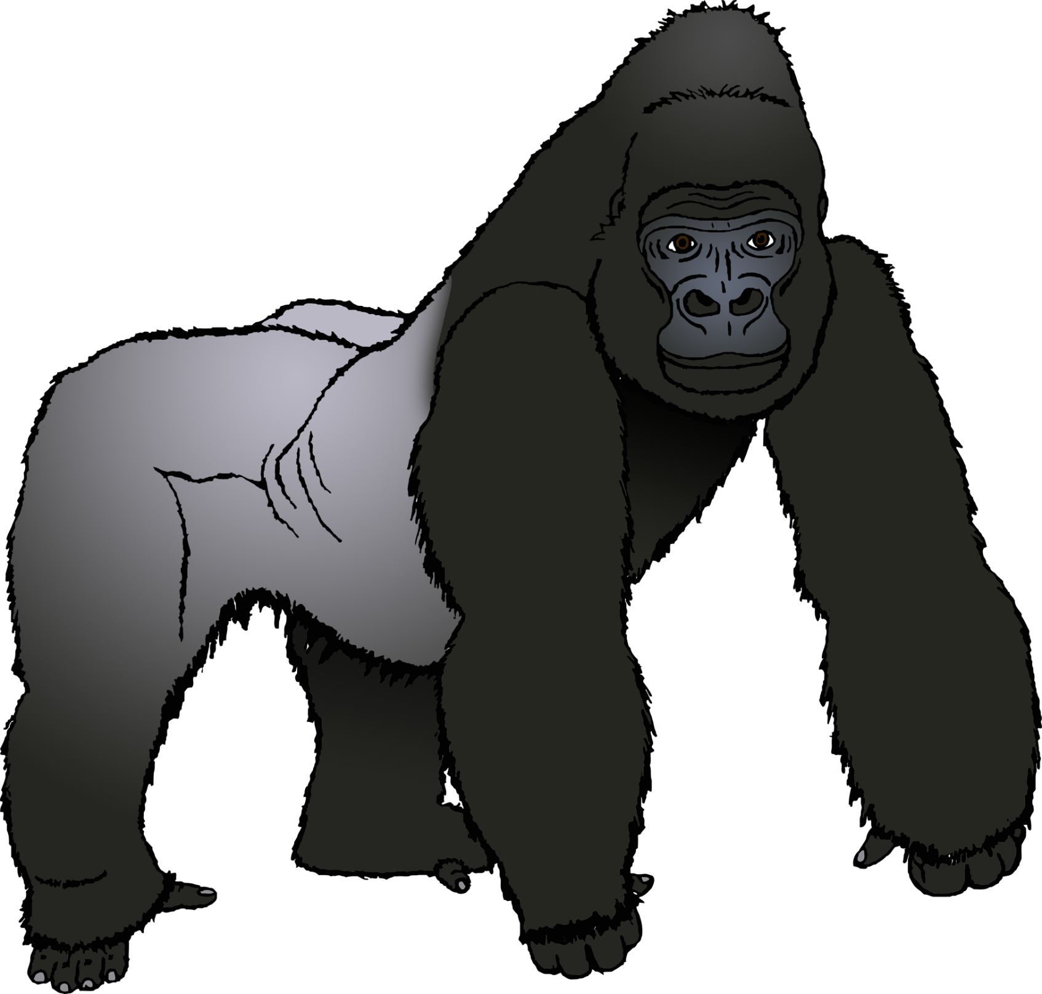

© 2021 Little Owls Resources

**Gorilla**

**Gorilla**

**Vulture**

**Vulture**

© 2021 Little Owls Resources

**Komodo Dragon**

**Komodo Dragon**

© 2021 Little Owls Resources