elephant

tiger

lion

flamingo

chimpanzee

penguin

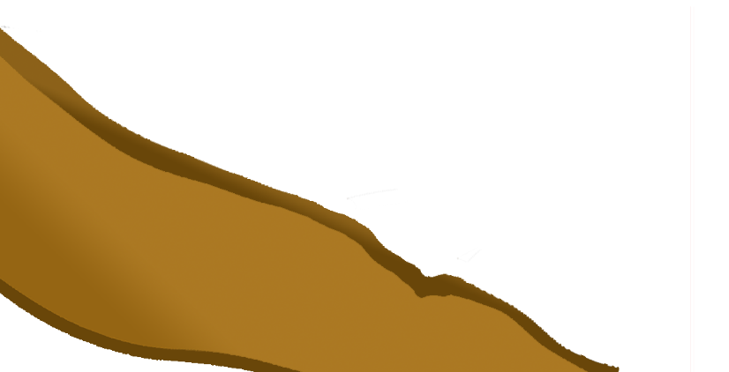

komodo dragon

poison dart frog

giraffe

rhinoceros

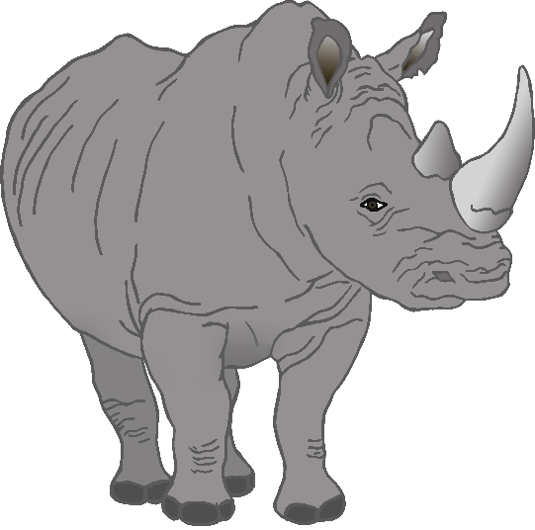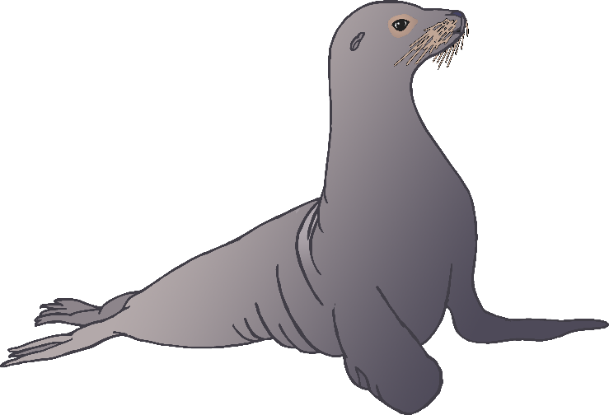

sea lion

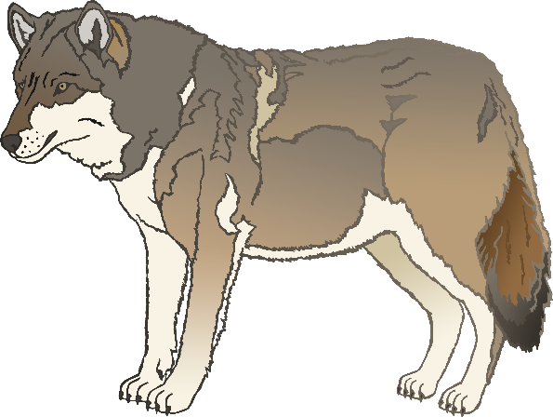

**w**olf

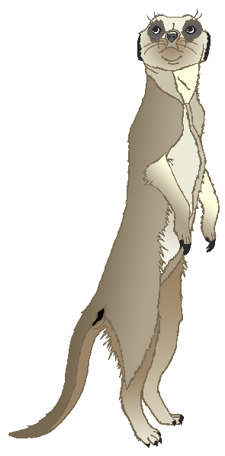

zebra

meerkat