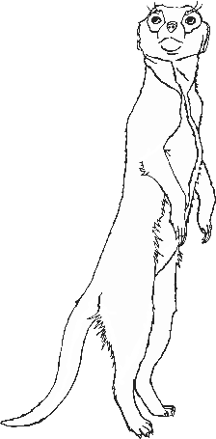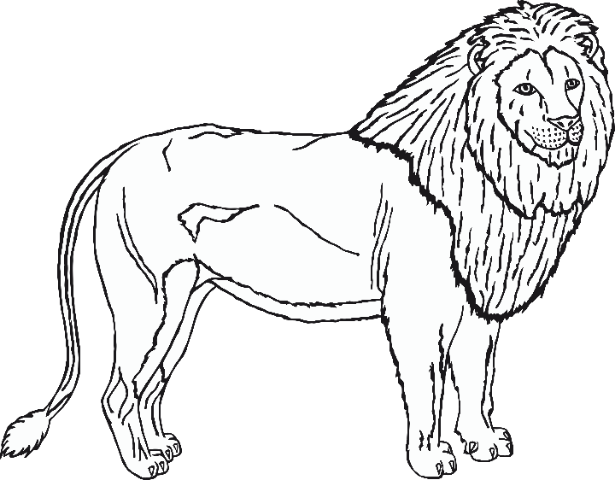

Zoo Animals

chimpanzee

zebra

tiger

poison dart frog

lion

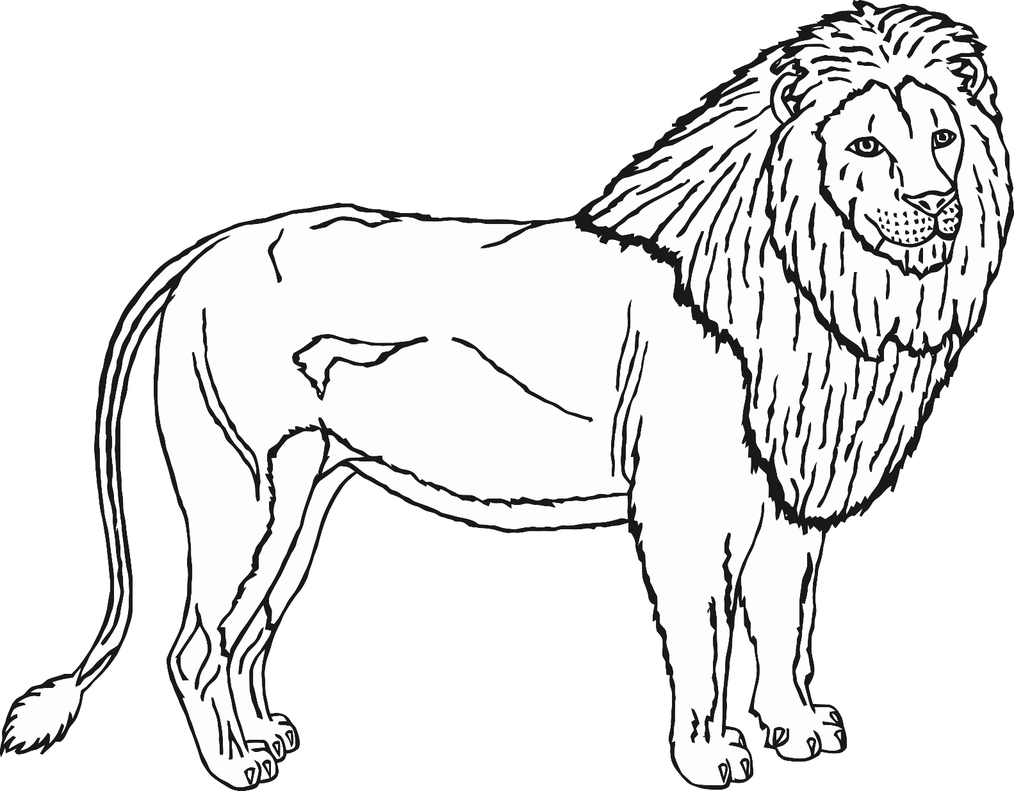

meerkat

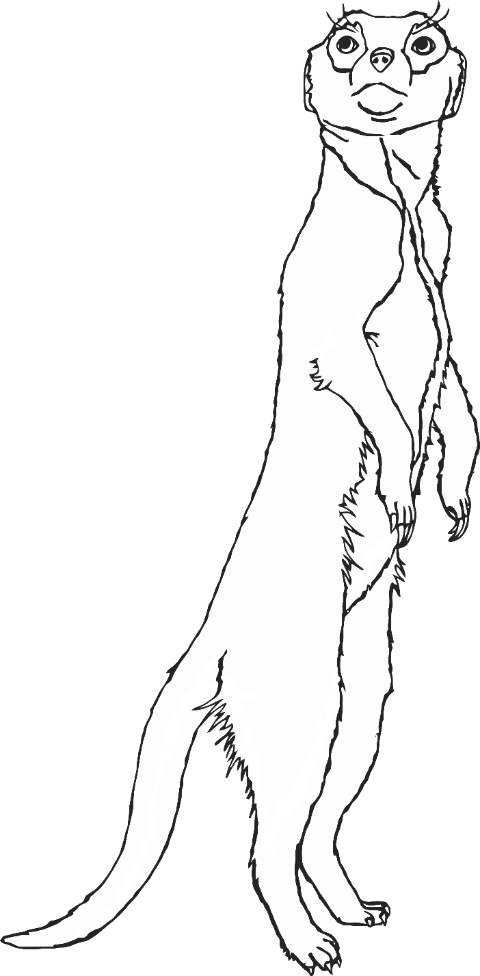

rhinoceros

wolf

sea lion

Komodo dragon

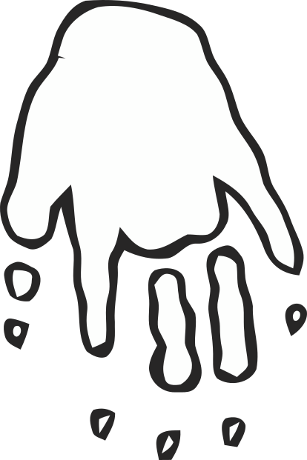

giraffe

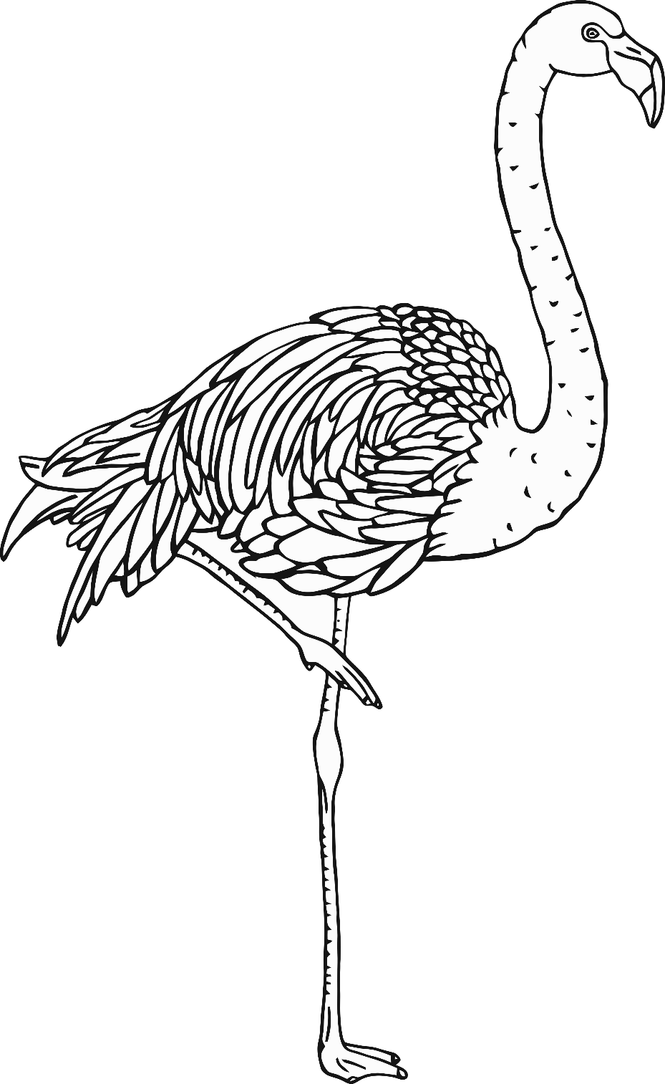

flamingo

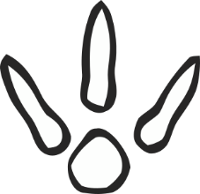

elephant

penguin