**Zoo Activity**

**Challenge!**

**1**

Keep very still…then…

Pounce!

**Zoo Activity**

**Challenge!**

**2**

Waddle along and then...

on your tummy!

**Slide!**

**PENGUIN**

**TIGER**

**Zoo Activity**

**Challenge!**

**3**

Jump along the branch…

**Jump! Jump!**

**Zoo Activity**

**Challenge!**

**4**

Stand on one leg in the water…

Balance!

**POISON**

**DART FROG**

**FLAMINGO**

**Zoo Activity**

**Challenge!**

**5**

Slow, heavy steps…

Stomp! Stomp!

**Zoo Activity**

**Challenge!**

**6**

Watch out for the eagle…

Look left! Look right!

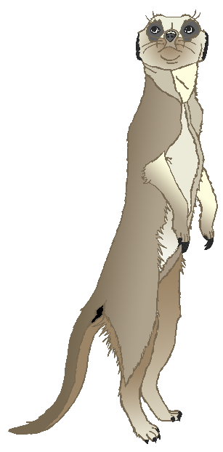

**ELEPHANT**

**MEERKAT**

**Zoo Activity**

**Challenge!**

**7**

Stretch up tall to reach the leaves!

Stretch! Stretch!

**Zoo Activity**

**Challenge!**

**8**

Howl like a wolf in the night!

Awooooooo!

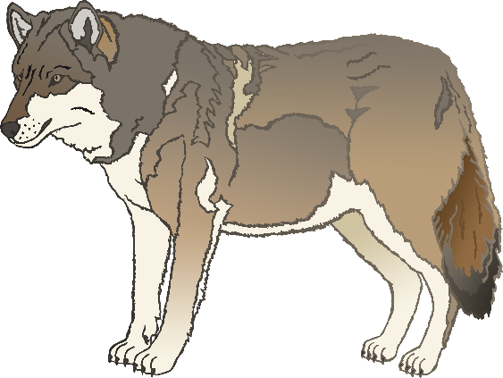

**WOLF**

**GIRAFFE**