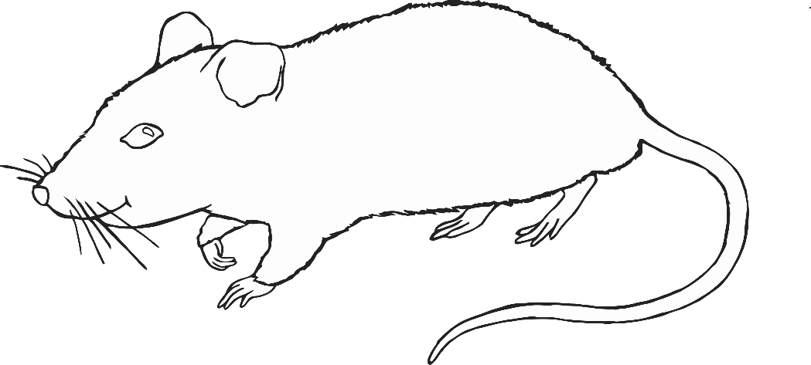

Rat

Years of the Rat:

1936, 1948, 1960, 1972, 1984, 1996, 2008, 2020, 2032

Rats are:

quick-witted, resourceful, versatile, kind, smart and lovely.

Ox

Years of the Ox:

1925, 1937, 1949, 1961, 1973, 1985, 1997, 2009, 2021

Oxen are:

diligent, dependable, strong and determined.

© 2019 Little Owls Resources

© 2019 Little Owls Resources

Tiger

Years of the Tiger:

1926, 1938, 1950, 1962, 1974, 1986, 1998, 2010, 2022

Tigers are:

brave, confident, competitive and unpredictable.

Rabbit

Years of the Rabbit:

1927, 1939, 1951, 1963, 1975, 1987, 1999, 2011, 2023

Rabbits are:

gentle, quiet, elegant, alert, quick and skilful.

© 2019 Little Owls Resources

© 2019 Little Owls Resources

Snake

Years of the Snake:

1929, 1941, 1953, 1965, 1977, 1989, 2001, 2013, 2025

Snakes are:

intelligent, wise, private and quiet.

Dragon

Years of the Dragon:

1928, 1940, 1952, 1964, 1976, 1988, 2000, 2012, 2024

Dragons are:

confident, intelligent, enthusiastic and hot-headed.

© 2019 Little Owls Resources

© 2019 Little Owls Resources

Horse

Years of the Horse:

1930, 1942, 1954, 1966, 1978, 1990, 2002, 2014, 2026

Horses are:

active, energetic, cunning and animated.

Ram

Years of the Ram:

1931, 1943, 1955, 1967, 1979, 1991, 2003, 2015, 2027

Rams are:

calm, gentle, shy, stable and kind-hearted.

© 2019 Little Owls Resources

© 2019 Little Owls Resources

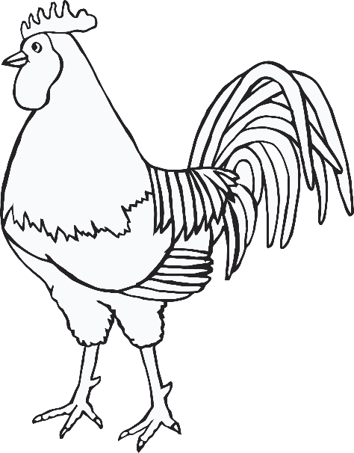

Monkey

Years of the Monkey:

1932, 1944, 1956, 1968, 1980, 1992, 2004, 2016, 2028

Monkeys are:

sharp, smart, curious, clever and mischievous.

Rooster

Years of the Rooster:

1933, 1945, 1957, 1969, 1981, 1993, 2005, 2017, 2029

Roosters are:

observant, hardworking, resourceful, courageous and talented.

© 2019 Little Owls Resources

© 2019 Little Owls Resources

Dog

Years of the Dog:

1934, 1946, 1958, 1970, 1982, 1994, 2006, 2018, 2030

Dogs are:

loyal, honest, amiable, kind and cautious.

Pig

Years of the Pig:

1935, 1947, 1959, 1971, 1983, 1995, 2007, 2019, 2031

Pigs are:

diligent, compassionate, calm and generous.

© 2019 Little Owls Resources

© 2019 Little Owls Resources