© 2020 Little Owls Resources

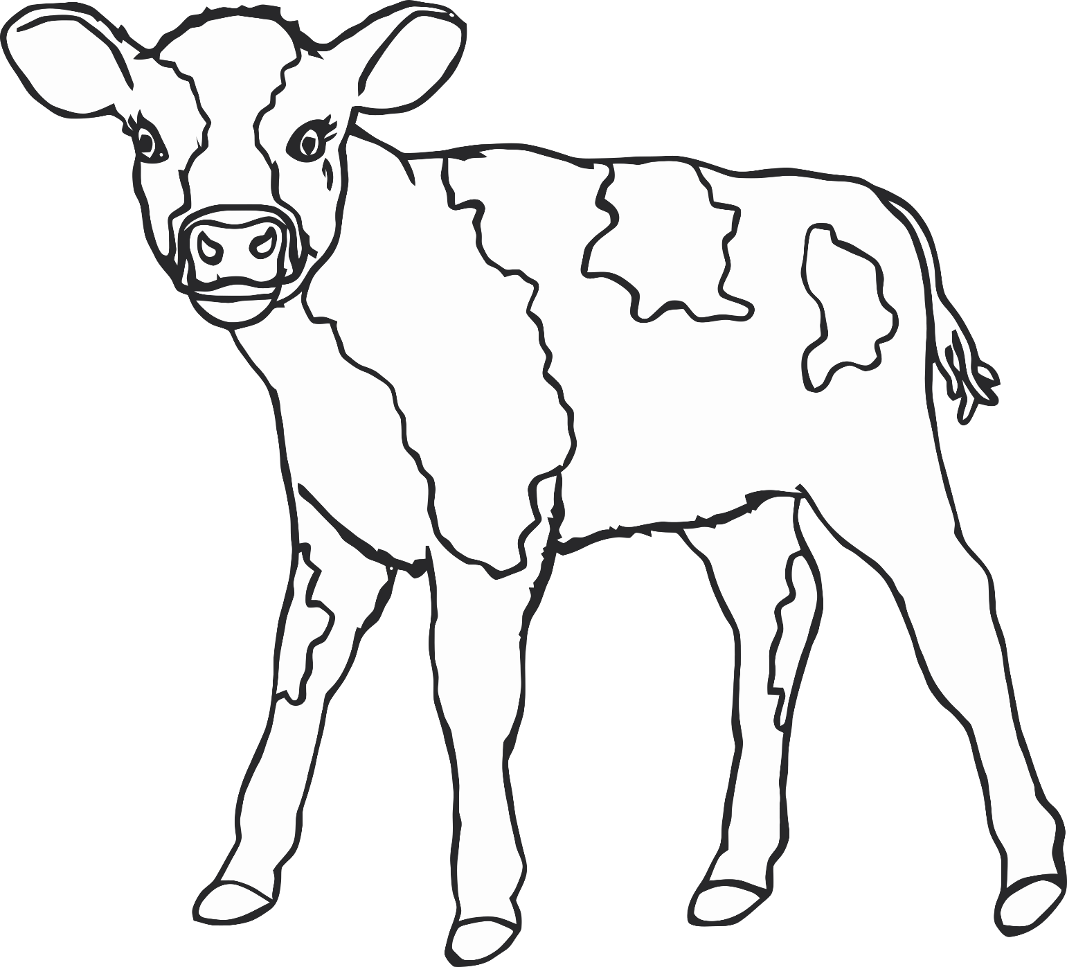

calf

(cow)

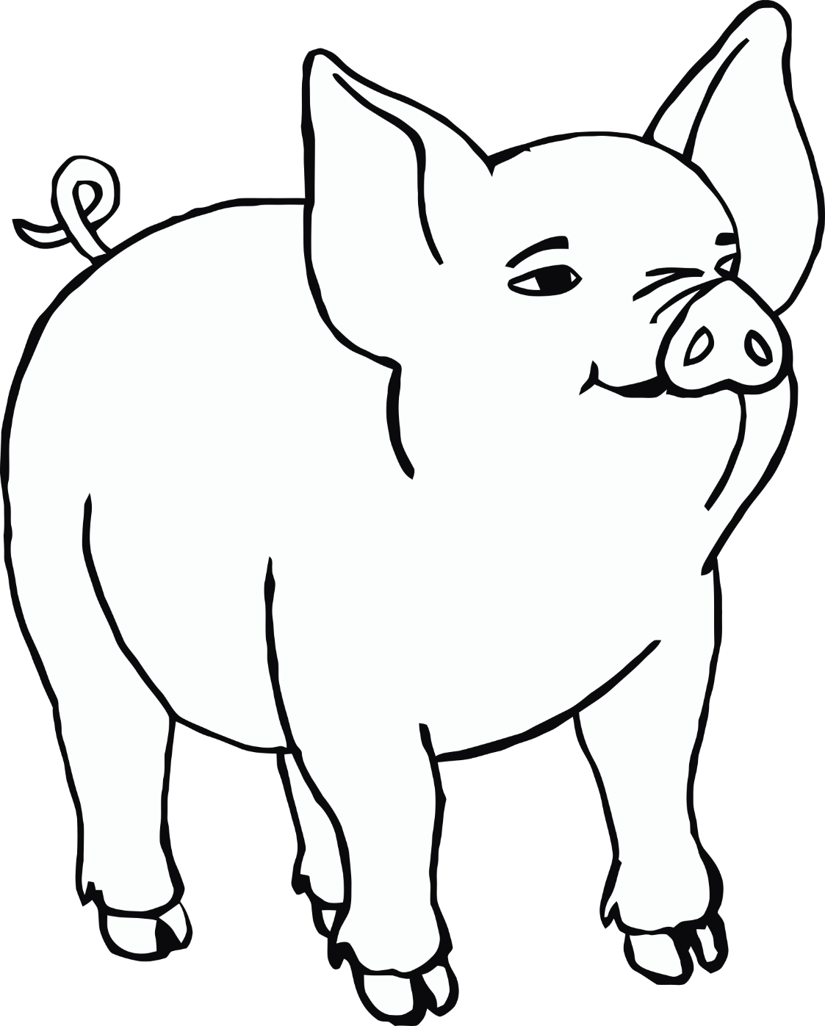

piglet

(pig)

© 2020 Little Owls Resources

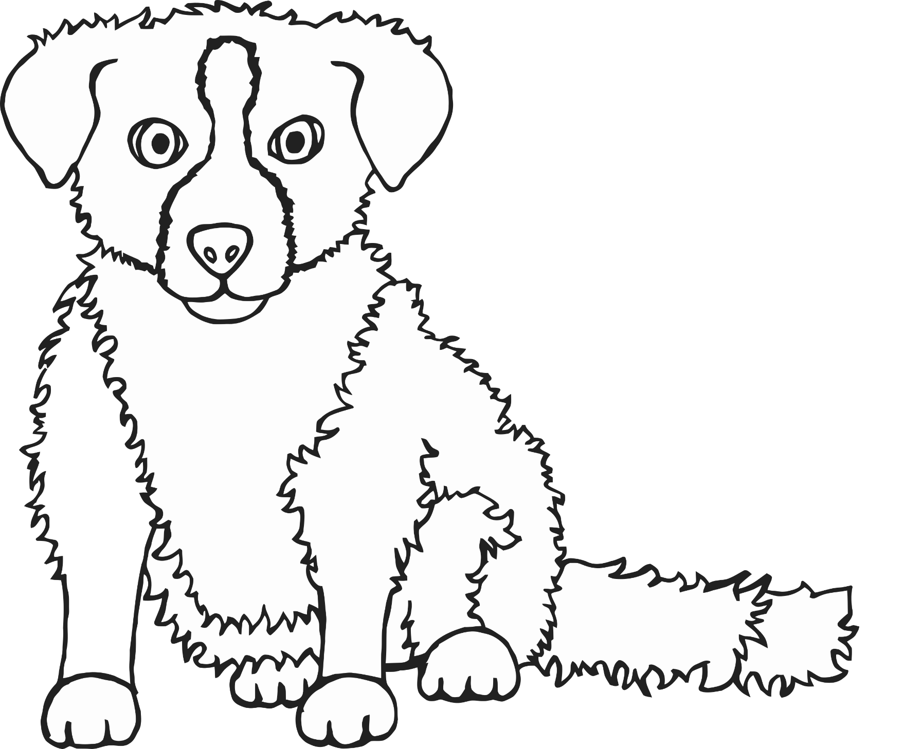

puppy

(dog)

© 2020 Little Owls Resources

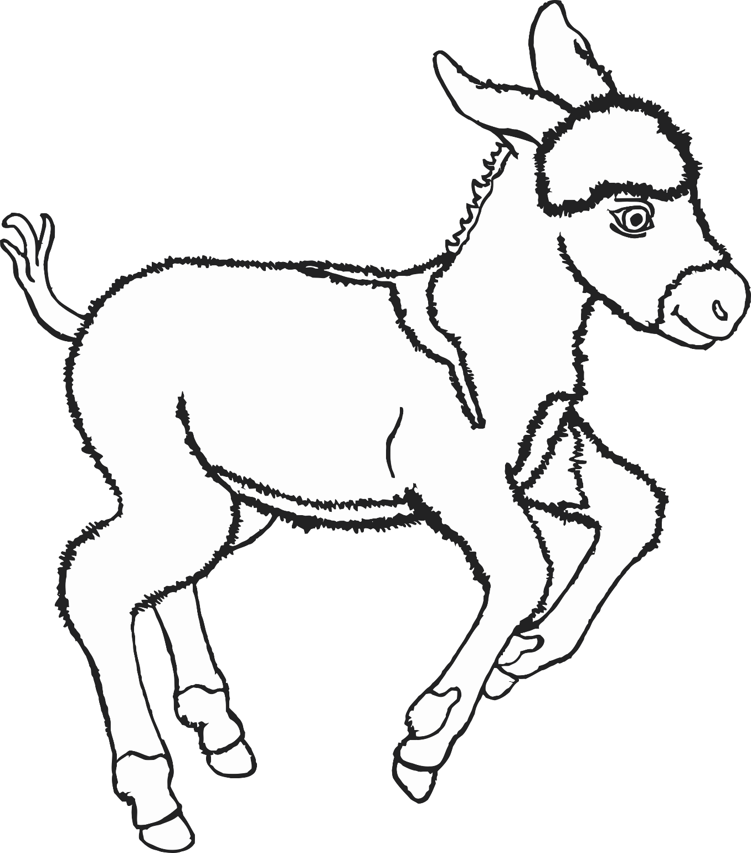

foal

(donkey)

© 2020 Little Owls Resources

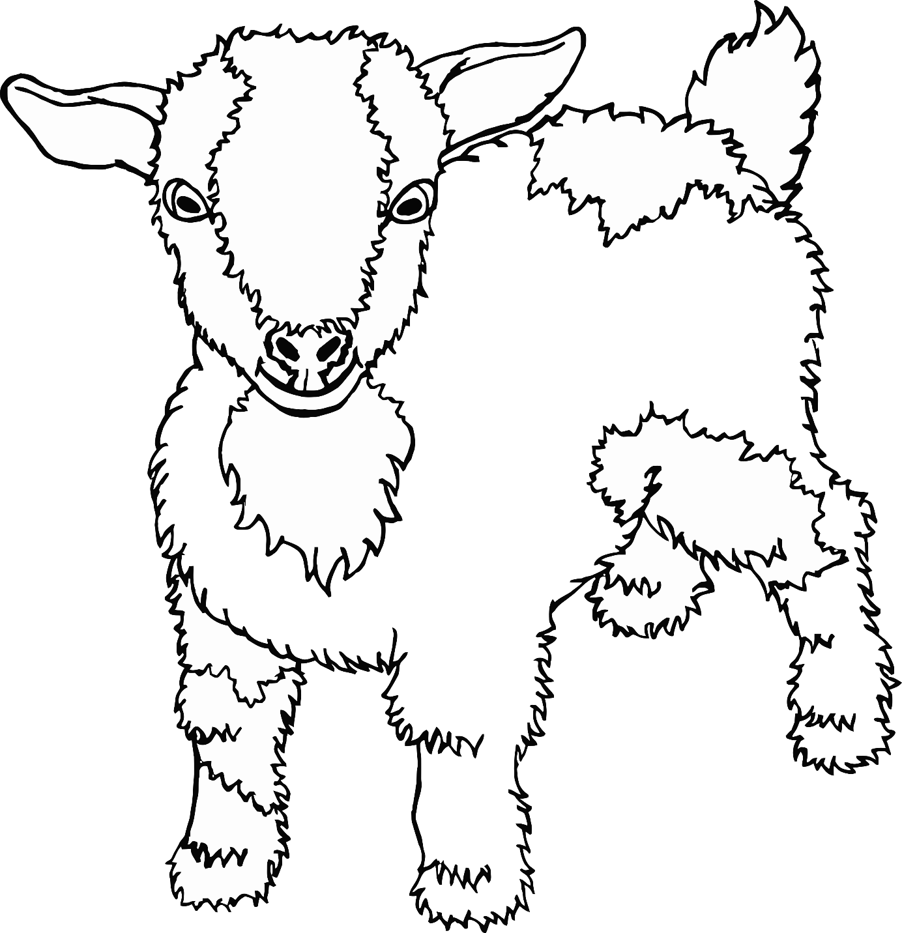

kid

(goat)

© 2020 Little Owls Resources

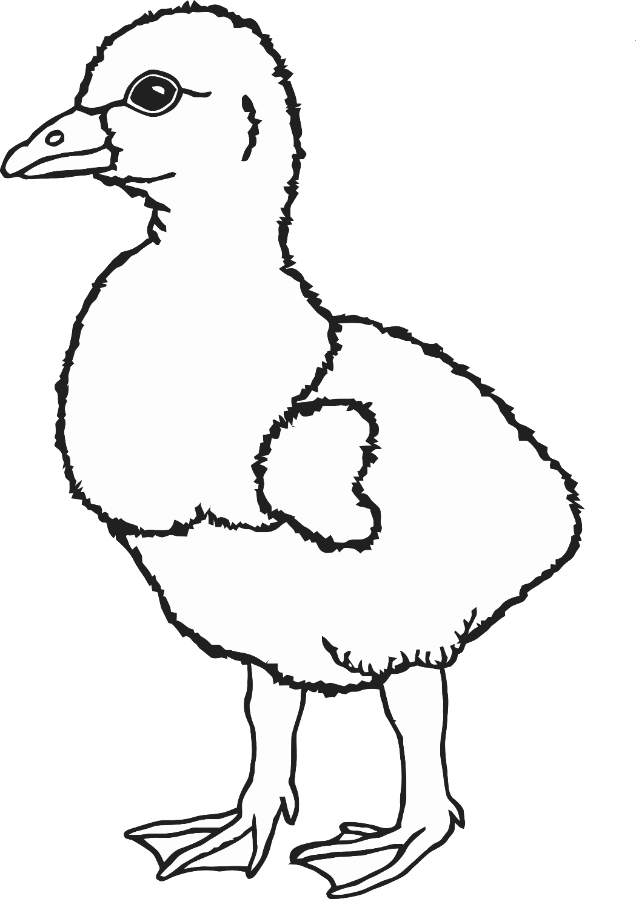

gosling

(goose)

© 2020 Little Owls Resources

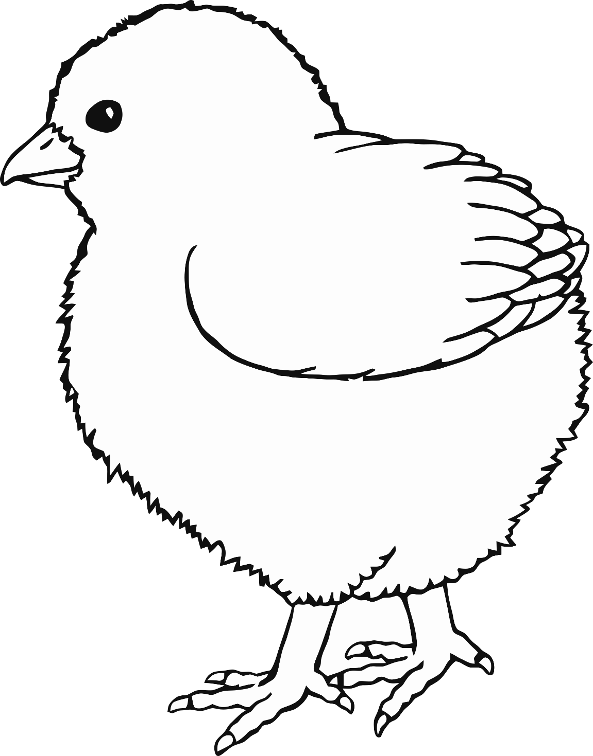

chick

(chicken)

© 2020 Little Owls Resources

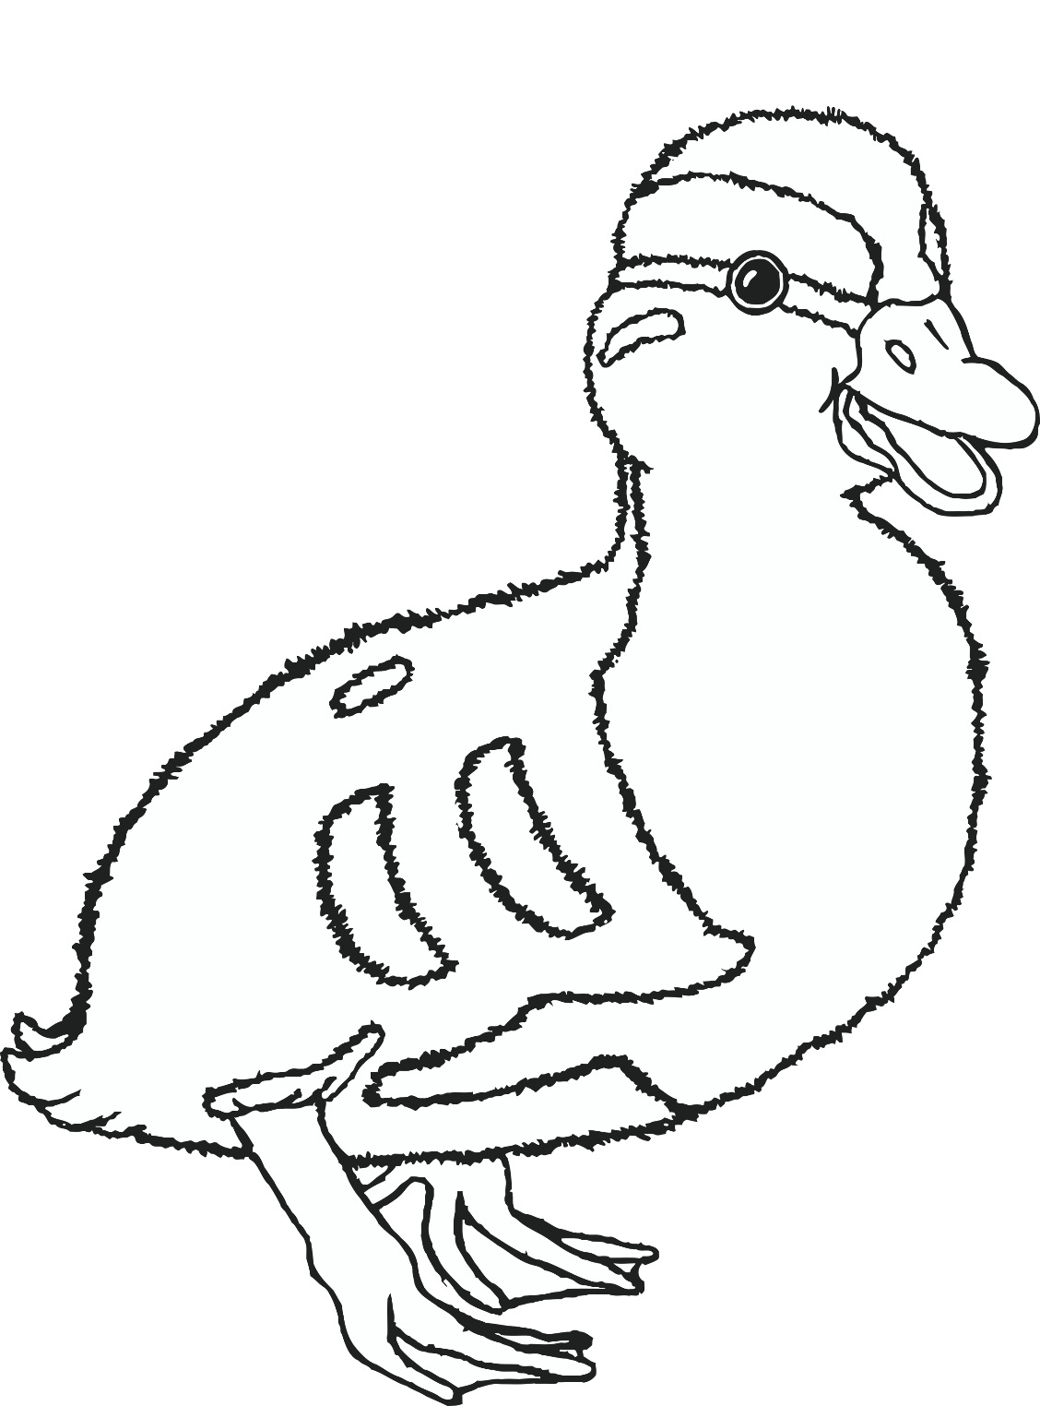

duckling

(duck)

© 2020 Little Owls Resources

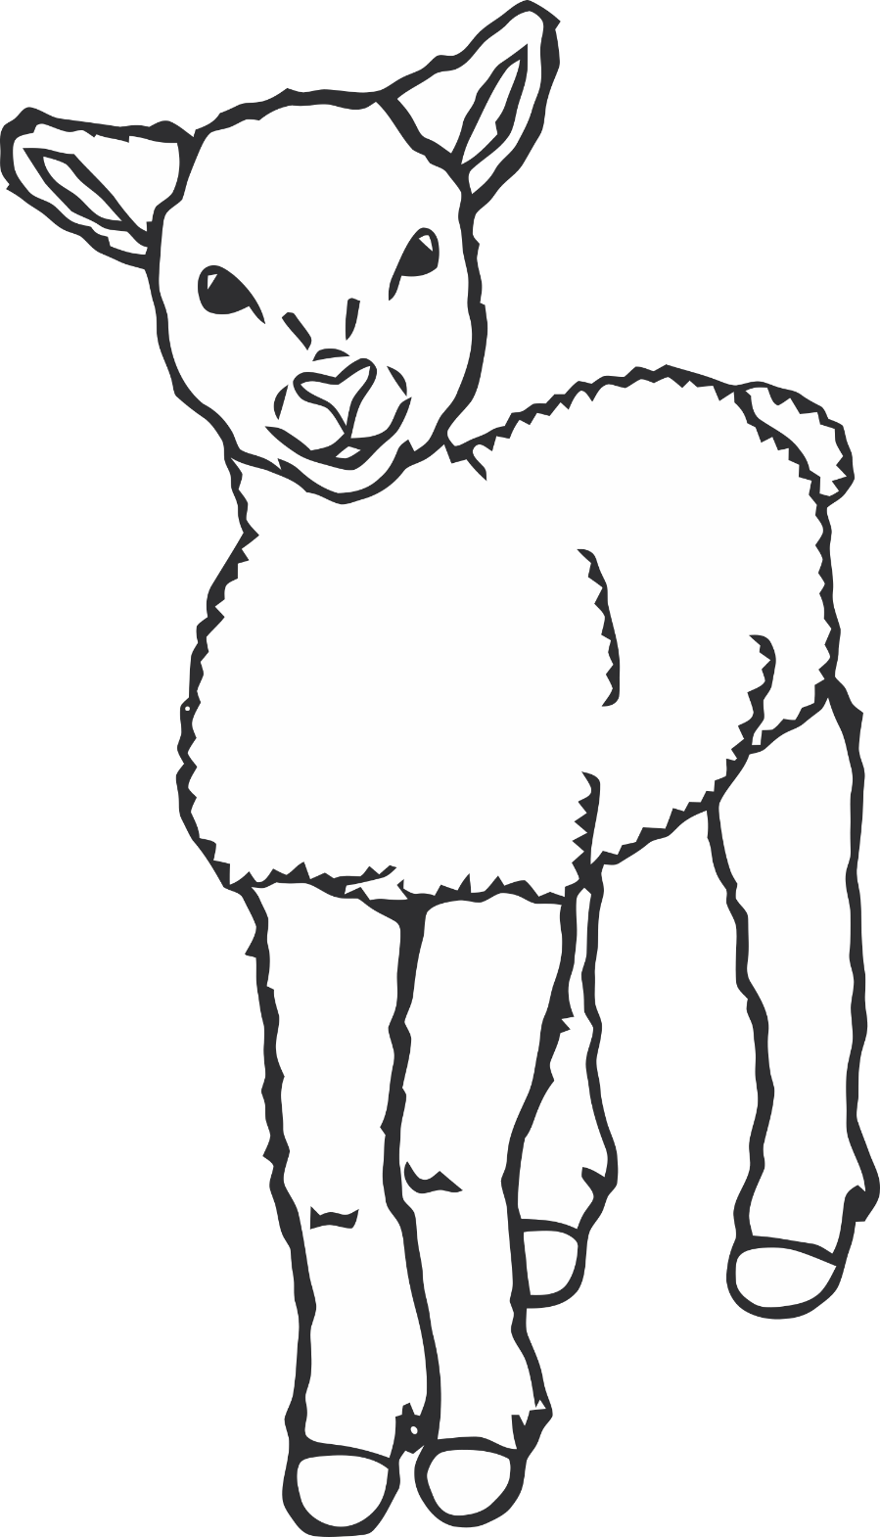

lamb

(sheep)

© 2020 Little Owls Resources

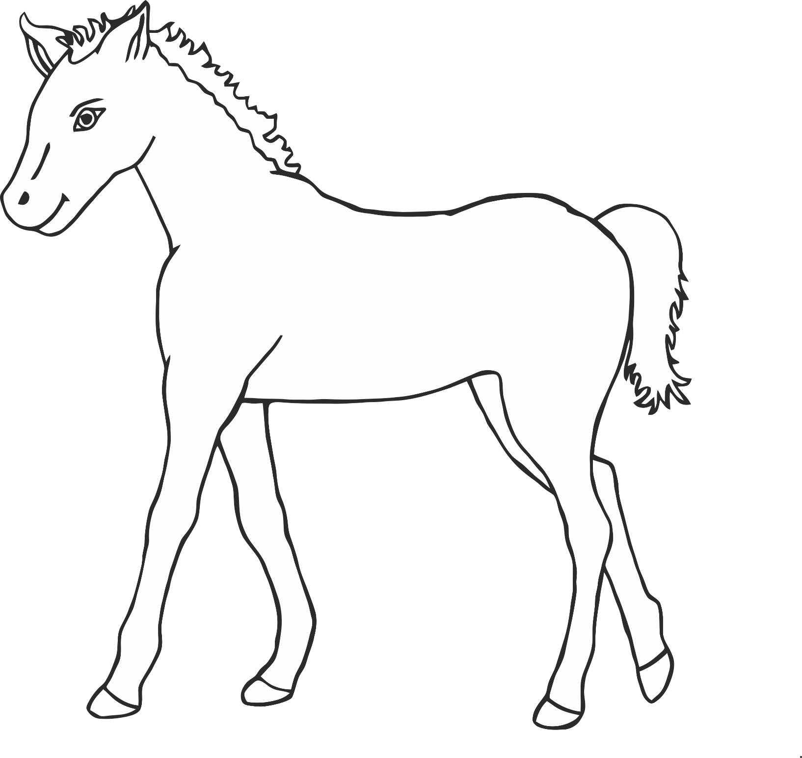

© 2020 Little Owls Resources

foal

(horse)