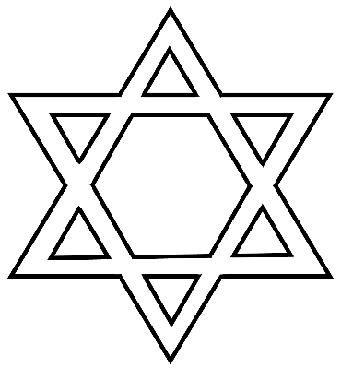

© 2022 Little Owls Resources

Yom Kippur

© 2022 Little Owls Resources

Tzom Kal

**צוֹם קַל**

G'mar Chatima Tovah

**גמר חתימה טובה**

© 2022 Little Owls Resources

Musical horn made from a ram’s horn

**Shofar**

© 2022 Little Owls Resources

**I’m Sorry**

© 2022 Little Owls Resources

**Candles**

© 2022 Little Owls Resources

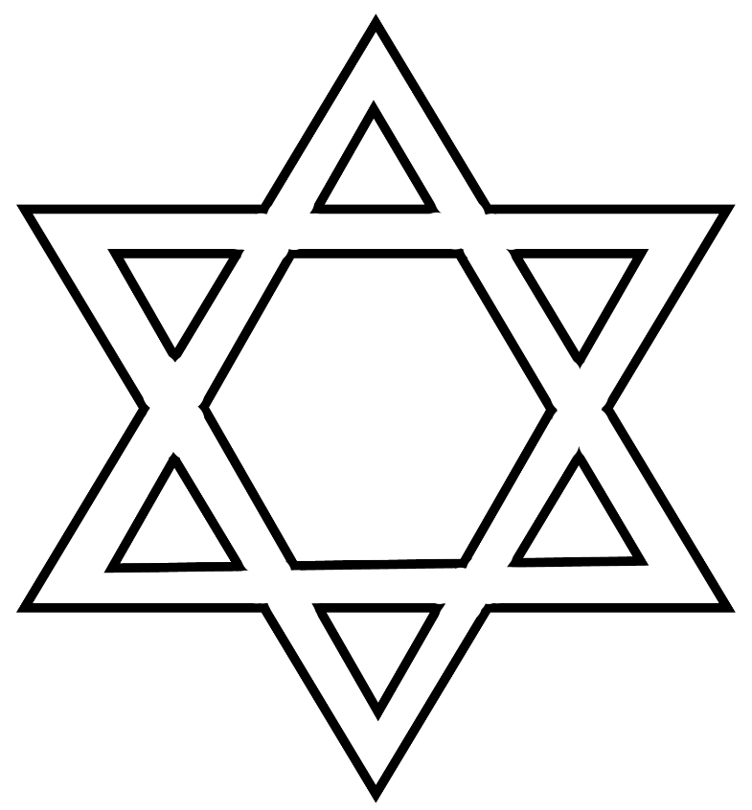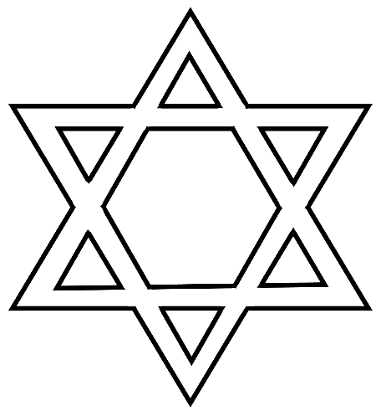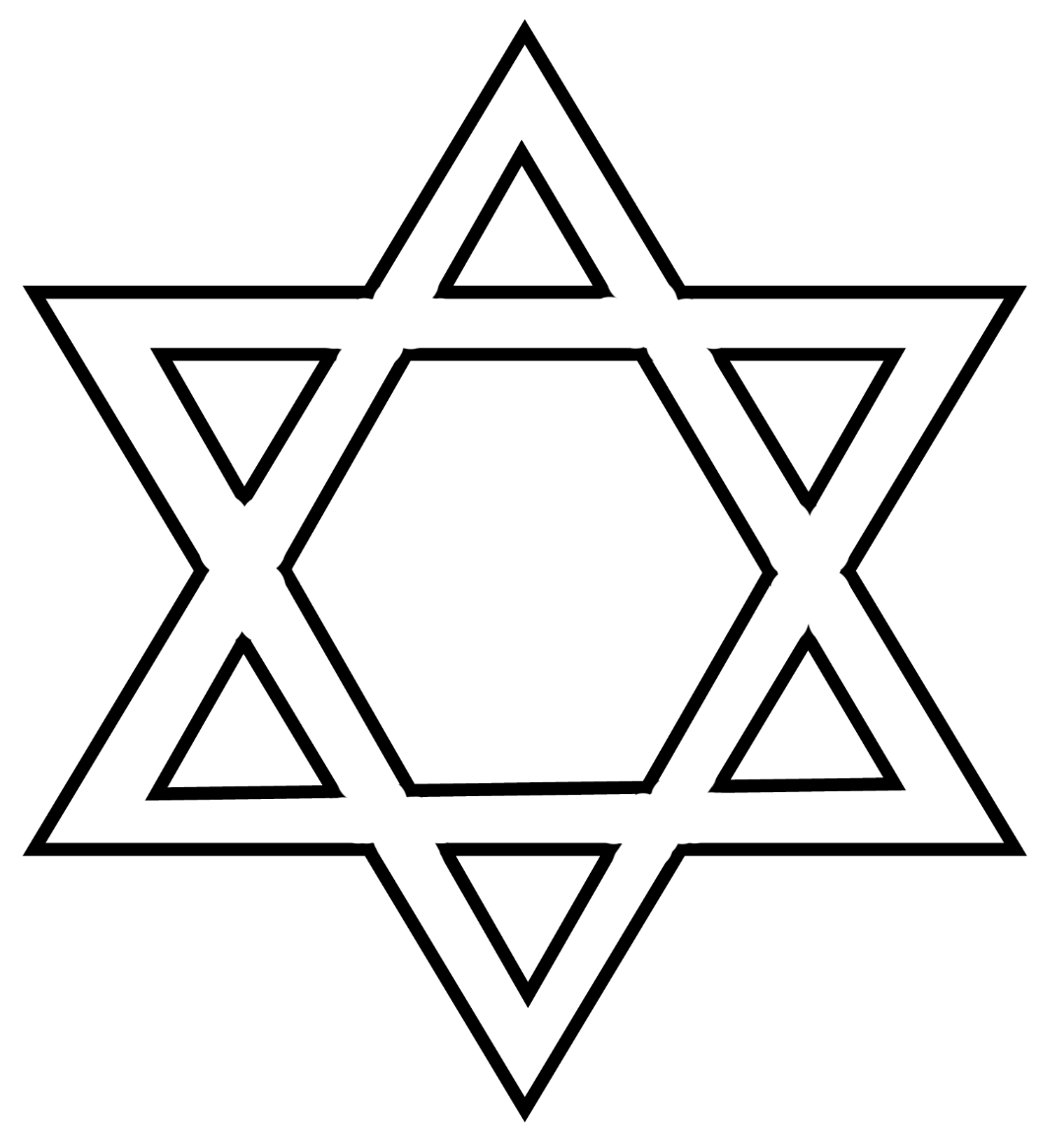

© 2022 Little Owls Resources