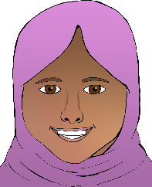

**Happy**

Can you draw and write about time when you were happy?

____________________________________________________________________________________

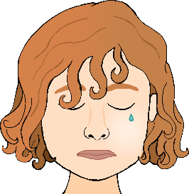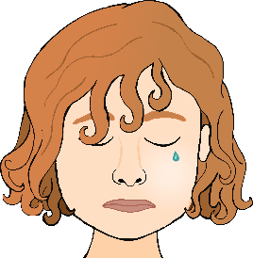

**Sad**

Can you draw and write about time when you were sad?

____________________________________________________________________________________

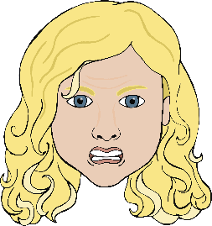

**Angry**

Can you draw and write about time when you were angry?

____________________________________________________________________________________

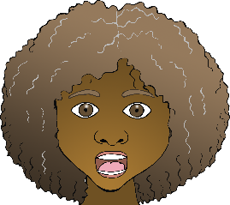

**Scared**

Can you draw and write about time when you were scared?

____________________________________________________________________________________