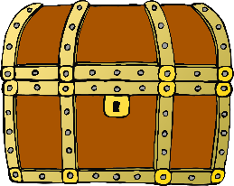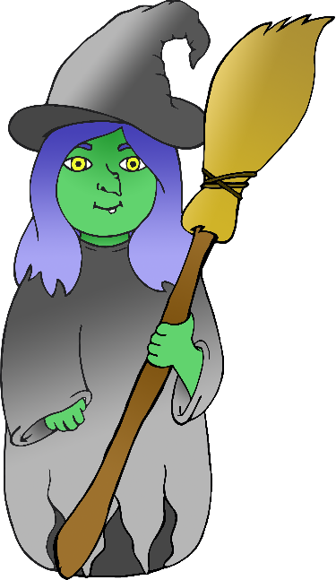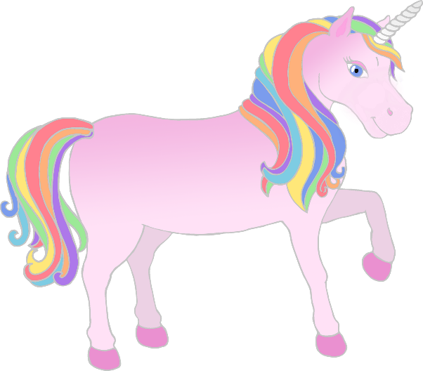

* Pictures of characters – to be stuck on lollipop sticks
* Pictures of objects – to be stuck on blocks
* Large setting pictures

**World Book Day Puppets**

www.littleowls-premium.com

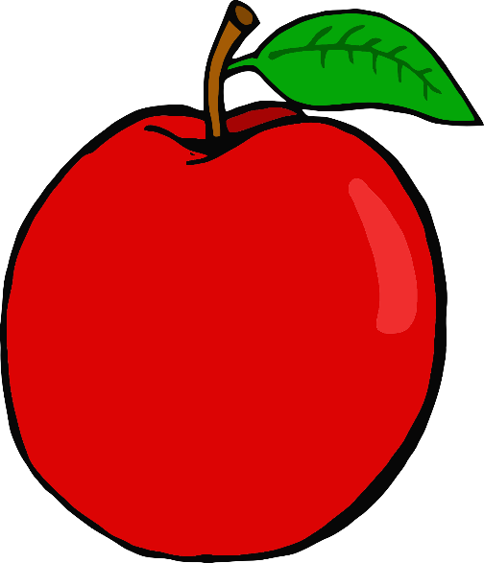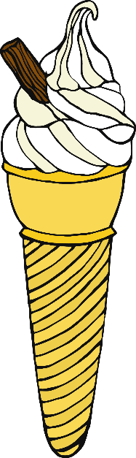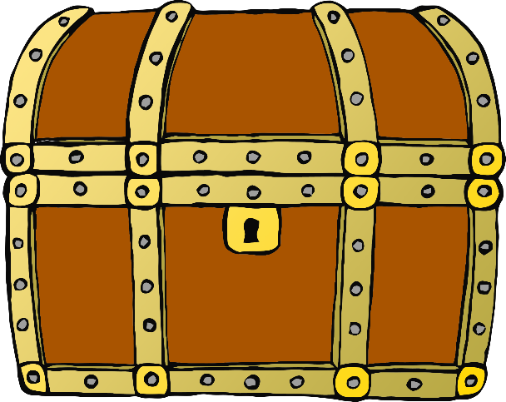



www.littleowls-premium.com

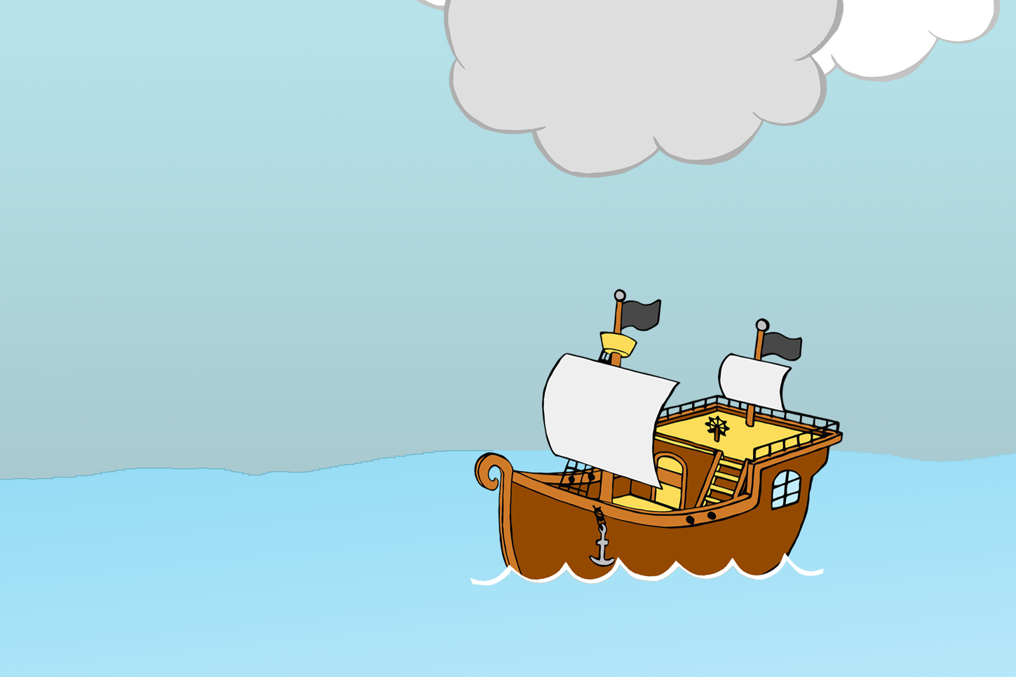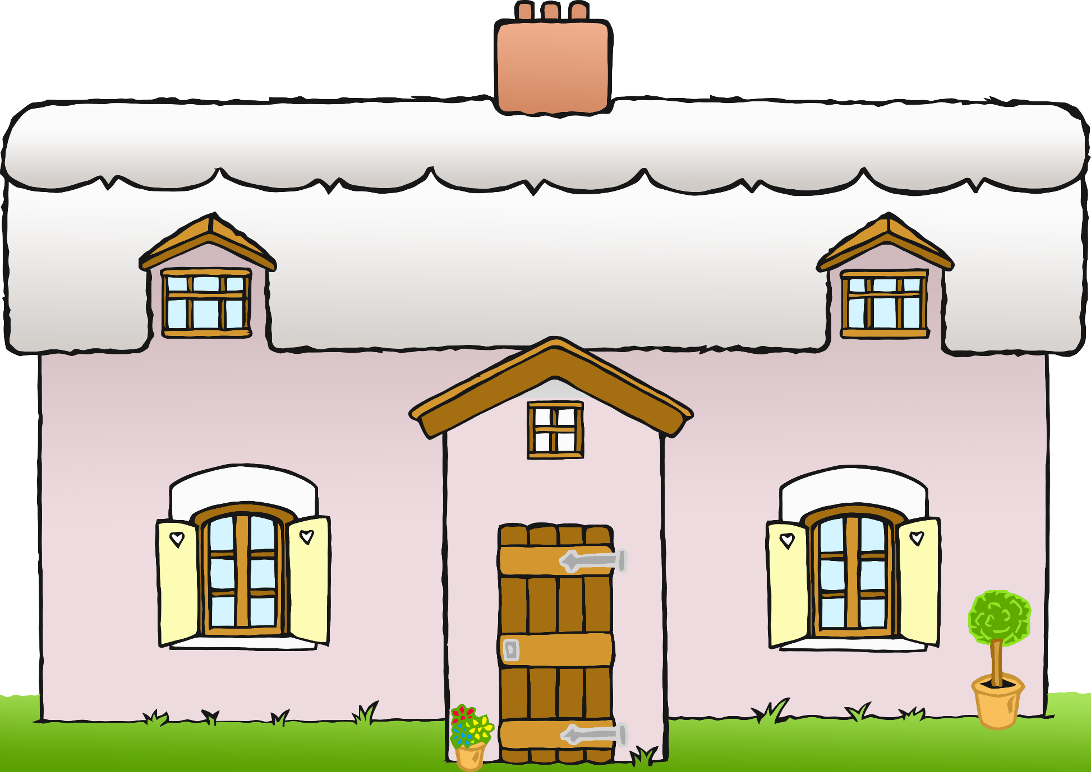

www.littleowls-premium.com

www.littleowlsresources.com

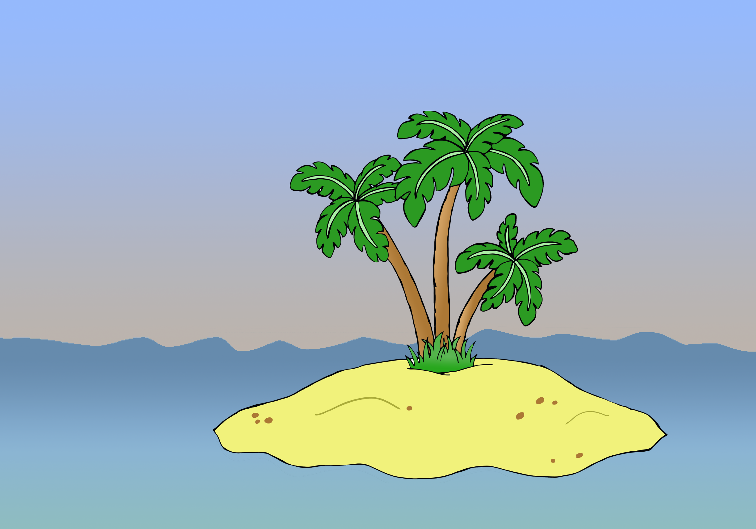

www.littleowls-premium.com

www.littleowlsresources.com

