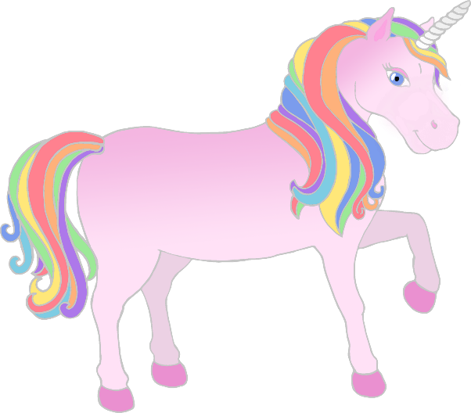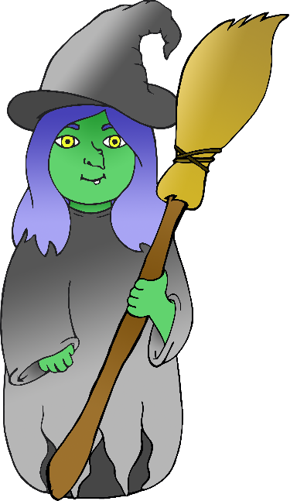

www.littleowls-premium.com

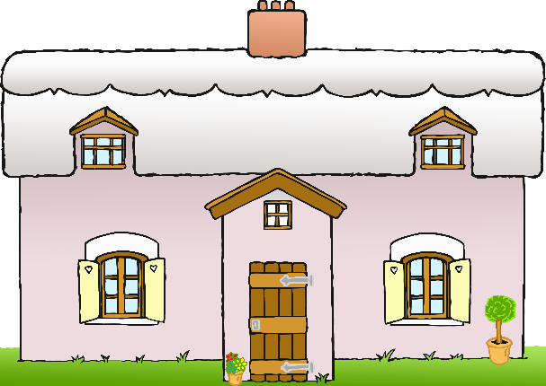

www.littleowls-premium.com

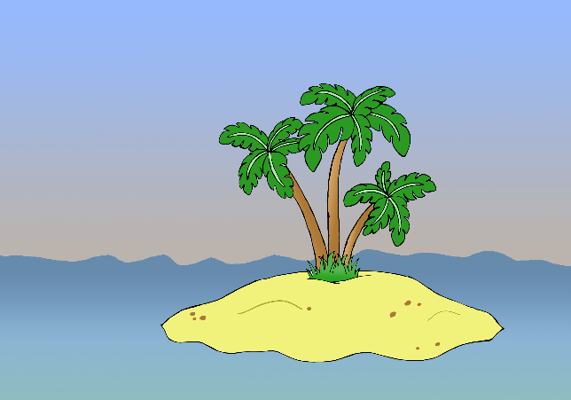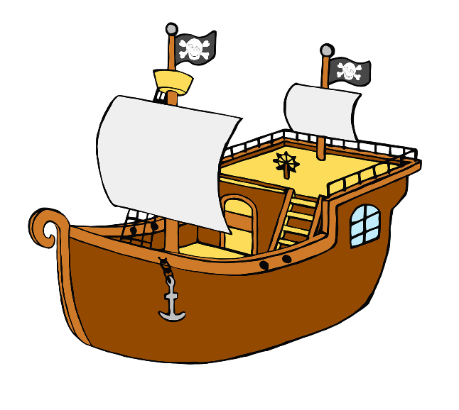

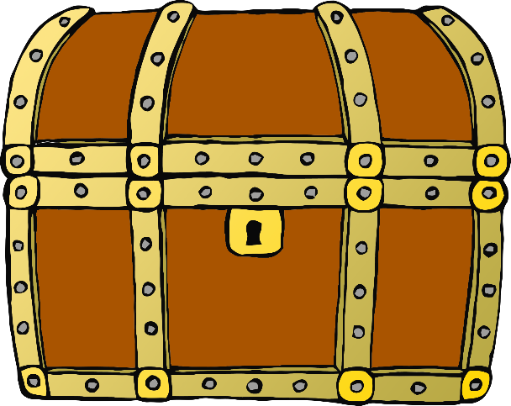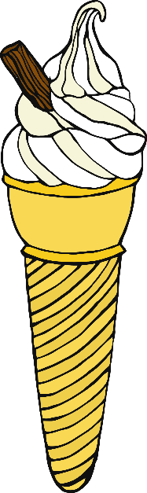

www.littleowls-premium.com

Character

Setting

Object

____________________________________________________________________________

www.littleowls-premium.com

_______________________________________

Character

Setting

Object

www.littleowls-premium.com

www.littleowls-premium.com

Character

Setting

Object