Woodland Wildlife Walk

These checklists are intended to focus the children on looking for aspects of the natural world around them on a wildlife walk.

The descriptions of each item are broad rather than specific so that there is greater scope for being able to complete each one. For example, the bird section can be ticked off when ANY bird is seen rather than a specific species.

The second sheet has spaces for small drawings/marks when recording what is seen.

Winter

© 2022 Little Owls Resources

Woodland Wildlife Walk

Winter

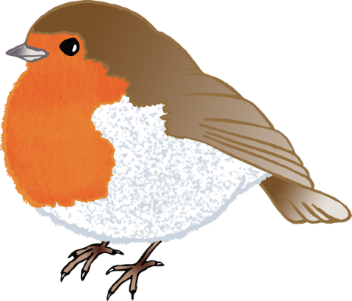

Pine needles

Fungus **DON’T TOUCH**

Minibeast

e.g. Ladybirds hibernating (diapause)

© 2022 Little Owls Resources

Bird

e.g. Robin

Grass

Tree

Plant/Flower

e.g. Holly

Stone/Pebble

Animal

e.g. Squirrel

Pine needles

Fungus

Tree

Grass

Animal

Minibeast

Bird

Stone/Pebble

Plant/Flower

© 2022 Little Owls Resources

Winter

Woodland Wildlife Walk