Woodland Wildlife Walk

These checklists are intended to focus the children on looking for aspects of the natural world around them on a wildlife walk.

The descriptions of each item are broad rather than specific so that there is greater scope for being able to complete each one. For example, the bird section can be ticked off when ANY bird is seen rather than a specific species.

The second sheet has spaces for small drawings/marks when recording what is seen.

Spring

© 2022 Little Owls Resources

Woodland Wildlife Walk



Spring

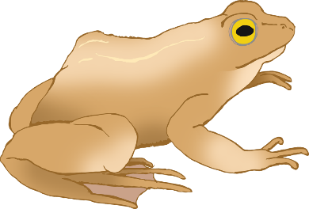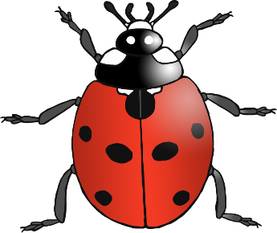

© 2022 Little Owls Resources

Bird

e.g. Blue Tit

Grass

Fungus

Leaves

Plant/Flower

e.g. Daffodil

Stone/Pebble

Minibeast

e.g. Ladybird

Animal

e.g. Frog

Wildlife home

e.g. Bird’s nest

Fungus

Leaves

Grass

Wildlife home

Animal

Minibeast

Bird

Stone/Pebble

Plant/Flower

© 2022 Little Owls Resources

Spring

Woodland Wildlife Walk