Winter

**Woodland Wildlife Draw & Write**

These sheets are intended to encourage children to record their expectations and/or observations of the winter season. They are differentiated by amounts of expected writing.

© 2021 Little Owls Resources

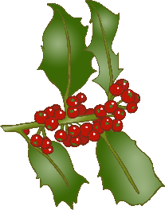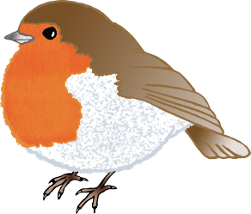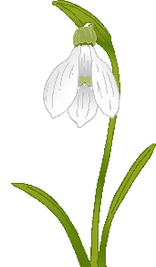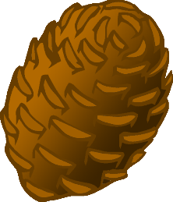

**Woodland Wildlife**

What can you see in…

Winter ?

© 2021 Little Owls Resources

**Woodland Wildlife**

What can you see in…

Winter ?

© 2021 Little Owls Resources

________­­­­­­­­­­­­­­­­­­­______________________

______________________________

______________________________

______________________________

­______________________________

______________________________

­______________________________

______________________________



**Woodland Wildlife**

What can you see in…

Winter ?

© 2021 Little Owls Resources

**________­­­­­­­­­­­­­­­­­­­______________________**

**______________________________**

**______________________________**

**______________________________**

**­______________________________**

**______________________________**

**­______________________________**



**Woodland Wildlife**

What can you see in…

Winter ?

© 2021 Little Owls Resources

**______________________________________________________**

­**______________________________________________________**

**______________________________________________________**

**______________________________________________________**

**______________________________________________________**

**______________________________________________________**

**______________________________________________________**