**Woodland Wildlife**

**Fact Cards** - **Trees (A5)**

These fact cards can be used as part of a display or as a stimulus for discussion, writing and drawing before or after time spent in a woodland setting.

© 2021 Little Owls Resources

Sycamore

Oak

Height:

Leaf:

Fact:

35m

Produces sycamore seeds that have fall slowly to the floor in a slow spinning motion.

Up to 16cm long with five lobes.

Height:

Leaf:

Fact:

20-40m

Produces acorns.

Up to 10cm long with four to five lobes.

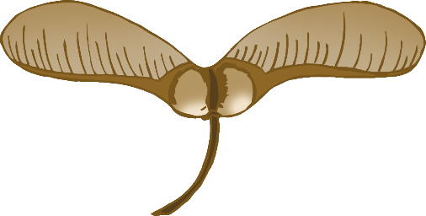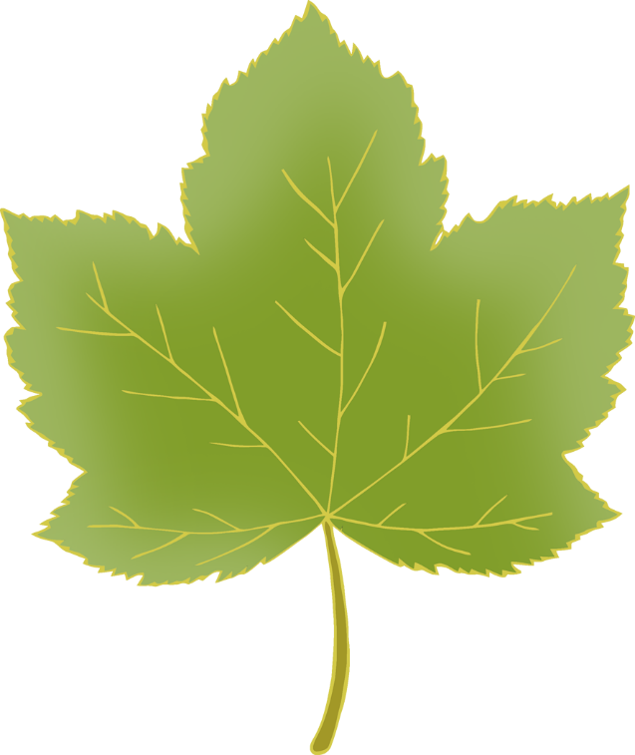

© 2021 Little Owls Resources

© 2021 Little Owls Resources

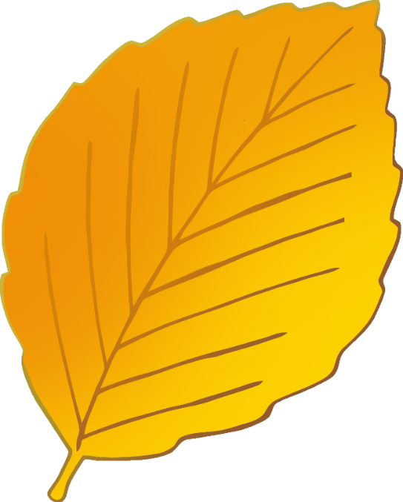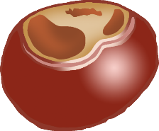

Horse Chestnut

Beech

Height:

Leaf:

Fact:

40m

* Produces conkers.
* Trees can live 300 years.

Each leaf has 5-7 leaflets.

Height:

Leaf:

Fact:

40m

Beech trees don’t drop their leaves when they turn brown.

Up to 9cm long.

© 2021 Little Owls Resources

© 2021 Little Owls Resources

Ash

Scots Pine

Height:

Leaf:

Fact:

35m

Leaves fall when they are still green.

Up to 40cm long.

Height:

Leaf:

Fact:

35m

* Evergreen.
* Trees can live for 700 years.

Green needles - slightly twisted.

© 2021 Little Owls Resources

© 2021 Little Owls Resources

Western Hemlock

London Plane

Height:

Leaf:

Fact:

45m

Evergreen.

Soft, flat needles.

Height:

Leaf:

Fact:

35m

Trees can live for over 300 years.

Up to 20cm long.

© 2021 Little Owls Resources

© 2021 Little Owls Resources

Black Poplar

Holly

Height:

Leaf:

Fact:

30m

Trees can live for over 200 years.

Shiny, green and heart-shaped.

Height:

Leaf:

Fact:

15m

* Evergreen.
* Trees can live for 300 years.

Leaves are spiky when the tree is young, but smoother when the tree is old.

© 2021 Little Owls Resources

© 2021 Little Owls Resources