**Woodland Wildlife**

**Fact Cards** - **Plants (A5)**

These fact cards can be used as part of a display or as a stimulus for discussion, writing and drawing before or after time spent in a woodland setting.

© 2021 Little Owls Resources

Bluebell

Ivy

Up to 30m (on tree)

Bluebells are an indication of an area of ancient woodland.

Spring

30cm

Ivy uses trees and walls to grow up high to get more sunlight.

Autumn

Height:

Flowering Season:

Fact:

Height:

Flowering Season:

Fact:

© 2021 Little Owls Resources

© 2021 Little Owls Resources

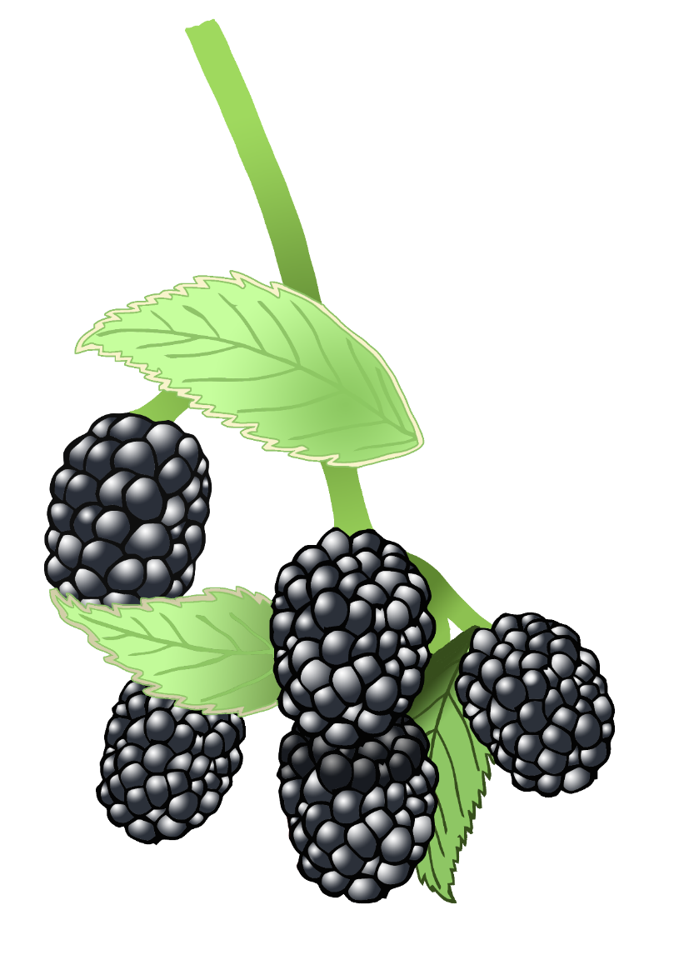

Winter >>> Spring

15cm

Used to treat headaches in the past.

Blackberries grow on bramble. People have traditionally picked blackberries for thousands of years.

Summer

2m

Height:

Flowering Season:

Fact:

Height:

Flowering Season:

Fact:

© 2021 Little Owls Resources

© 2021 Little Owls Resources

Snowdrop

Bramble

Spring >>> Autumn

Up to 60cm

Used to treat coughs and asthma in the past.

Brought to UK by the Romans.

Spring

42cm

Daisy

Daffodil

Height:

Flowering Season:

Fact:

Height:

Flowering Season:

Fact:

© 2021 Little Owls Resources

© 2021 Little Owls Resources

Spring

5-15cm

Wood Anemone are an indication of an area of ancient woodland.

Late Spring >>> Summer

30cm

Used to treat stomach aches in the past.

Wood Anemone

Herb Robert

Height:

Flowering Season:

Fact:

Height:

Flowering Season:

Fact:

© 2021 Little Owls Resources

© 2021 Little Owls Resources