**Woodland Wildlife**

**Fact Cards** - **Plants (A4)**

These fact cards can be used as part of a display or as a stimulus for discussion, writing and drawing before or after time spent in a woodland setting.

© 2021 Little Owls Resources

© 2021 Little Owls Resources

Ivy

Height:

Flowering Season:

Fact:

Up to 30m (on tree)

Ivy uses trees and walls to grow up high to get more sunlight.

Autumn

© 2021 Little Owls Resources

Bluebell

Height:

Flowering Season:

Fact:

30cm

Bluebells are an indication of an area of ancient woodland.

Spring

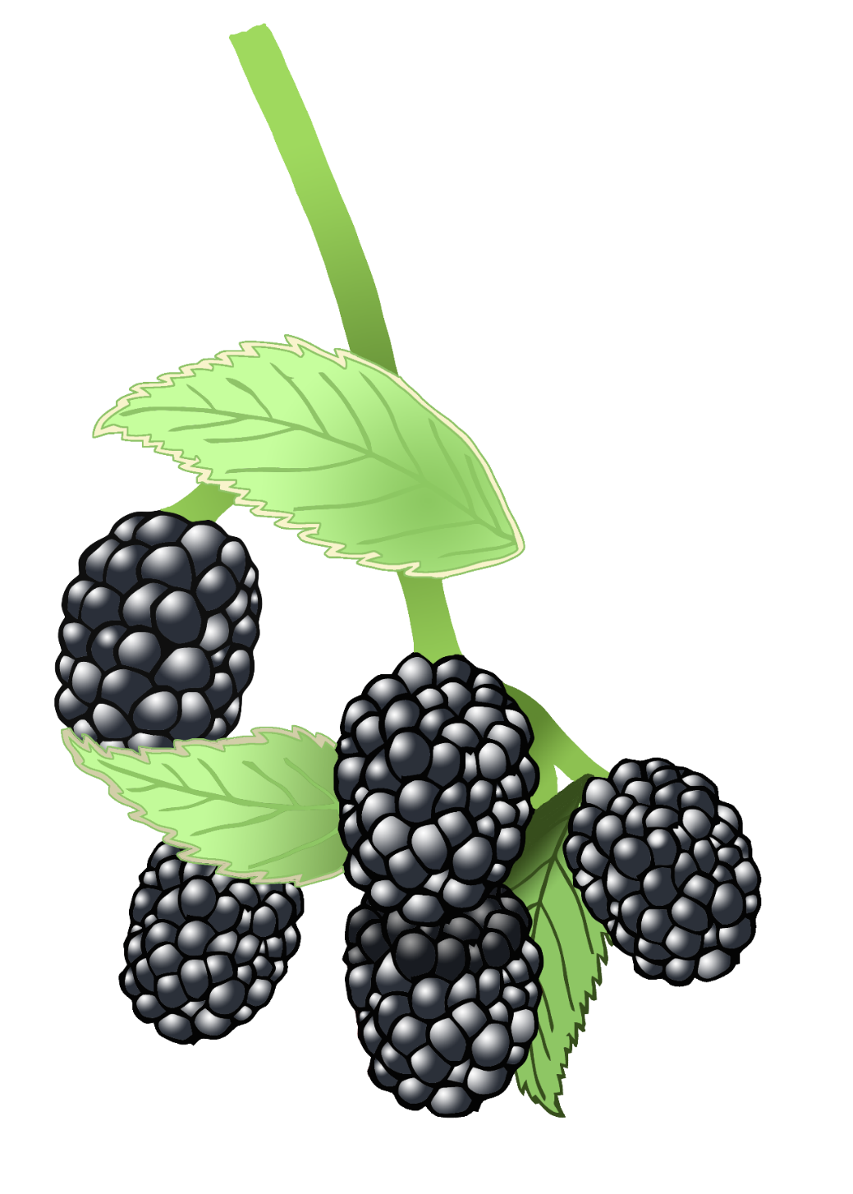

© 2021 Little Owls Resources

Bramble

Height:

Flowering Season:

Fact:

2m

Blackberries grow on bramble. People have traditionally picked blackberries for thousands of years.

Summer

Height:

Flowering Season:

Fact:

15cm

Used to treat headaches in the past.

Winter >>> Spring

© 2021 Little Owls Resources

Snowdrop

© 2021 Little Owls Resources

Daffodil

Height:

Flowering Season:

Fact:

42cm

Brought to UK by the Romans.

Spring

© 2021 Little Owls Resources

Daisy

Height:

Flowering Season:

Fact:

Up to 60cm

Used to treat coughs and asthma in the past.

Spring >>> Autumn

© 2021 Little Owls Resources

Herb Robert

Height:

Flowering Season:

Fact:

30cm

Used to treat stomach aches in the past.

Late Spring >>> Summer

© 2021 Little Owls Resources

Wood Anemone

Height:

Flowering Season:

Fact:

5-15cm

Wood Anemone are an indication of an area of ancient woodland.

Spring