**Woodland Wildlife**

**Fact Cards** - **Minibeasts (A5)**

These fact cards can be used as part of a display or as a stimulus for discussion, writing and drawing before or after time spent in a woodland setting.

© 2021 Little Owls Resources

Garden Snail

Earthworm

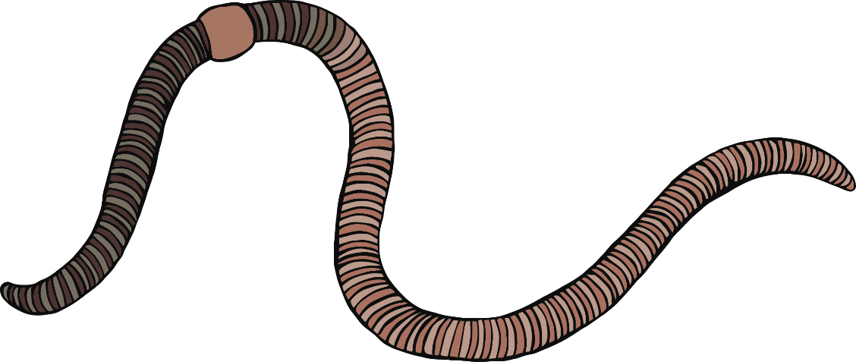

Up to 3-4cm

Snails can carry ten times their body weight.

Seedlings, small plants.

Worms help to make soil ready for plants to grow successfully.

Nutrients in soil.

Up to 35cm

Length:

Food:

Fact:

Length:

Food:

Fact:

© 2021 Little Owls Resources

© 2021 Little Owls Resources

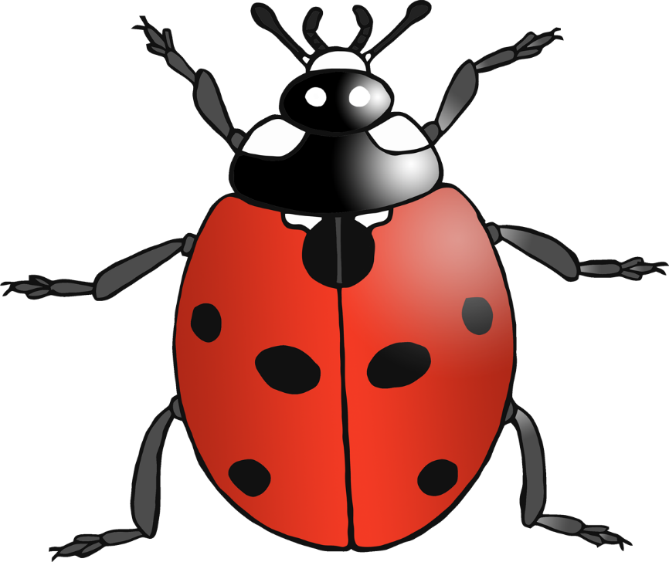

Earwigs have wings but hardly ever fly.

Small plants, flowers, and insects.

Up to 1.5cm

Ladybirds pretend to be dead when they are threatened.

Aphids and other small insects.

Up to 1cm

Length:

Food:

Fact:

Length:

Food:

Fact:

© 2021 Little Owls Resources

© 2021 Little Owls Resources

Earwig

Ladybird

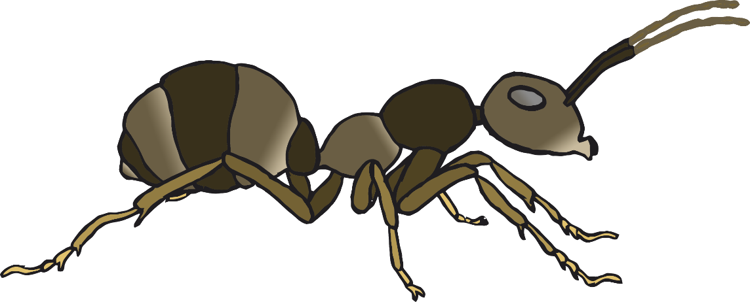

Very important in helping to spread pollen from flower to flower.

Nectar and pollen from flowers.

Ants can carry FIFTY times their own body weight!

Almost anything!

Up to 2cm

Up to 0.5cm

Length:

Food:

Fact:

Length:

Food:

Fact:

© 2021 Little Owls Resources

© 2021 Little Owls Resources

Bumblebee

Ant

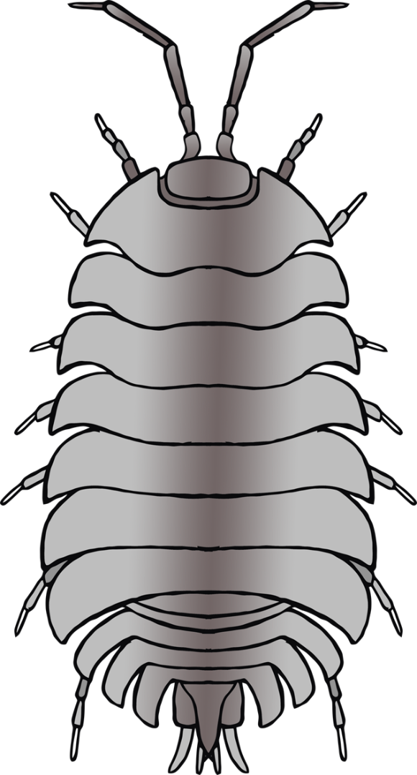

Centipedes hunt for food at night.

Small insects, worms, and slugs.

Up to 3cm

Related to shrimps and crabs.

Old wood, leaves, fruit, and dead insects.

Up to 1.5cm

Length:

Food:

Fact:

Length:

Food:

Fact:

© 2021 Little Owls Resources

© 2021 Little Owls Resources

Centipede

Woodlouse

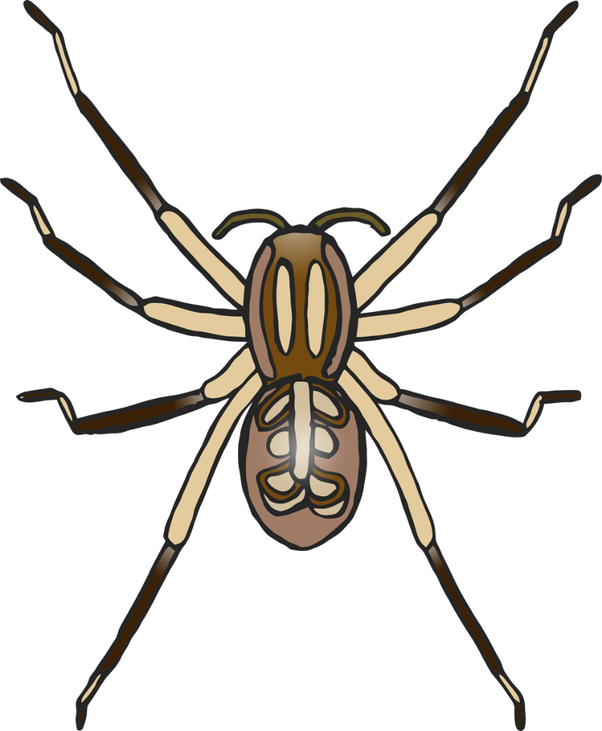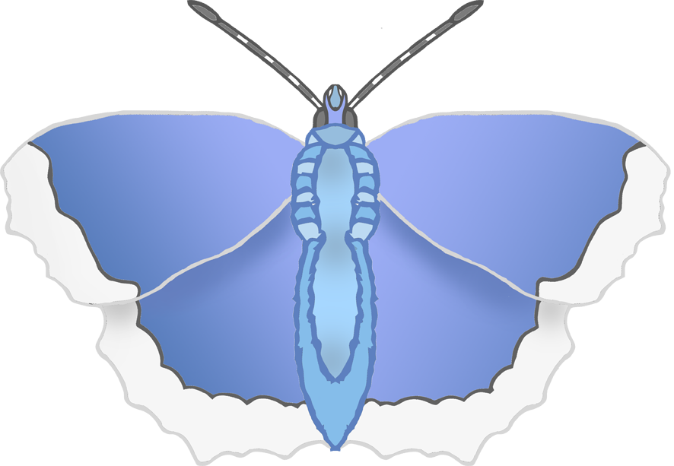

Length:

Food:

Fact:

Size:

Food:

Fact:

Most likely to see them from May until October.

Nectar flowers.

Up to 3.5cm wide.

The main predator of garden spiders are birds.

Flying insects.

Up to 1.5cm

Garden Spider

Common Blue Butterfly

© 2021 Little Owls Resources

© 2021 Little Owls Resources