Mindfulness Woodland Scavenger Hunt

Prompt Cards

These prompt cards are to promote mindfulness and awareness of surroundings when in a woodland setting.

This activity is intended to help children engage their senses to better notice and appreciate the environment around them.

© 2021 Little Owls Resources

© 2021 Little Owls Resources

Can you find...?

Something that grows



Mindfulness Woodland Scavenger Hunt

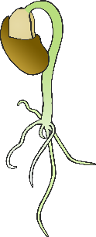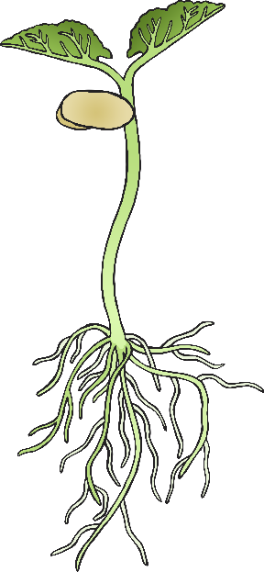

© 2021 Little Owls Resources

Can you find...?

Birds singing



Mindfulness Woodland Scavenger Hunt

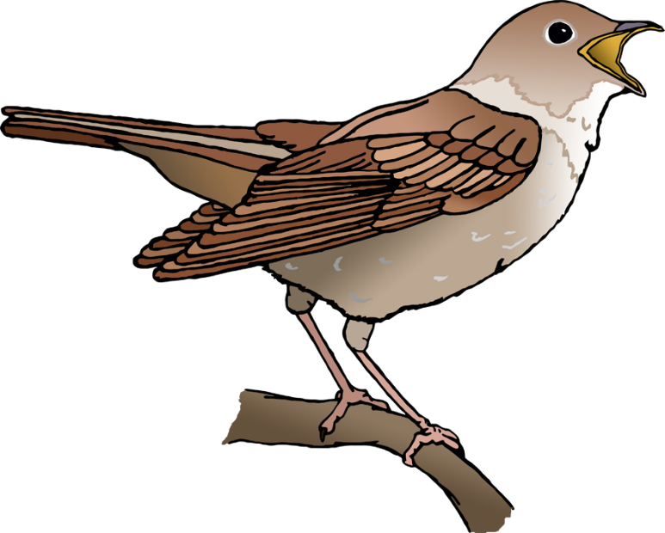

© 2021 Little Owls Resources

Can you find...?

Something you can smell



Mindfulness Woodland Scavenger Hunt

© 2021 Little Owls Resources

Can you find...?

Something very big



Mindfulness Woodland Scavenger Hunt

?

© 2021 Little Owls Resources

Can you find...?

Something red



Mindfulness Woodland Scavenger Hunt

© 2021 Little Owls Resources

Can you find...?

Something you have never seen before



Mindfulness Woodland Scavenger Hunt

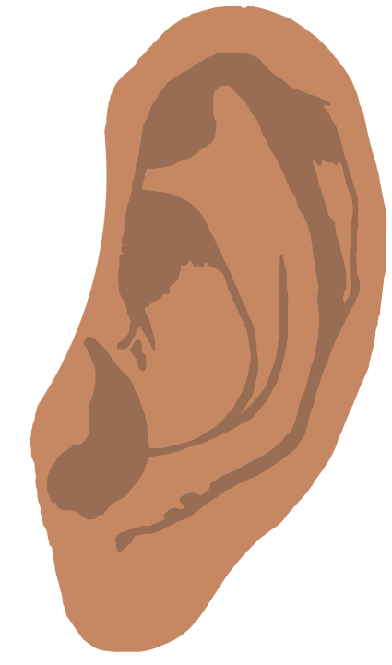

© 2021 Little Owls Resources

Can you find...?

Something that makes a sound



Mindfulness Woodland Scavenger Hunt

© 2021 Little Owls Resources

Can you find...?

A tiny minibeast



Mindfulness Woodland Scavenger Hunt

© 2021 Little Owls Resources

Can you find...?

A bird’s nest



Mindfulness Woodland Scavenger Hunt

© 2021 Little Owls Resources

Can you find...?

A flower



Mindfulness Woodland Scavenger Hunt

© 2021 Little Owls Resources

Can you find...?

Wind blowing through trees



Mindfulness Woodland Scavenger Hunt

© 2021 Little Owls Resources

Can you find...?

Something delicate



Mindfulness Woodland Scavenger Hunt

© 2021 Little Owls Resources

Can you find...?

Something green



Mindfulness Woodland Scavenger Hunt

© 2021 Little Owls Resources

Can you find...?

Something very small



Mindfulness Woodland Scavenger Hunt

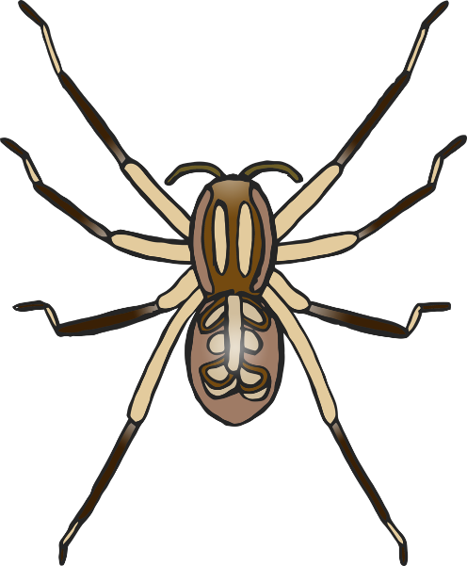

© 2021 Little Owls Resources

Can you find...?

Something you can hold with one hand



Mindfulness Woodland Scavenger Hunt

© 2021 Little Owls Resources

Can you find...?

Something that moves



Mindfulness Woodland Scavenger Hunt

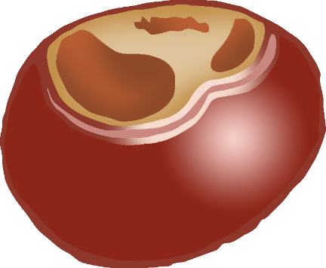

© 2021 Little Owls Resources

Can you find...?

Something that fell from a tree



Mindfulness Woodland Scavenger Hunt

© 2021 Little Owls Resources

Can you find...?

Dry mud



Mindfulness Woodland Scavenger Hunt