Mindfulness Woodland Scavenger Hunt

Checklists

These checklists are to promote mindfulness and awareness of surroundings when in a woodland setting.

This activity is intended to help children engage their senses to better notice and appreciate the environment around them.

© 2021 Little Owls Resources

© 2021 Little Owls Resources

Can you find...?

Something that grows

Birds singing

Something you can smell

Something very big

Something you have never seen before

Something red

Something that makes a sound

A tiny minibeast

Bird’s nest



Mindfulness Woodland Scavenger Hunt

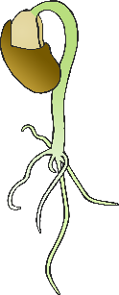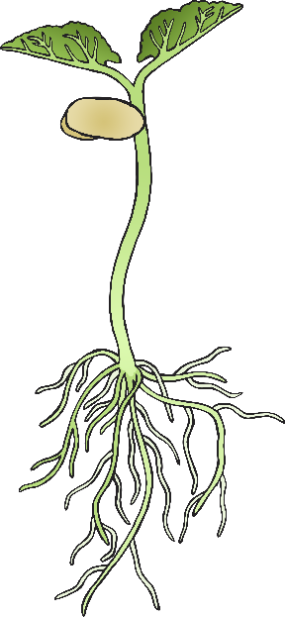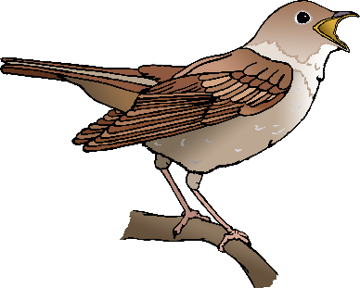

?

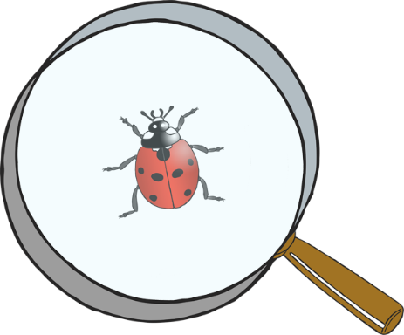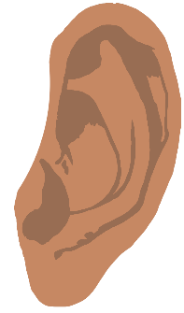

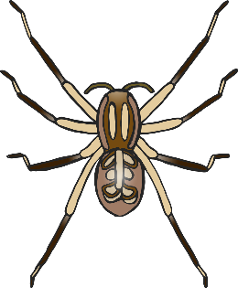

© 2021 Little Owls Resources

Can you find...?

A flower

Wind blowing through trees

Something delicate

Something green

Something you can hold with one hand

Something very small

Something that moves

Something that fell from a tree

Dry mud



Mindfulness Woodland Scavenger Hunt