**Mindfulness Activity Cards**

These activity cards contain ideas to promote mindfulness and awareness of surroundings when in a woodland setting.

The activities are intended to give the children time and space to think about the environment around them and their own interactions with it.

Woodland

© 2021 Little Owls Resources

© 2021 Little Owls Resources

Blow bubbles

**Mindfulness**

Woodland

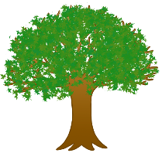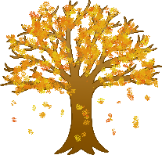

Watch the bubbles move through the air and slowly fall to the ground.



© 2021 Little Owls Resources

Look at the clouds

**Mindfulness**

Woodland



Watch the cloud shapes slowly move, change, and evolve.

© 2021 Little Owls Resources

Plant seeds

**Mindfulness**

Woodland



Prepare the soil for the seed. Plant the seed and add some water.

© 2021 Little Owls Resources

Reading

**Mindfulness**

Woodland



Look at a book or listen to a story whilst sitting under a tree.

© 2021 Little Owls Resources

Make marks

**Mindfulness**

Woodland



Use a stick or twig to make marks in the mud.

© 2021 Little Owls Resources

Create artwork

**Mindfulness**

Woodland



Use woodland items, such as stones and leaves, to create natural artwork.

Breathe out…

Breathe in…

© 2021 Little Owls Resources

Sit and breathe

**Mindfulness**

Woodland



Sit on the ground. Close your eyes. Breathe in slowly. Breathe out slowly.

© 2021 Little Owls Resources

Smell flowers

**Mindfulness**

Woodland



Compare the smell of different flowers. Which is your favourite?

© 2021 Little Owls Resources

Hold a pose

**Mindfulness**

Woodland



With the woods around you find a space and hold different body poses.

© 2021 Little Owls Resources

Role-play

**Mindfulness**

Woodland



Think of a woodland animal. Can you act like that animal?

© 2021 Little Owls Resources

I spy colours

**Mindfulness**

Woodland



Play colour ‘I spy’ with woodland items around you.

© 2021 Little Owls Resources

Create mandala

**Mindfulness**

Woodland



Use natural items to create a mandala; repeating patterns in concentric circles.

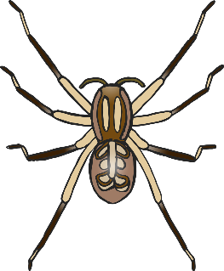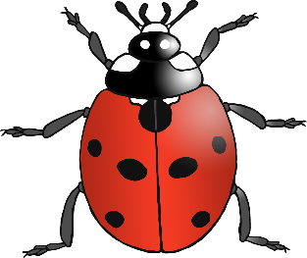

Hug a tree

© 2021 Little Owls Resources

t

**Mindfulness**

Woodland

Feel the bark of the tree with your fingers. How does it feel?

© 2021 Little Owls Resources

Watch wildlife

**Mindfulness**

Woodland



Closely watch the movement and behaviour of wildlife in the woodland area.

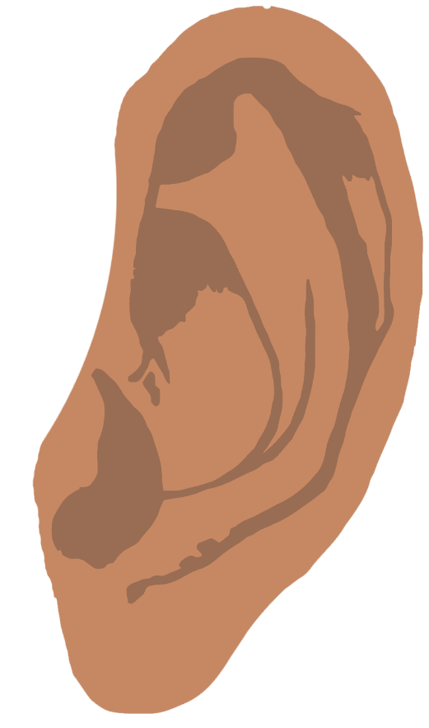

© 2021 Little Owls Resources

Listening walk

**Mindfulness**

Woodland



What different sounds can you hear as you move through the woods?

© 2021 Little Owls Resources

Smell walk

**Mindfulness**

Woodland



As you move through the woods what different smells are you aware of?

© 2021 Little Owls Resources

**Mindfulness**

Woodland



© 2021 Little Owls Resources

**Mindfulness**

Woodland

