**Woodland Wildlife**

**Fact Cards** - **Birds (A5)**

These fact cards can be used as part of a display or as a stimulus for discussion, writing and drawing before or after time spent in a woodland setting.

© 2021 Little Owls Resources

Robin

Blackbird

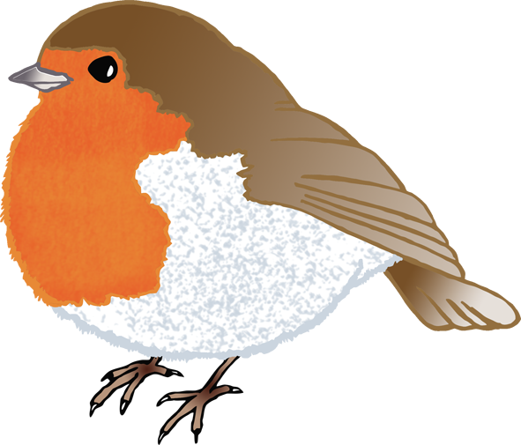

Season:

Length:

Food:

Number of eggs:

All year

Insects, worms, berries.

25 cm

3-5

Season:

Length:

Food:

Number of eggs:

All year

Worms, seeds, insects.

14 cm

4-6

© 2021 Little Owls Resources

© 2021 Little Owls Resources

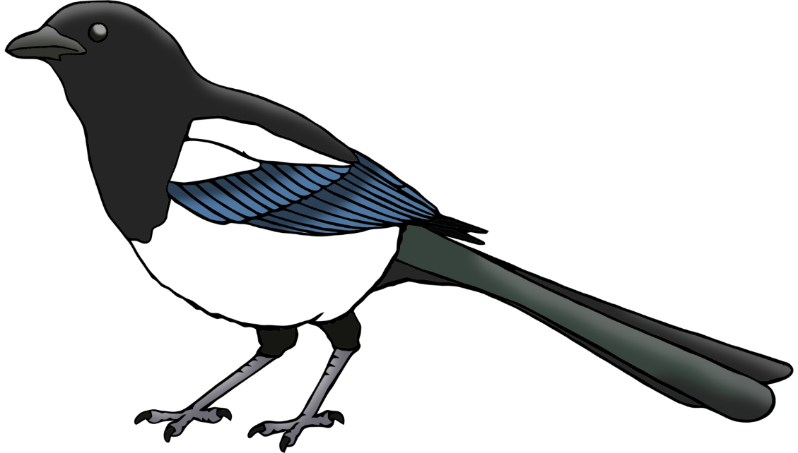

Season:

Length:

Food:

Number of eggs:

All year

Insects, fruit.

45 cm

6

Season:

Length:

Food:

Number of eggs:

All year

Nuts, seeds, berries, grain.

40 cm

2

© 2021 Little Owls Resources

© 2021 Little Owls Resources

Pigeon

Magpie

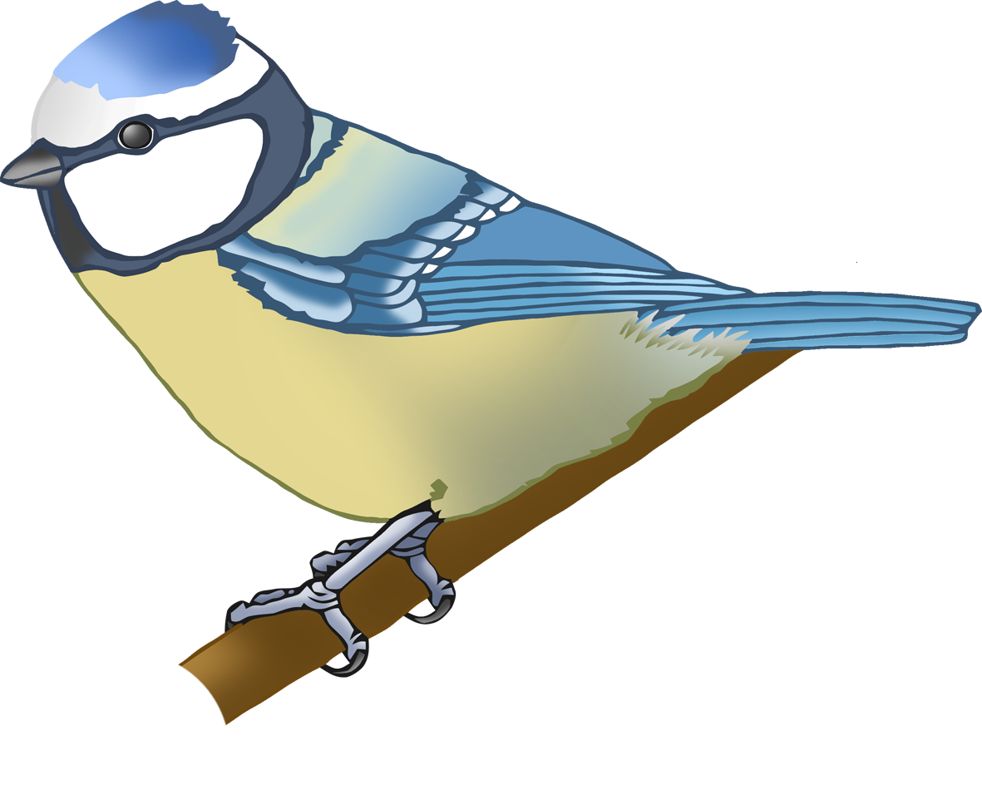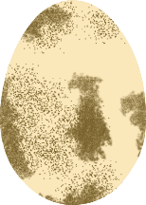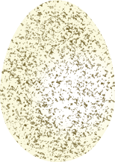

Season:

Length:

Food:

Number of eggs:

All year

Insects, seeds, nuts.

12 cm

8-10

Season:

Length:

Food:

Number of eggs:

All year (most in spring)

Small mammals/birds, large insects.

50-55 cm

2-4

Buzzard

Blue Tit

© 2021 Little Owls Resources

© 2021 Little Owls Resources

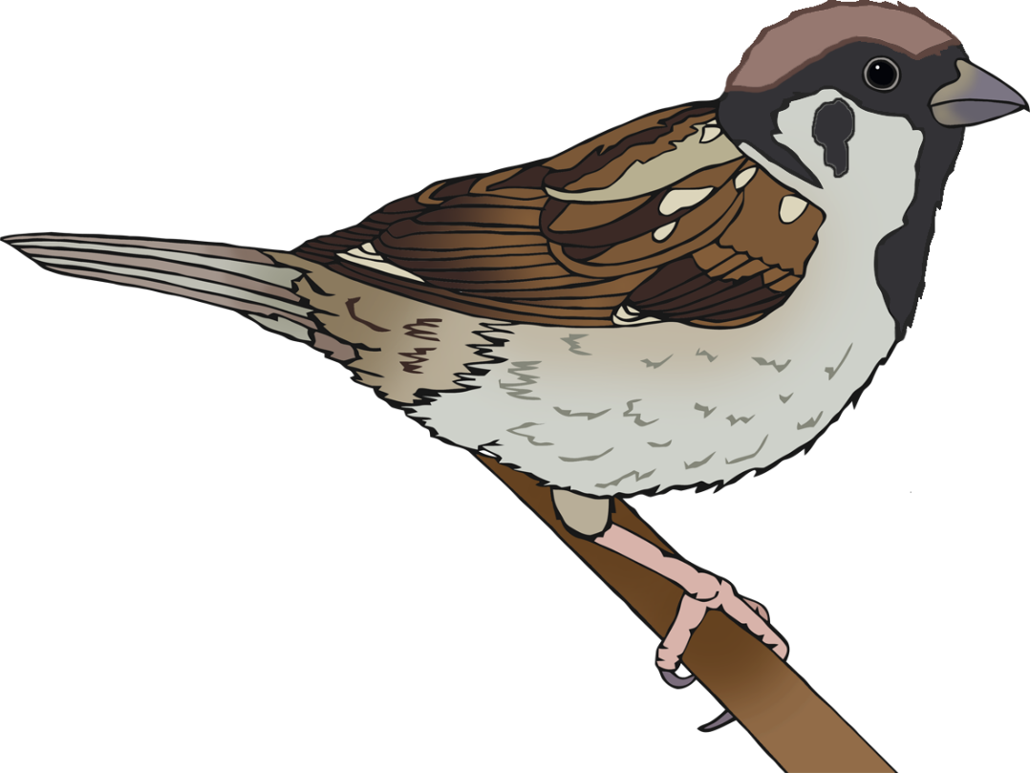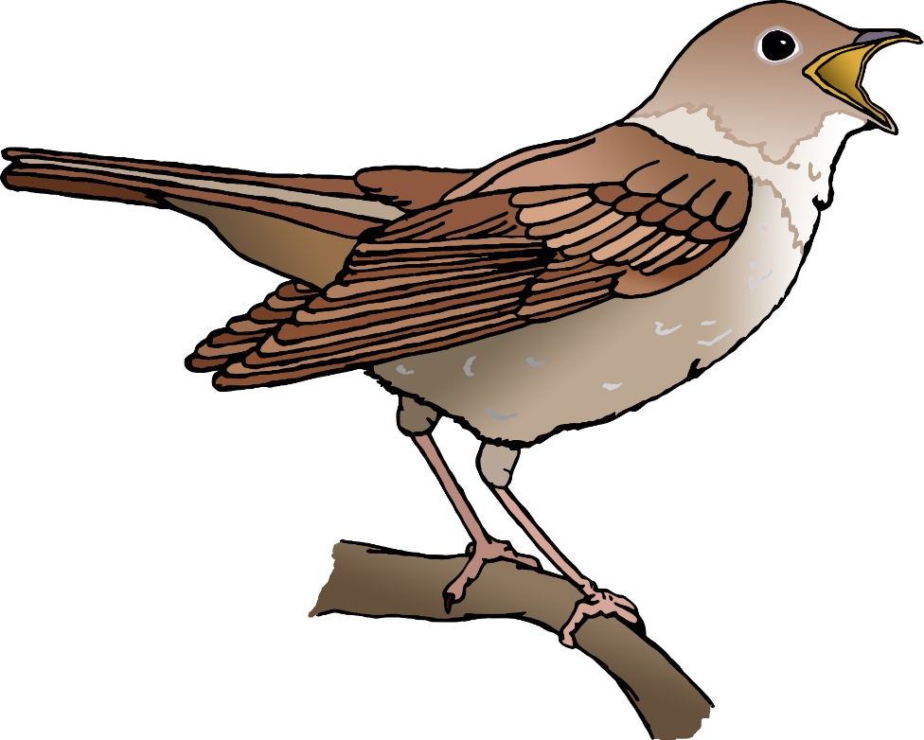

Season:

Length:

Food:

Number of eggs:

Spring

Insects

16 cm

3

Season:

Length:

Food:

Number of eggs:

All year

Seeds and insects.

14 cm

5-6

© 2021 Little Owls Resources

© 2021 Little Owls Resources

Tree Sparrow

Nightingale

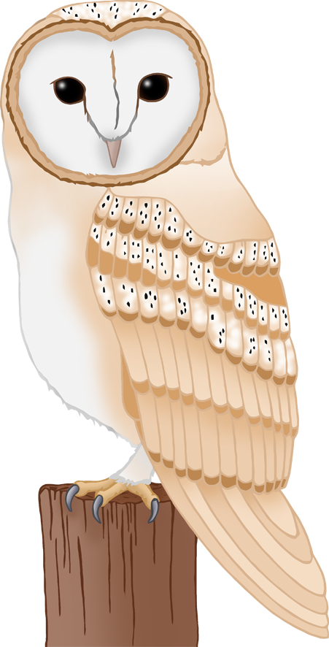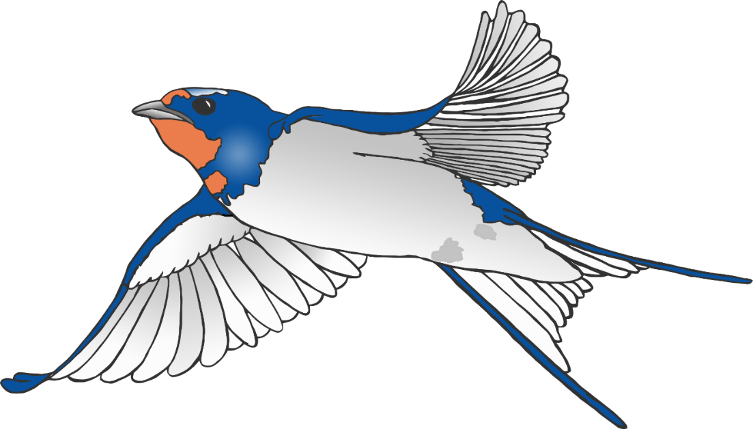

Season:

Length:

Food:

Number of eggs:

Spring and summer

Flying insects.

18 cm

2-3

Season:

Length:

Food:

Number of eggs:

All year (dusk)

Mice, voles, shrews.

35 cm

4-7

© 2021 Little Owls Resources

© 2021 Little Owls Resources

Swallow

Barn Owl