**Woodland Wildlife**

**Fact Cards** - **Birds (A4)**

These fact cards can be used as part of a display or as a stimulus for discussion, writing and drawing before or after time spent in a woodland setting.

© 2021 Little Owls Resources

© 2021 Little Owls Resources

Blackbird

Season:

Length:

Food:

Number of eggs:

All year

Insects, worms, berries.

25 cm

3-5

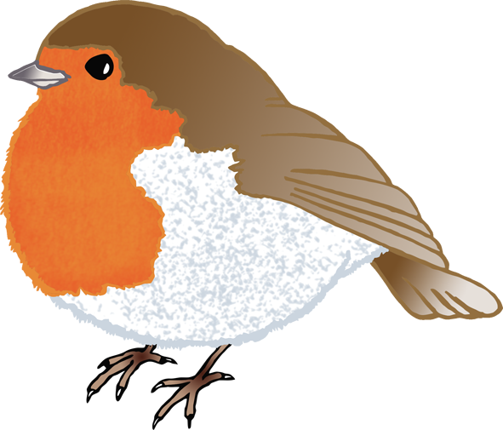

© 2021 Little Owls Resources

Robin

Season:

Length:

Food:

Number of eggs:

All year

Worms, seeds, insects.

14 cm

4-6

© 2021 Little Owls Resources

Magpie

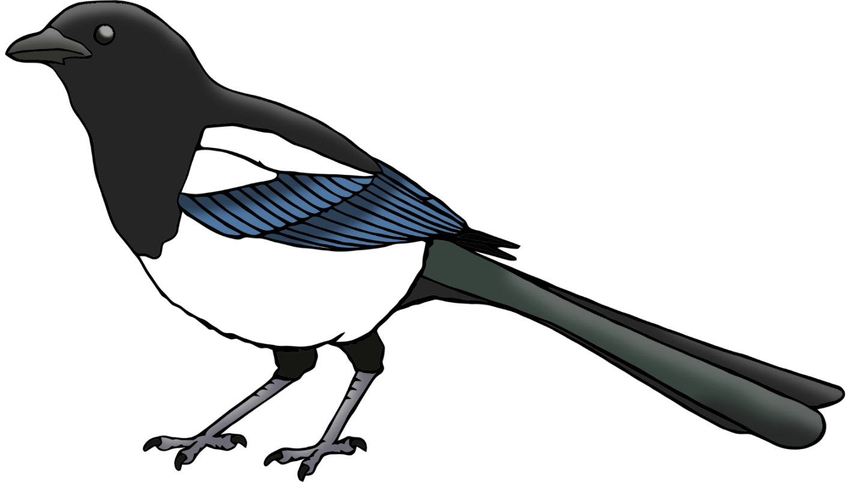

Season:

Length:

Food:

Number of eggs:

All year

Insects, fruit.

45 cm

6

Season:

Length:

Food:

Number of eggs:

All year

Nuts, seeds, berries, grain.

40 cm

2

© 2021 Little Owls Resources

Pigeon

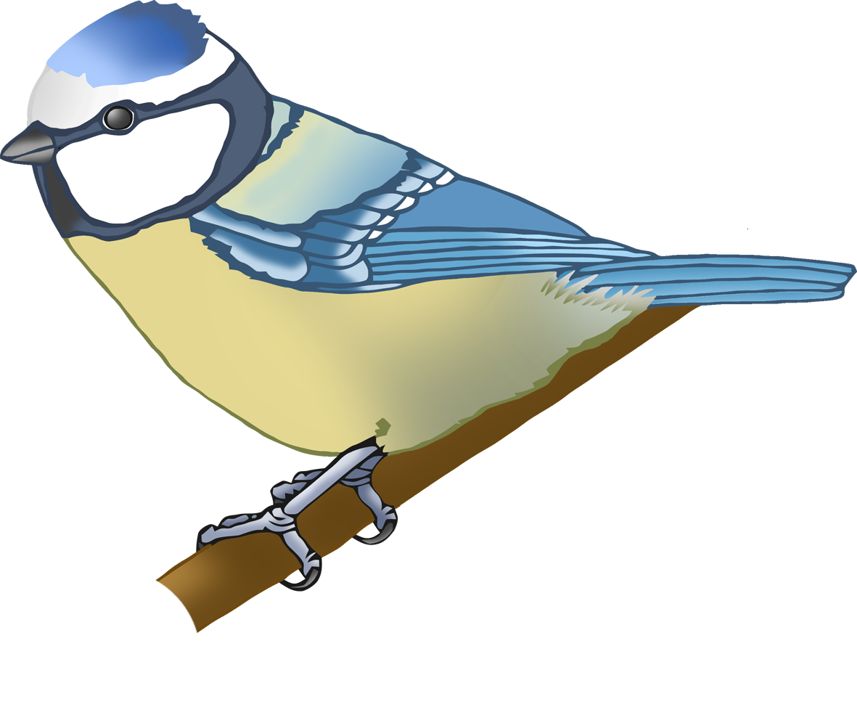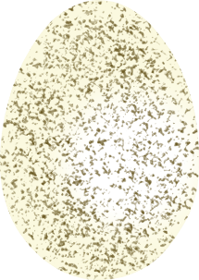

© 2021 Little Owls Resources

Blue Tit

Season:

Length:

Food:

Number of eggs:

All year

Insects, seeds, nuts.

12 cm

8-10

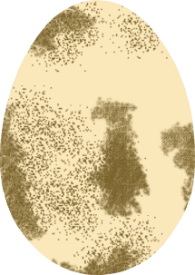

© 2021 Little Owls Resources

Buzzard

Season:

Length:

Food:

Number of eggs:

All year (most in spring)

Small mammals/birds and large insects

50-55 cm

2-4

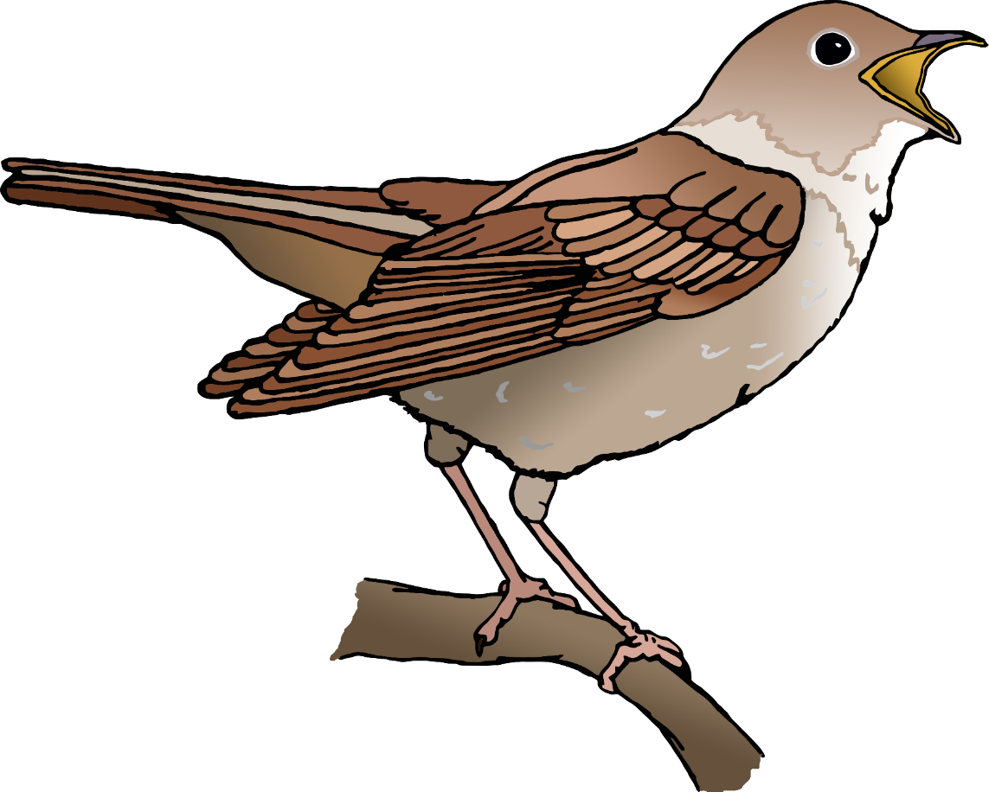

© 2021 Little Owls Resources

Nightingale

Season:

Length:

Food:

Number of eggs:

Spring

Insects

16 cm

3

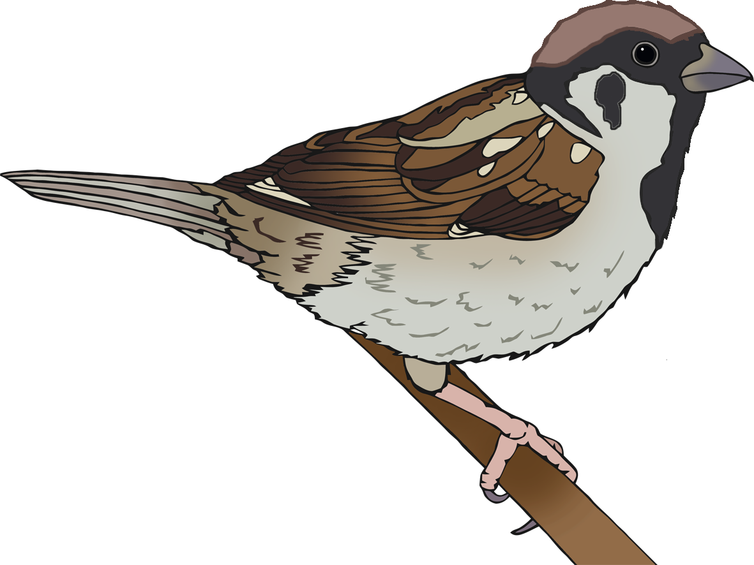

© 2021 Little Owls Resources

Tree Sparrow

Season:

Length:

Food:

Number of eggs:

All year

Seeds and insects

14 cm

5-6

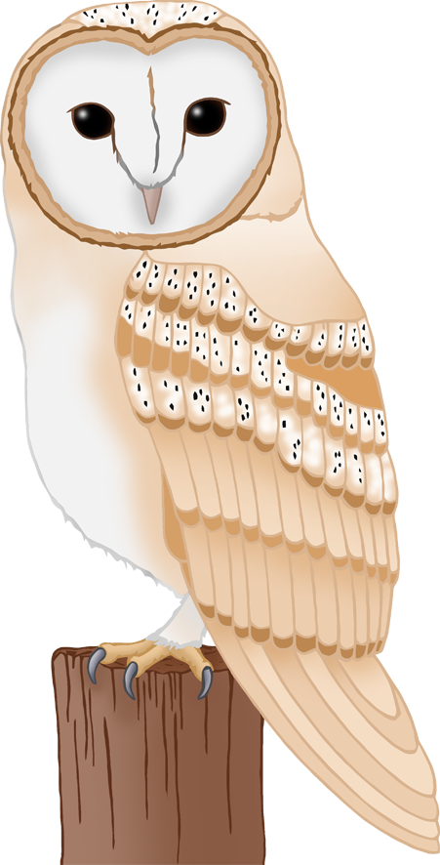

All year (dusk)

Mice, voles, shrews.

35 cm

4-7

Season:

Length:

Food:

Number of eggs:

© 2021 Little Owls Resources

Barn Owl

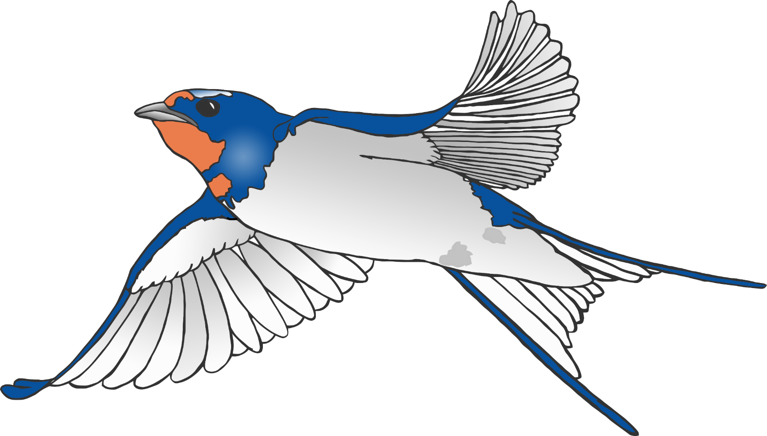

Season:

Length:

Food:

Number of eggs:

Spring and summer.

Flying insects.

18 cm

2-3

© 2021 Little Owls Resources

Swallow