Woodland Bird Egg Match Puzzle

This matching puzzle has a different connection for each set to allow the children to self-correct.

The intention of the resource is not necessarily for children to learn the different egg types. It is more to become aware that eggs from different birds can look very different.

© 2021 Little Owls Resources

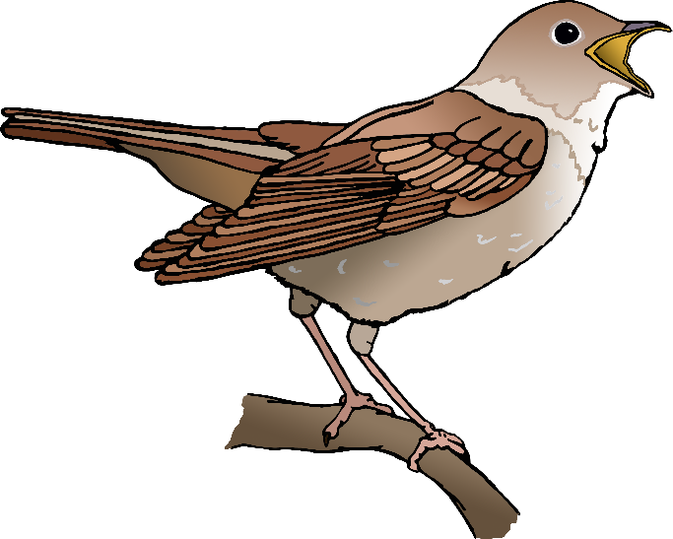

pigeon

nightingale

© 2021 Little Owls Resources

© 2021 Little Owls Resources

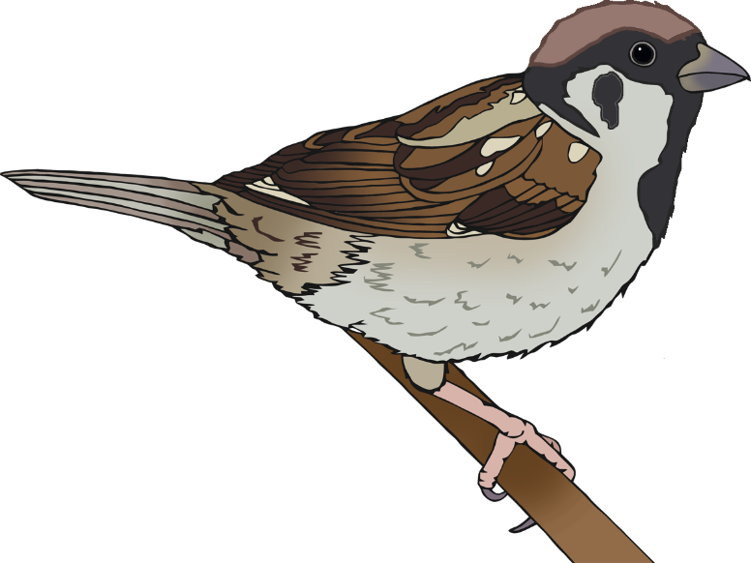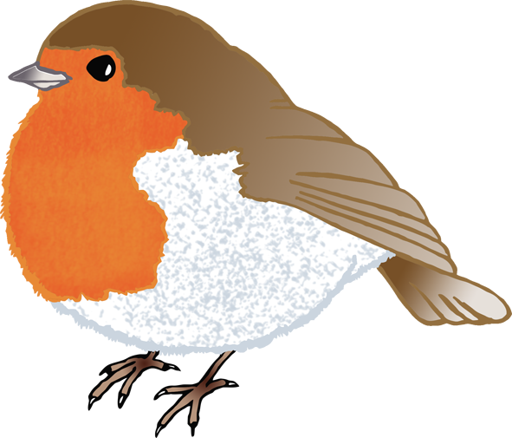

tree sparrow

© 2021 Little Owls Resources

© 2021 Little Owls Resources

robin

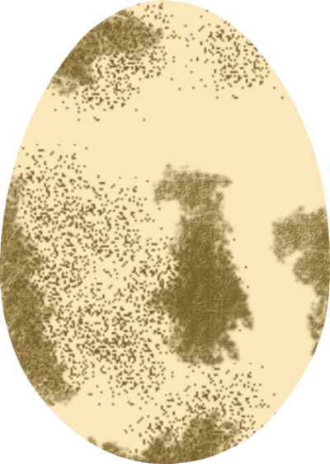

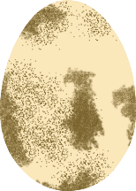

magpie

buzzard

© 2021 Little Owls Resources

© 2021 Little Owls Resources

© 2021 Little Owls Resources

© 2021 Little Owls Resources

blackbird

blue tit

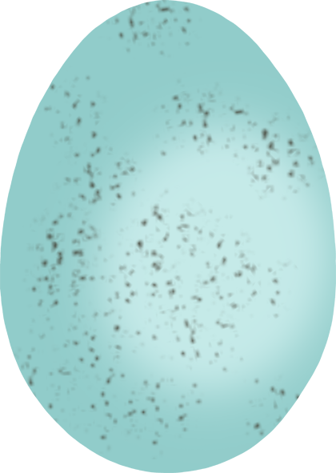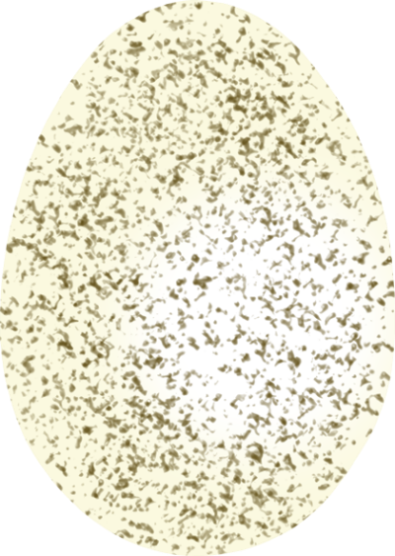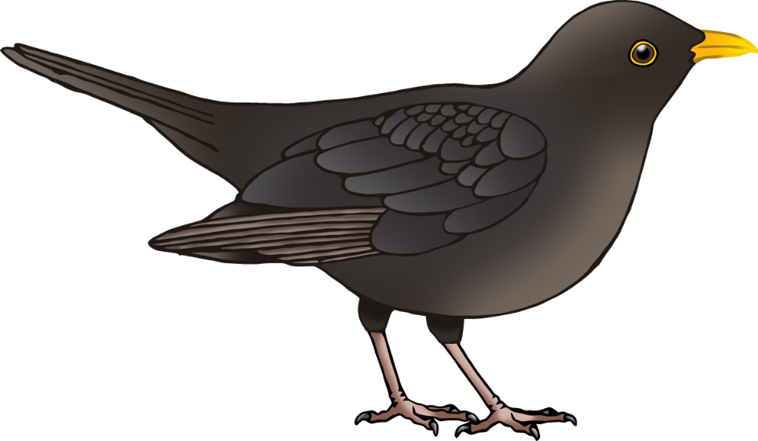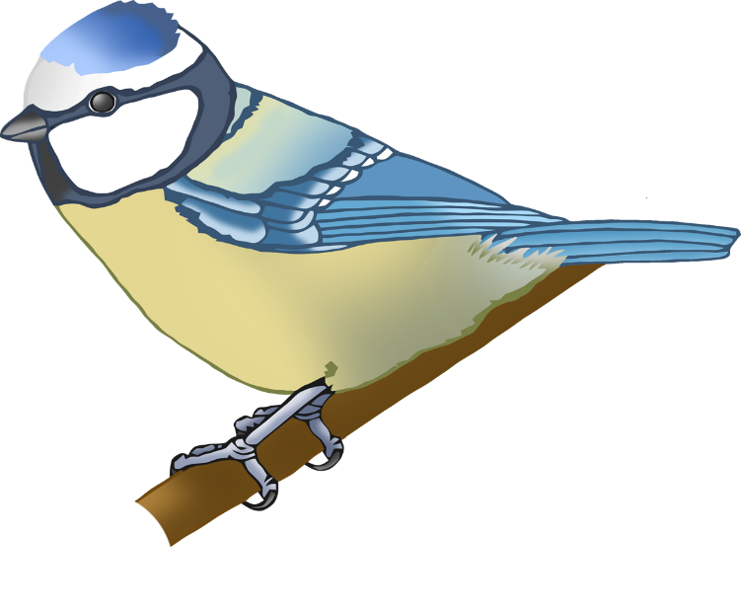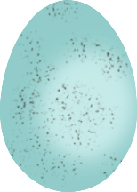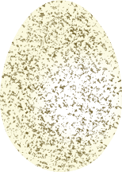

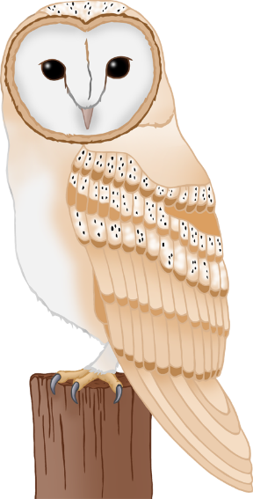

© 2021 Little Owls Resources

© 2021 Little Owls Resources

barn owl

swallow