**Woodland Wildlife**

**Fact Cards** - **(A5)**

These fact cards can be used as part of a display or as a stimulus for discussion, writing and drawing before or after time spent in a woodland setting.

© 2021 Little Owls Resources

Squirrel

Fox

Body – 30 cm

Tail – 25 cm

Acorns, bulbs, nuts, and roots.

3 years

A squirrel’s home is called a ‘drey’.

Length:

Average Lifespan:

Food:

Fact:

70cm

Rabbits, frogs, rodents, birds, worms.

3 years

Length:

Average Lifespan:

Food:

Fact:

A fox’s home is called an ‘earth’.

© 2021 Little Owls Resources

© 2021 Little Owls Resources

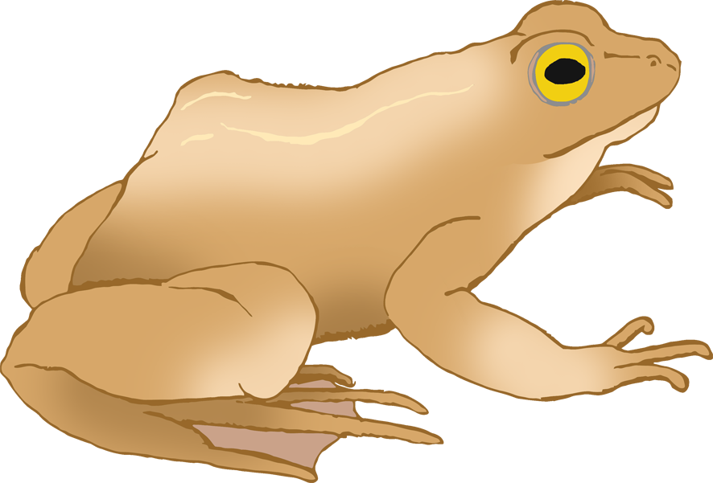

Earthworms, frogs, birds, eggs, insects, berries.

UK’s largest land carnivore.

14 years

90cm

Up to 13cm

Frogs drink through their skin.

5-10 years

Insects, snails, slugs, worms.

Length:

Average Lifespan:

Food:

Fact:

Length:

Average Lifespan:

Food:

Fact:

© 2021 Little Owls Resources

© 2021 Little Owls Resources

Badger

Frog

Up to 40cm

Brought to UK 900 years ago by the Romans.

9 years

Grass, leaves, shoots.

UK’s largest land mammal.

16 years

Grass, leaves, shoots.

Size:

Average Lifespan:

Food:

Fact:

Length:

Average Lifespan:

Food:

Fact:

Up to 140cm at the shoulder.

© 2021 Little Owls Resources

© 2021 Little Owls Resources

Rabbit

Deer

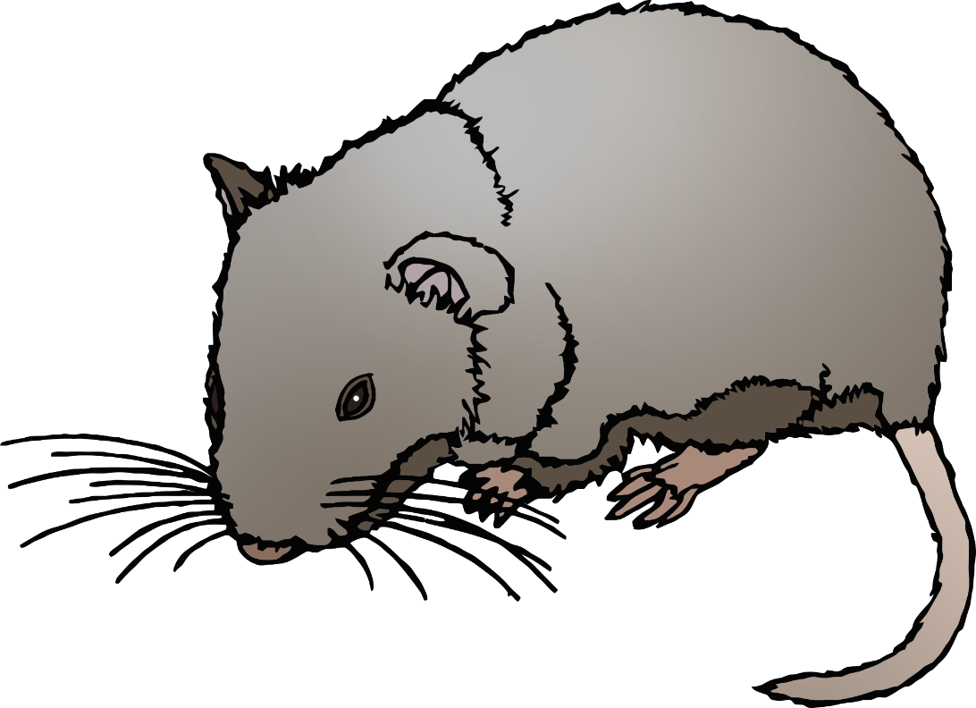

Nocturnal. They hunt at night.

5 years

Moths, earwigs, flies, beetles.

8 cm

Don’t hibernate.

2 years

Roots, fungi, fruit, nuts.

15cm

Long-Eared Bat

© 2021 Little Owls Resources

© 2021 Little Owls Resources

Bank Vole

Length:

Average Lifespan:

Food:

Fact:

Length:

Average Lifespan:

Food:

Fact:

5000-7000 spines on their backs.

2-3 years

Worms, beetles, slugs, caterpillars, earwigs.

Up to 35cm

They are not snakes, they are ‘legless lizards’.

20-30 years

Slugs, worms, snails, spiders.

Up to 50cm

Length:

Average Lifespan:

Food:

Fact:

Length:

Average Lifespan:

Food:

Fact:

© 2021 Little Owls Resources

© 2021 Little Owls Resources

Hedgehog

Slow Worm