**Woodland Wildlife**

**Fact Cards** - **(A4)**

These fact cards can be used as part of a display or as a stimulus for discussion, writing and drawing before or after time spent in a woodland setting.

© 2021 Little Owls Resources

© 2021 Little Owls Resources

Fox

Length:

Average Lifespan:

Food:

Fact:

70cm

Rabbits, frogs, rodents, birds, worms.

3 years

A fox’s home is called an ‘earth’.

© 2021 Little Owls Resources

Squirrel

Body – 30 cm

Tail – 25 cm

Acorns, bulbs, nuts, and roots.

3 years

A squirrel’s home is called a ‘drey’.

Length:

Average Lifespan:

Food:

Fact:

© 2021 Little Owls Resources

Frog

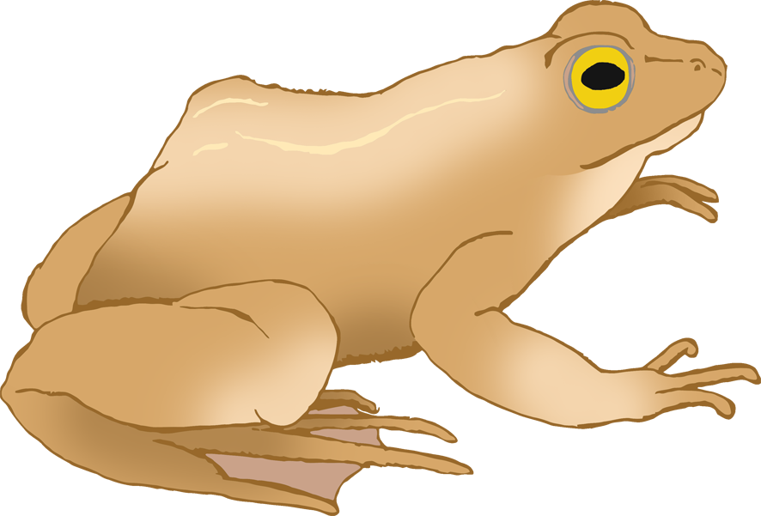

Length:

Average Lifespan:

Food:

Fact:

Up to 13cm

Insects, snails, slugs, worms.

5-10 years

Frogs drink through their skin.

Length:

Average Lifespan:

Food:

Fact:

90cm

Earthworms, frogs, birds, eggs, insects, berries.

14 years

UK’s largest land carnivore.

© 2021 Little Owls Resources

Badger

© 2021 Little Owls Resources

Deer

Size:

Average Lifespan:

Food:

Fact:

Up to 140cm at the shoulder.

Grass, leaves, shoots.

16 years

UK’s largest land mammal.

© 2021 Little Owls Resources

Rabbit

Length:

Average Lifespan:

Food:

Fact:

Up to 40cm

Grass, leaves, shoots.

9 years

Brought to UK 900 years ago by the Romans.

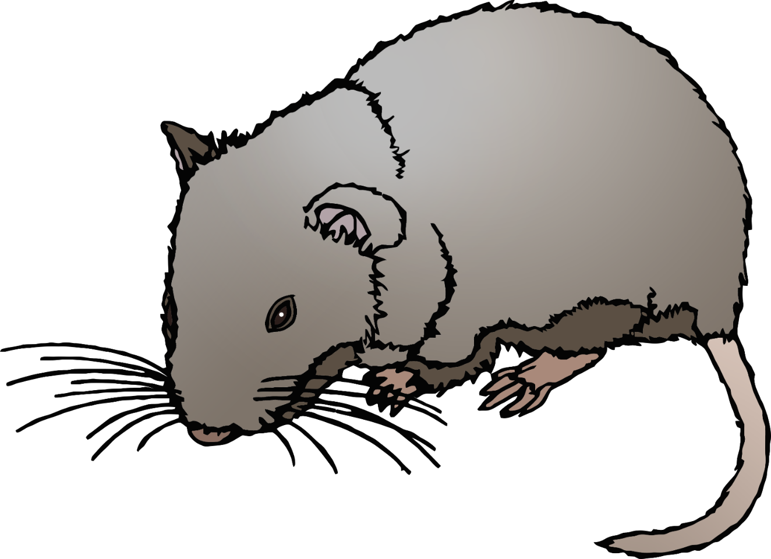

© 2021 Little Owls Resources

Bank Vole

Length:

Average Lifespan:

Food:

Fact:

15cm

Roots, fungi, fruit, nuts.

2 years

Don’t hibernate.

© 2021 Little Owls Resources

Long-Eared Bat

8 cm

Moths, earwigs, flies, beetles.

5 years

Nocturnal. They hunt at night.

Length:

Average Lifespan:

Food:

Fact:

Length:

Average Lifespan:

Food:

Fact:

Up to 50cm

Slugs, worms, snails, spiders.

20-30 years

They are not snakes, they are ‘legless lizards’.

© 2021 Little Owls Resources

Slow Worm

Up to 35cm

Worms, beetles, slugs, caterpillars, earwigs.

2-3 years

5000-7000 spines on their backs.

Length:

Average Lifespan:

Food:

Fact:

© 2021 Little Owls Resources

Hedgehog