_______________________________________________________________________________________________



© 2023 Little Owls Resources

With my mummy I love to…

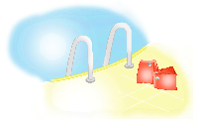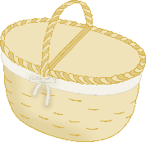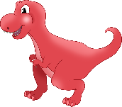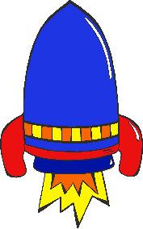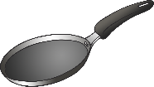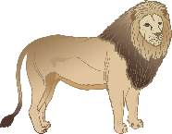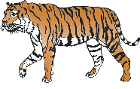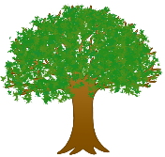

_______________________________________



© 2023 Little Owls Resources

With my mummy I love to…



© 2023 Little Owls Resources

With my mummy I love to…



_______________________________________________________________________________________________



© 2023 Little Owls Resources



© 2023 Little Owls Resources



_______________________________________



© 2023 Little Owls Resources

