**Wise Men Gifts Pom Pom Mat** (1)

© 2020 Little Owls Resources

**Wise Men Gifts Pom Pom Mat** (2)

© 2020 Little Owls Resources

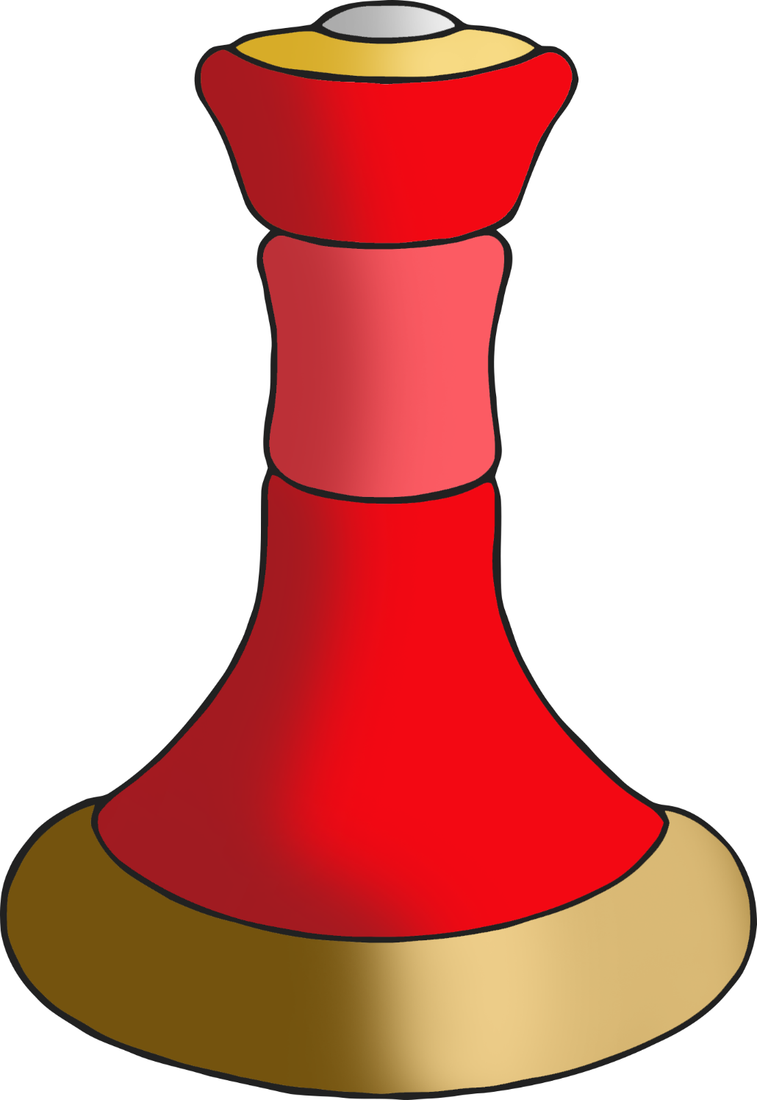

**Wise Men Gifts Pom Pom Mat** (3)

© 2020 Little Owls Resources