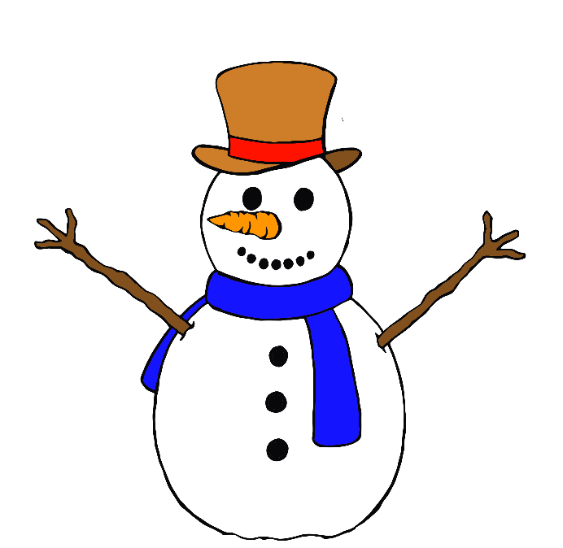c

Snowman

Snowman



Snowman

Snowman

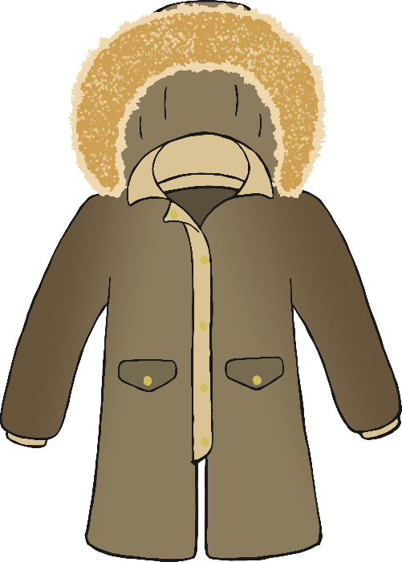

Winter Coat

Winter Coat







Winter Coat

Winter Coat

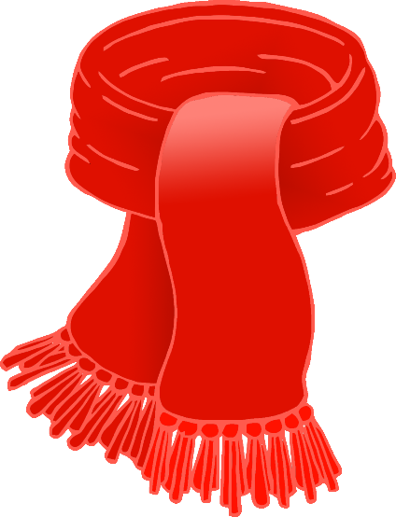

Scarf

Scarf



Scarf

Scarf

Sledge

Sledge

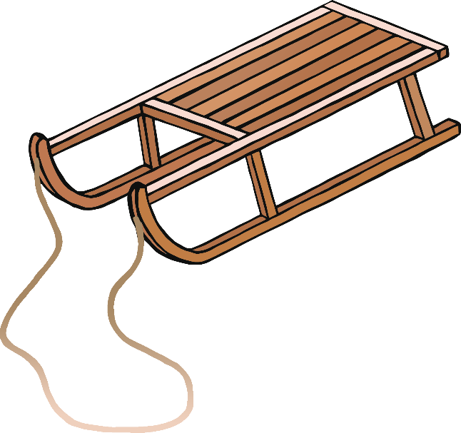



Sledge

Sledge

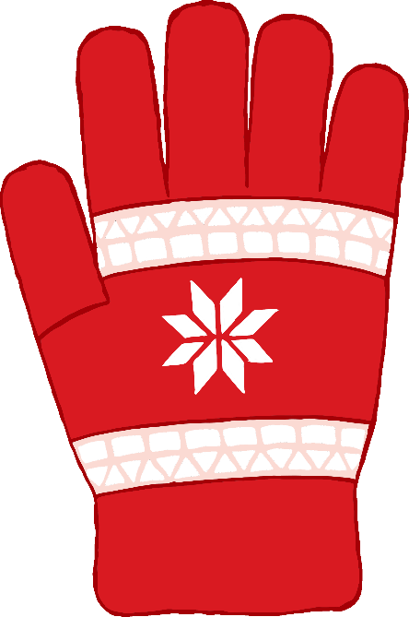

Glove

Glove





Glove

Glove



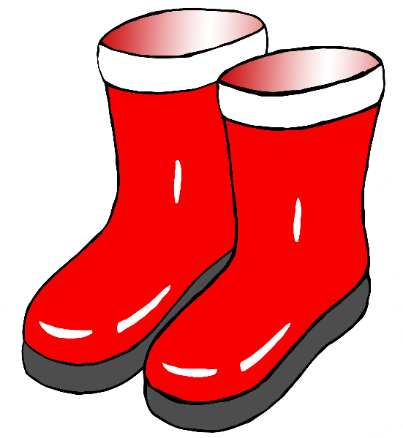

Boots

Boots



Boots

Boots

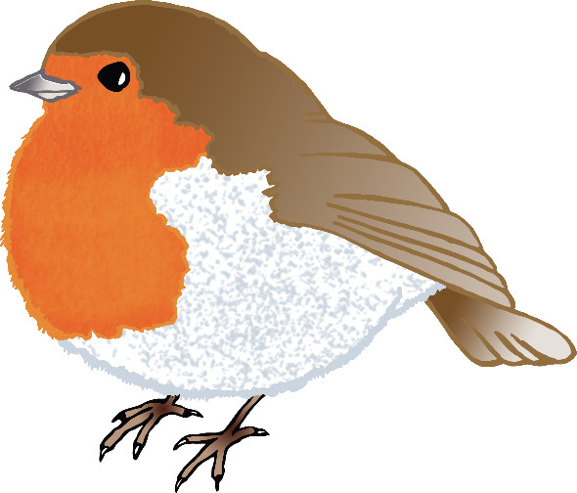

Robin

Robin



Robin

Robin

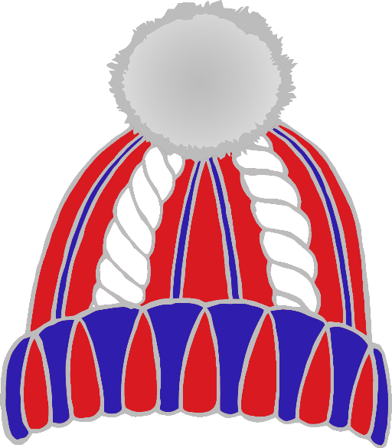

Hat

Hat



Hat

Hat

Sled

Sled



Sled

Sled

