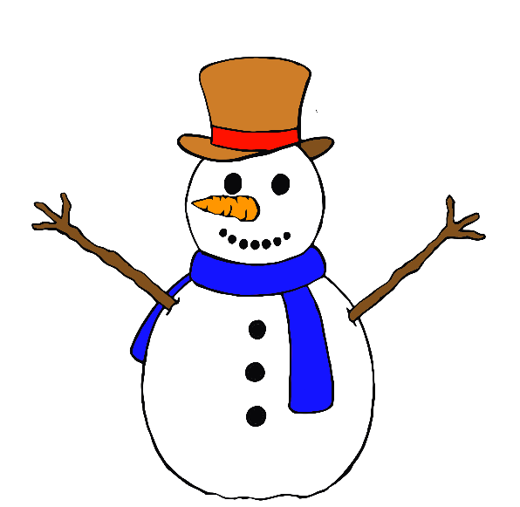

Snowman

Scarf

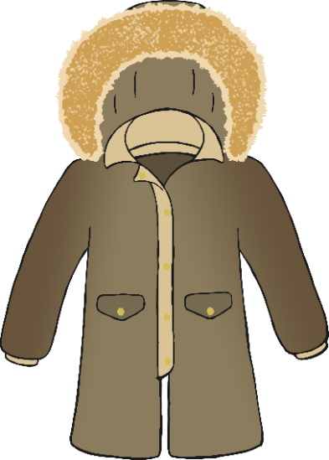

Winter Coat

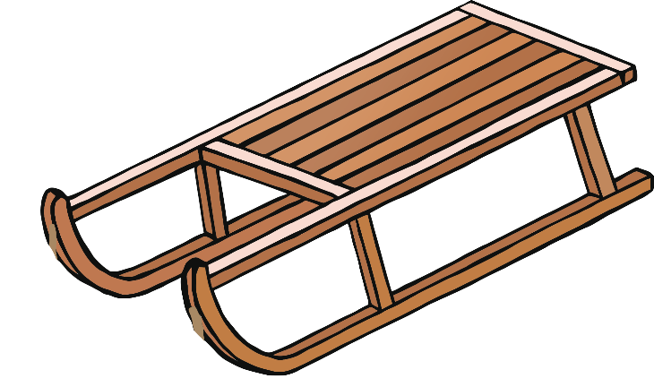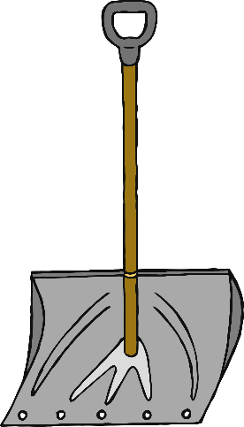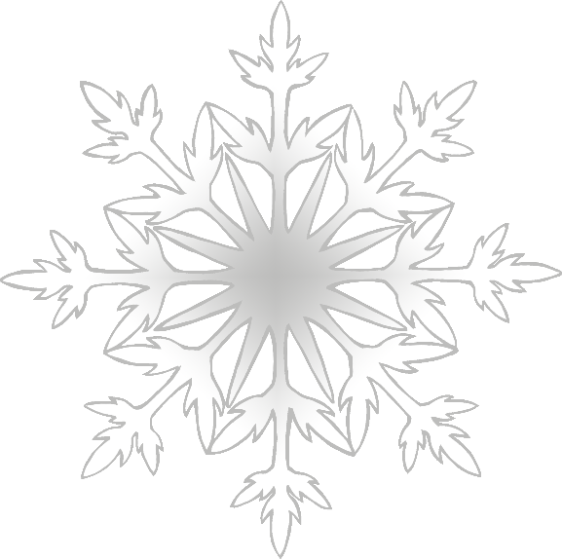

Sledge

Snow Shovel

Snowflake

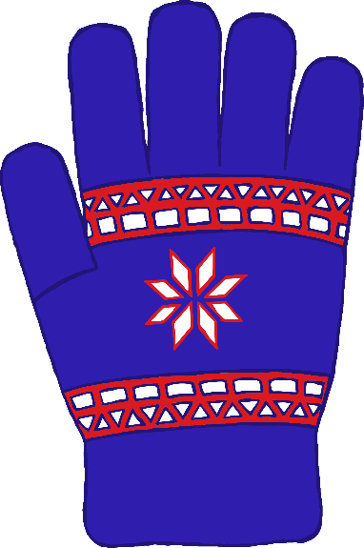

Boots

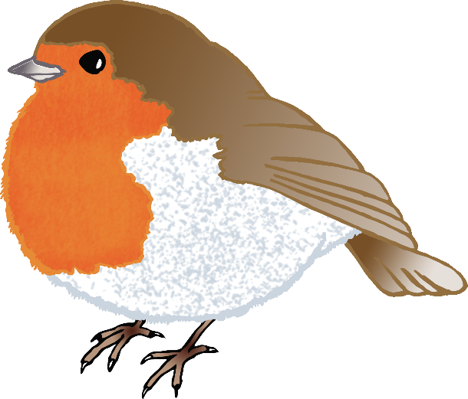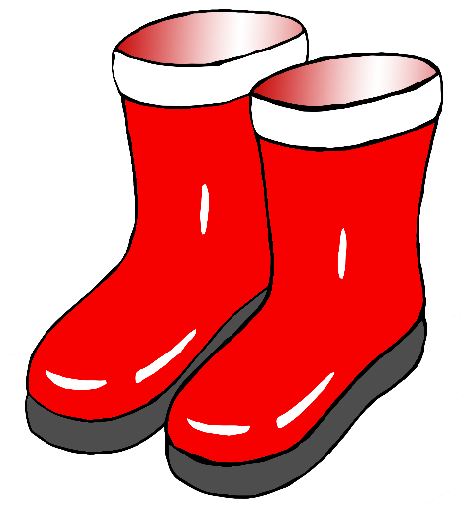

Robin

Glove

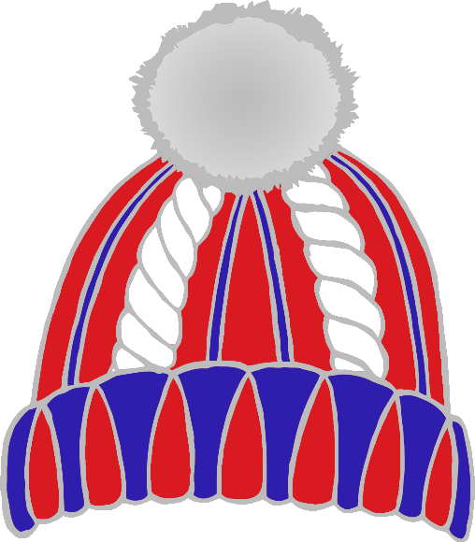

Hat

Snowball

Holly

Sled

Icicles

Ice Skates

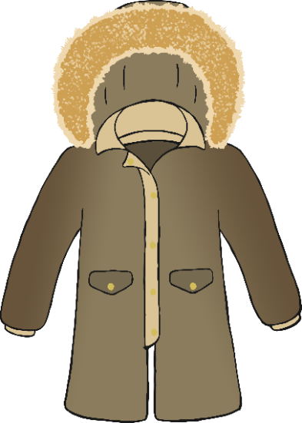

winter coat

scarf

snowman





snowflake

snow shovel

sledge



boots



robin

glove



hat

snowball

holly



ice skates

icicles

sled