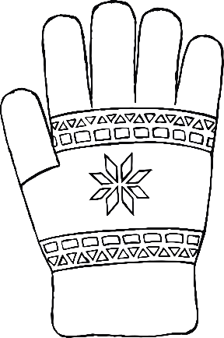c





