dog

cat

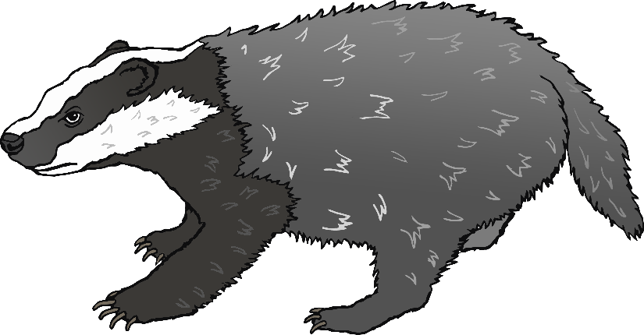

badger

fox

squirrel

deer