**Winter Checklist**  ✔️✔️✔️

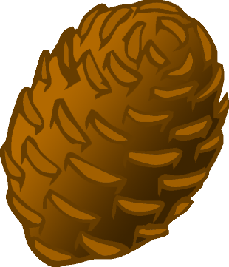

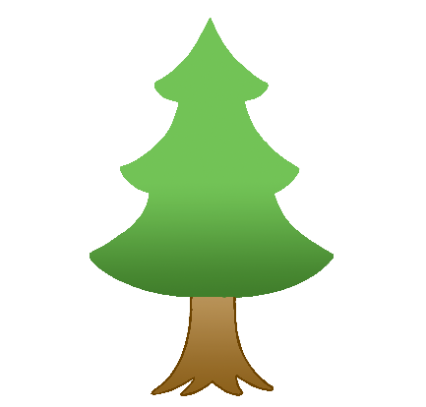

© 2022 Little Owls Resources

**Winter Checklist ✔️✔️✔️**

leaves

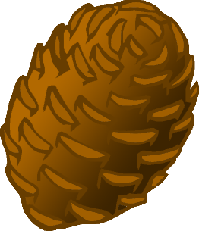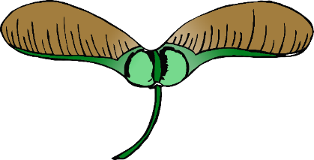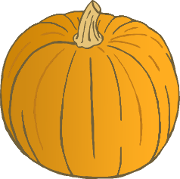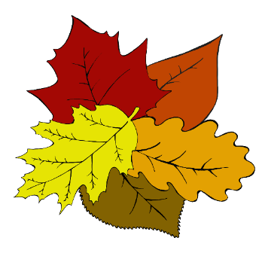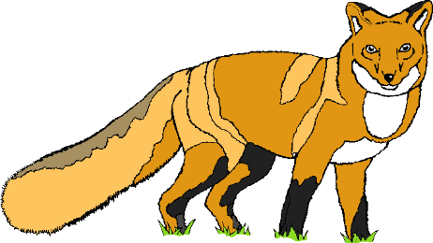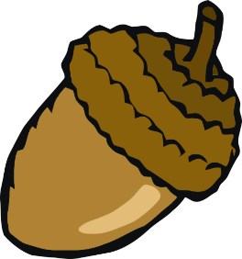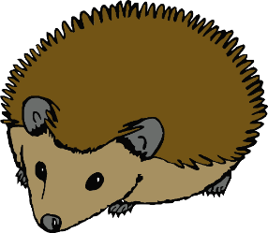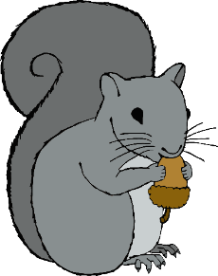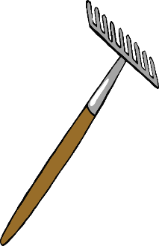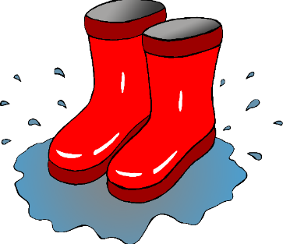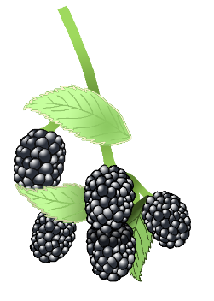

pinecone



evergreen tree

ladybirds

leafless tree

holly

squirrel

snowdrop

frost

robin

© 2022 Little Owls Resources

conker

sycamore seeds

pumpkin

fox

acorn

hedgehog

squirrel

rake

fungus

blackberries

wellies