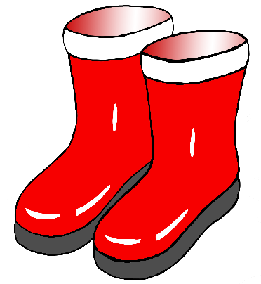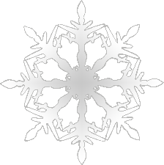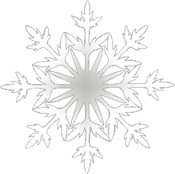

Winter Activity

Challenge!

Float through the air like falling snowflakes.

2

Winter Activity

Challenge!

Crunch your boots in the snow!

Crunch! Crunch!

1

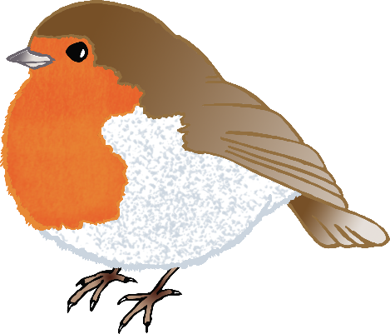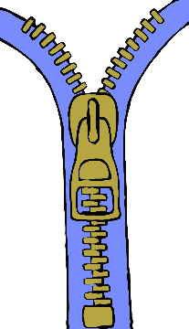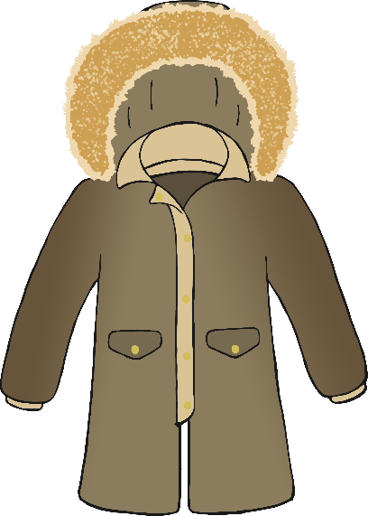

4

Winter Activity

Challenge!

Put on your winter coat.

Left arm…. Right arm…

Then… Zip!

Winter Activity

Challenge!

3

Hop on both feet like a robin!

Hop! Hop!

Winter Activity

Challenge!

5

Use a snow shovel to clear the snow!

Push! Push!

Winter Activity

Challenge!

6

Slip and slide down the snow!

Slide… bump! Slide… bump!

Winter Activity

Challenge!

7

Put on your skates… do up the laces, then…

Skate! Skate!

Winter Activity

Challenge!

8

Make a snowball… then throw it as far as you can!