© 2023 Little Owls Resources

Why is Teddy feeling sad?

© 2021 Little Owls Resources

© 2023 Little Owls Resources

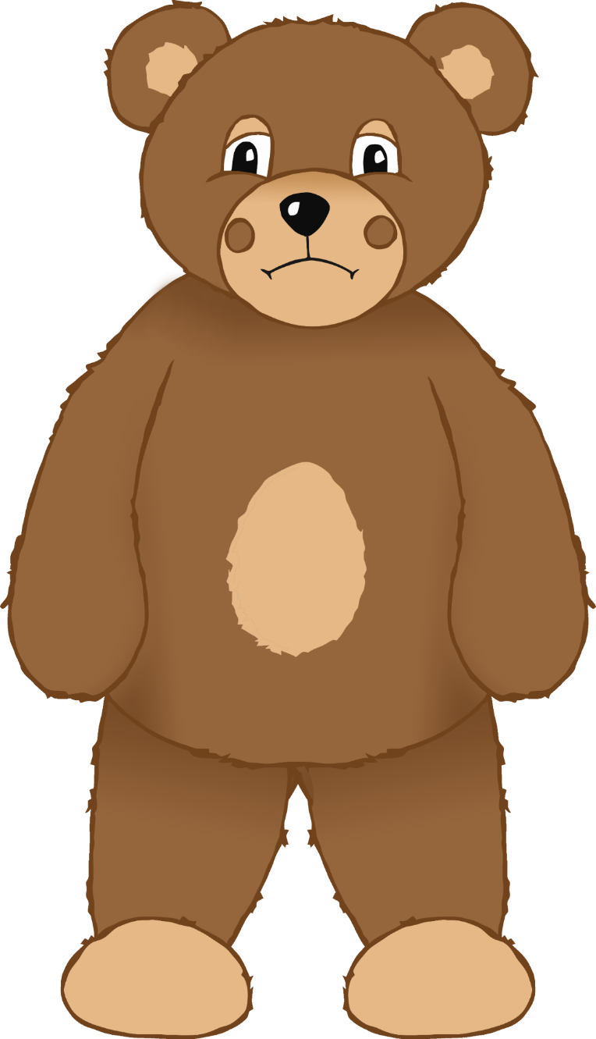

Why is Teddy feeling sad?

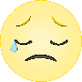

© 2023 Little Owls Resources



Why is Teddy feeling sad?



Why is Teddy feeling sad?

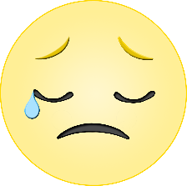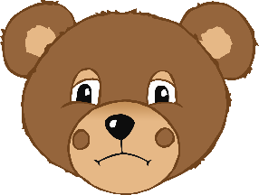

© 2023 Little Owls Resources

Why is Teddy feeling sad?



© 2023 Little Owls Resources

________­­­­­­­­­­­­­­­­­­­______________________

______________________________

______________________________

______________________________

­______________________________

______________________________

­______________________________

______________________________

Why is Teddy feeling sad?



© 2023 Little Owls Resources

**________­­­­­­­­­­­­­­­­­­­______________________**

**______________________________**

**______________________________**

**______________________________**

**­______________________________**

**______________________________**

**­______________________________**

Why is Teddy feeling sad?



© 2023 Little Owls Resources

**______________________________________________________**

­**______________________________________________________**

**______________________________________________________**

**______________________________________________________**

**______________________________________________________**

**______________________________________________________**

**______________________________________________________**

His Nanny is very poorly in hospital. He is worried about her.

© 2023 Little Owls Resources

Idea 2

He accidentally stepped on his favourite toy and now it is broken.

© 2023 Little Owls Resources

Idea 1

His best friend said something unkind to him.

© 2023 Little Owls Resources

Idea 4

His tummy hurts and he doesn’t know why.

© 2023 Little Owls Resources

Idea 3