Who’s coming to the picnic?

© 2021 Little Owls Resources

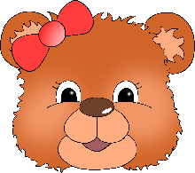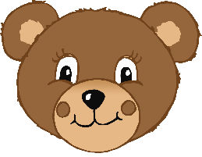

Who’s coming to the picnic?

© 2021 Little Owls Resources



Name:

Who’s coming to the picnic?

Name:

What do they like to eat?

What do they like to drink?

© 2021 Little Owls Resources



Who’s coming to the picnic?

What do they like to drink?

What do they do for fun?

Name:

© 2021 Little Owls Resources

What do they like to eat?