What makes a good friend?

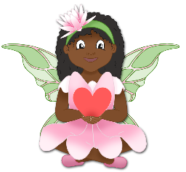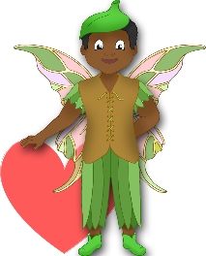

© 2022 Little Owls Resources

____________________________________________________________________________________________________

© 2022 Little Owls Resources

______________________________________________________

What makes a good friend?



What makes a good friend?



© 2022 Little Owls Resources