You will need: A metal spoon A plastic cup

A duplo brick A wooden block

A scrunched paper A cushion

A plastic bottle

‘What made the sound?’ – Listening Game

* One person to make a hidden sound with one of the objects.
* Other player/players to look at their mats as they listen and choose which object made the sound.
* Can be played with an adult and a group of children or two children working as a pair.

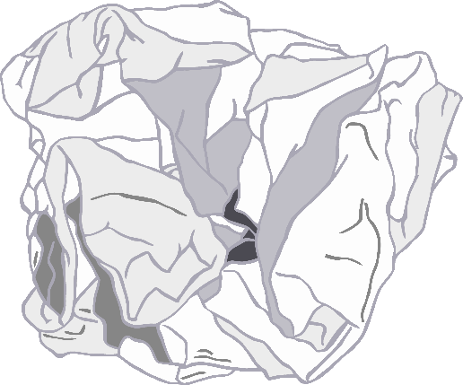

scrunched paper

wooden block

metal spoon

plastic cup

cushion

duplo brick

plastic bottle

What made the sound?

What made the sound?