(Prompt Cards)

What happens when you feel… ?

© 2023 Little Owls Resources

The cards can then be used as part of an input about emotions and feelings. The intention is that the cards would be held with the image facing the child/children and the prompts facing the adult. The activity should help the child/children think carefully about what each emotion feels like to them when they experience them.

These cards are to be cut, folded and laminated first.

happy

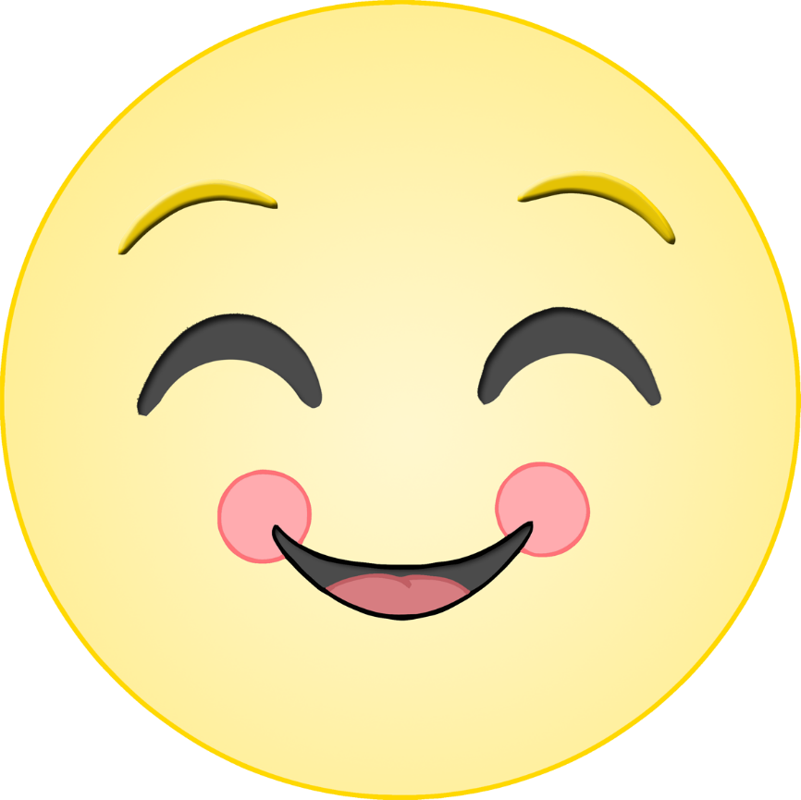

What happens when you feel happy?

© 2023 Little Owls Resources

*e.g.*

smile

dance

clap

warm feeling

laugh

© 2023 Little Owls Resources

sad

What happens when you feel sad?

© 2023 Little Owls Resources

*e.g.*

cry

quiet

feel alone

grumpy

need a cuddle

© 2023 Little Owls Resources

excited

What happens when you feel excited?

© 2023 Little Owls Resources

*e.g.*

laugh

jump

smile

fluttery tummy

loud

© 2023 Little Owls Resources

angry

What happens when you feel angry?

© 2023 Little Owls Resources

*e.g.*

shout

frown

tense fists

feel hot

hard to think

© 2023 Little Owls Resources

worried

What happens when you feel worried?

© 2023 Little Owls Resources

*e.g.*

frown

pursed lips

fidget

fluttery tummy

need a cuddle

© 2023 Little Owls Resources

confused

What happens when you feel confused?

© 2023 Little Owls Resources

*e.g.*

look around

ask questions

feel lost

frown

need help

© 2023 Little Owls Resources

scared

What happens when you feel scared?

© 2023 Little Owls Resources

*e.g.*

cry

open mouth

shout/scream

need a cuddle

run away

© 2023 Little Owls Resources