The pages of this pack give some general information about whale sharks and some fun and engaging activities to foster and develop children’s interest in them.

**Whale Shark**

**This pack includes:**

* Fact posters x3 (Could be used as stimuli for a lesson input)
* Number slice activity (1-10) (Can be pre-cut for a pure number ordering activity or left to be cut by child to add scissor practice)
* Number slice activity - colouring version (1-10) (As above but to be coloured before cutting)
* Description sheet (Can be used as an independent writing activity or with an adult scribing the ideas of a younger child)
* A4 poster
* A4 poster - colouring version
* ‘Body Parts’ x3 (fully labelled, initial sounds only, blank)
* Draw and write sheets x3 (blank sheet, wide lines and narrow lines)
* 1x 4-piece puzzle
* Multimats x2 (for Colouring/Art & Craft/Loose Parts/Playdough)

© 2021 Little Owls Resources

This pack includes:

The pages of this pack give some general information about the role of a paramedic and some fun and engaging activities to foster and develop children’s interest in this role in society.

© 2021 Little Owls Resources

**Whale Shark Facts**

**biggest**

Whale sharks eat **plankton**.

Whale sharks are the fish in the world!

Whale sharks can live for

years.

**100**

Humans have hunted and killed many whale sharks.

Climate change has changed the waters in which whale sharks live.

This means there is a very high risk that they may become extinct.

**Whale Sharks are** Endangered.

© 2021 Little Owls Resources

**How big is a Whale Shark?**

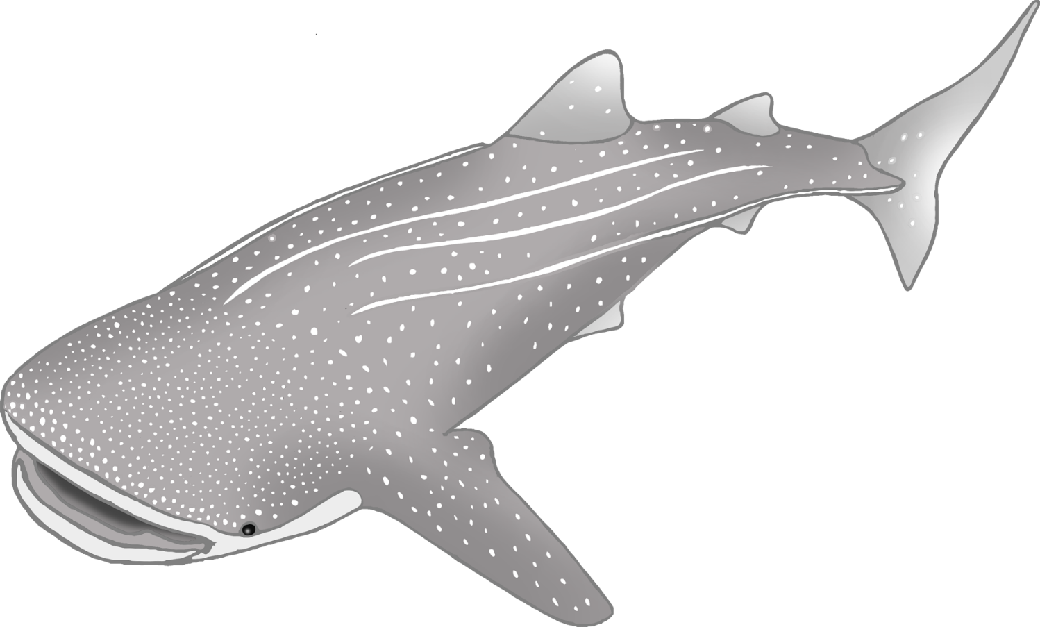

1000cm / 10m

© 2021 Little Owls Resources

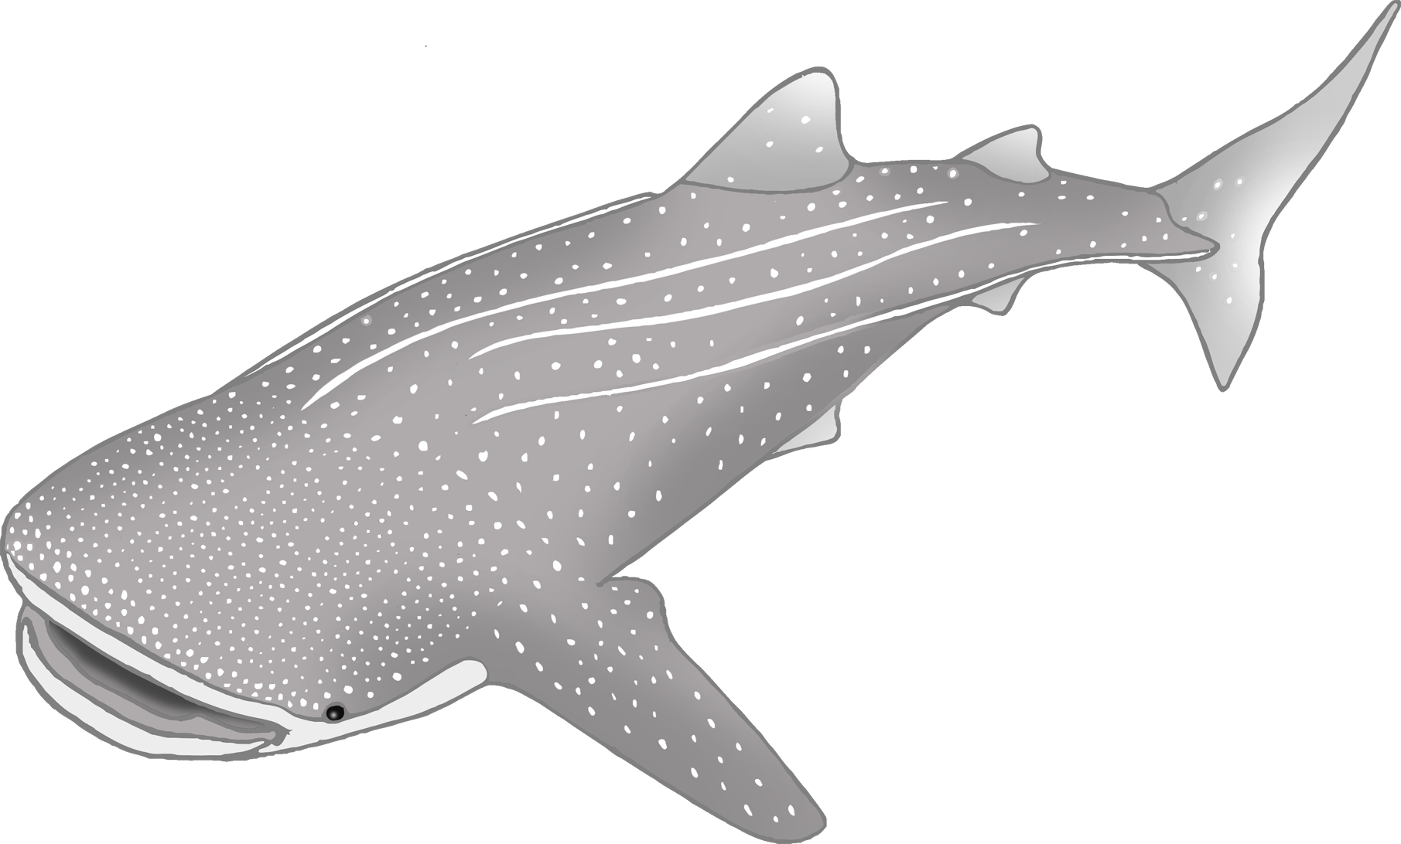

1

2

3

4

5

6

7

8

9

10

© 2021 Little Owls Resources

© 2021 Little Owls Resources

1

2

3

4

5

6

7

8

9

10

© 2021 Little Owls Resources

**What words would you use to describe a whale shark?**

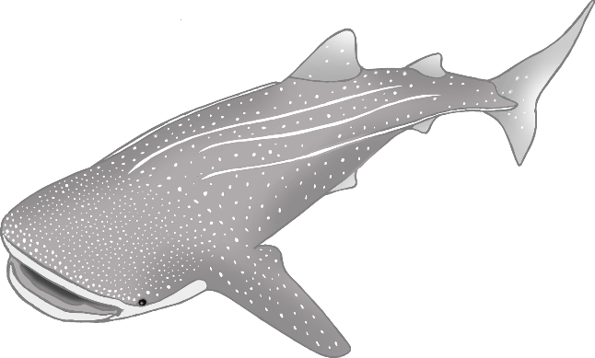

**Whale Shark**



© 2021 Little Owls Resources

**Whale Shark**

© 2021 Little Owls Resources

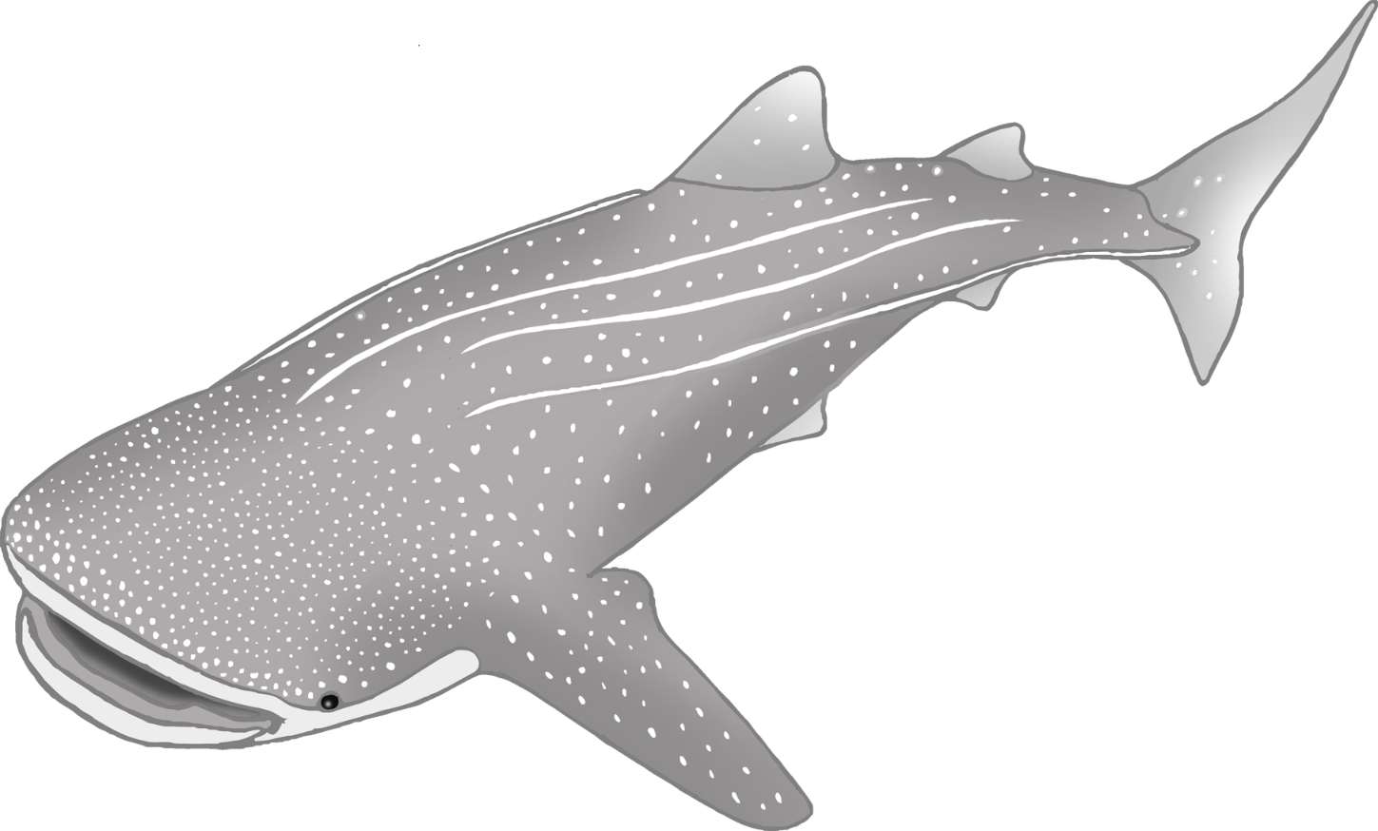

**Whale Shark body parts**

© 2021 Little Owls Resources

tail

head

eye

mouth

fin

fin



t

f

e

f

h

**Whale Shark body parts**

© 2021 Little Owls Resources

m

**Whale Shark body parts**



© 2021 Little Owls Resources

© 2021 Little Owls Resources

**Draw a Whale Shark!**

© 2021 Little Owls Resources

**Draw and write about a Whale Shark!**

____________________________________________________

© 2021 Little Owls Resources

**Draw and write about a Whale Shark!**

______________________________________________________________________________________________________

**Whale Shark**



© 2021 Little Owls Resources

© 2021 Little Owls Resources

**Whale Shark Multimat – Whale Shark**

© 2021 Little Owls Resources

**Whale Shark Multimat – Plankton**

