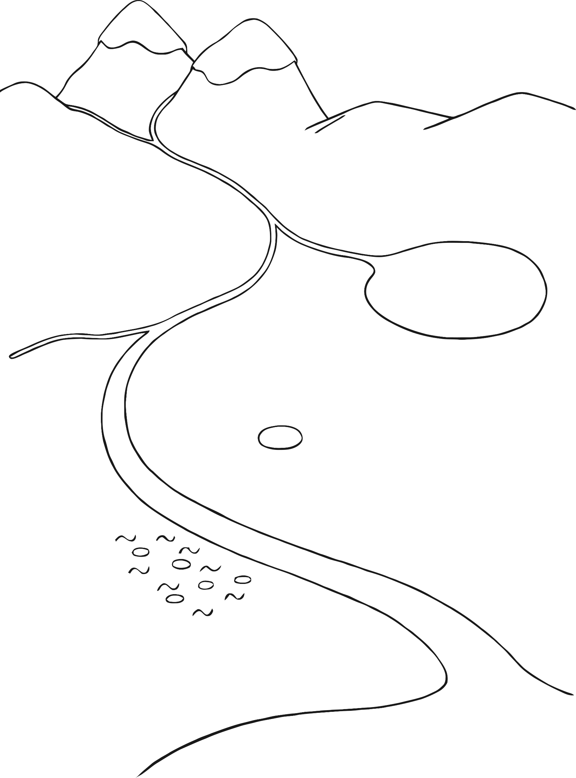

© 2021 Little Owls Resources

**Wetlands**



© 2021 Little Owls Resources

Wetlands

m

p

l

r