Duck

Duckling

Wolf

Water Avens

© 2021 Little Owls Resources

© 2021 Little Owls Resources

© 2021 Little Owls Resources



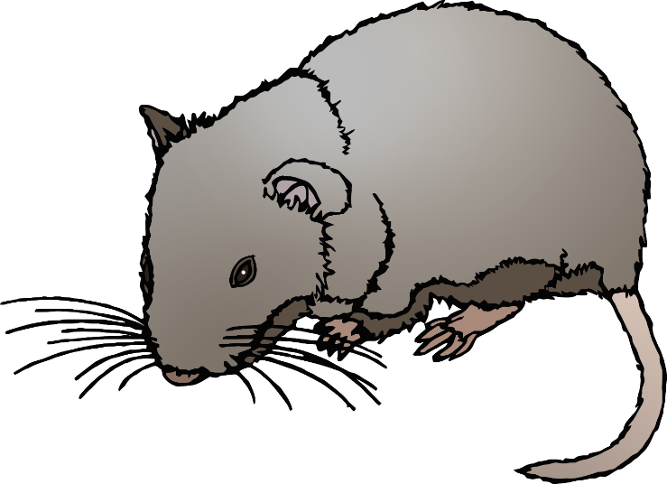

Fish

Water Vole

Water Lily

© 2021 Little Owls Resources

© 2021 Little Owls Resources

© 2021 Little Owls Resources

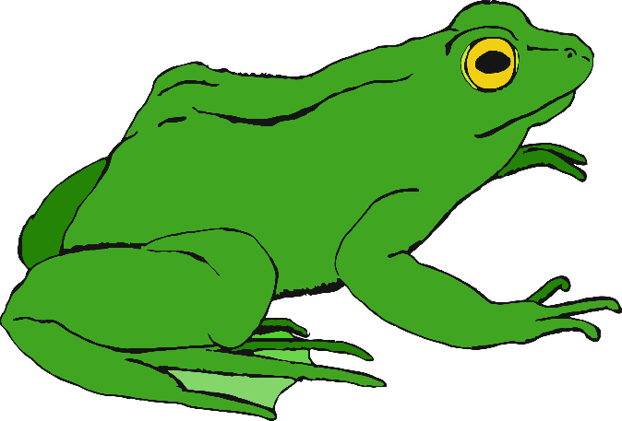

Frog

© 2021 Little Owls Resources

© 2021 Little Owls Resources

© 2021 Little Owls Resources

Tadpole

Birds

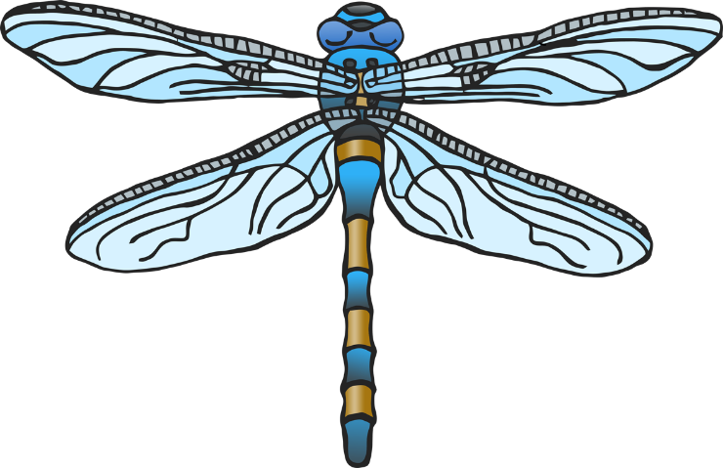

Pond

Dragonfly

Lake

© 2021 Little Owls Resources

© 2021 Little Owls Resources

Grass

River

Marsh

© 2021 Little Owls Resources

© 2021 Little Owls Resources

© 2021 Little Owls Resources

Plants

Pond Weed

© 2021 Little Owls Resources

© 2021 Little Owls Resources

Reeds

duck

duckling

Wolf

water avens

© 2021 Little Owls Resources

© 2021 Little Owls Resources

© 2021 Little Owls Resources



fish

water vole

water lily

© 2021 Little Owls Resources

© 2021 Little Owls Resources

© 2021 Little Owls Resources

frog

© 2021 Little Owls Resources

© 2021 Little Owls Resources

© 2021 Little Owls Resources

tadpole

birds

pond

dragonfly

lake

© 2021 Little Owls Resources

© 2021 Little Owls Resources

grass

river

marsh

© 2021 Little Owls Resources

© 2021 Little Owls Resources

© 2021 Little Owls Resources

plants

© 2021 Little Owls Resources

pond weed

© 2021 Little Owls Resources

© 2021 Little Owls Resources

reeds