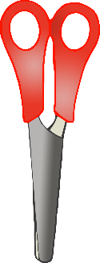

Wetlands Scene Cut and Stick shapes

