**Wetlands**

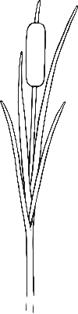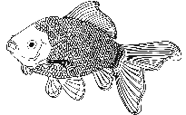

**Duckling**

**Duck**

**Dragonfly**



**Reeds**

**Water Lily**

**Pond Weed**

**Winter Avens**

**Water Vole**

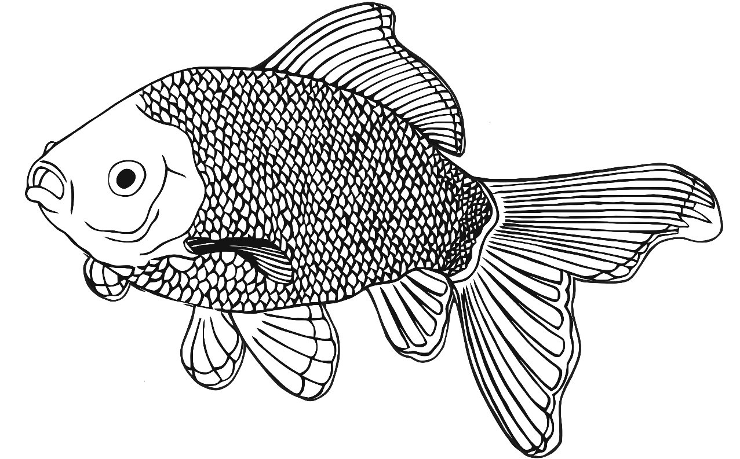

**Fish**

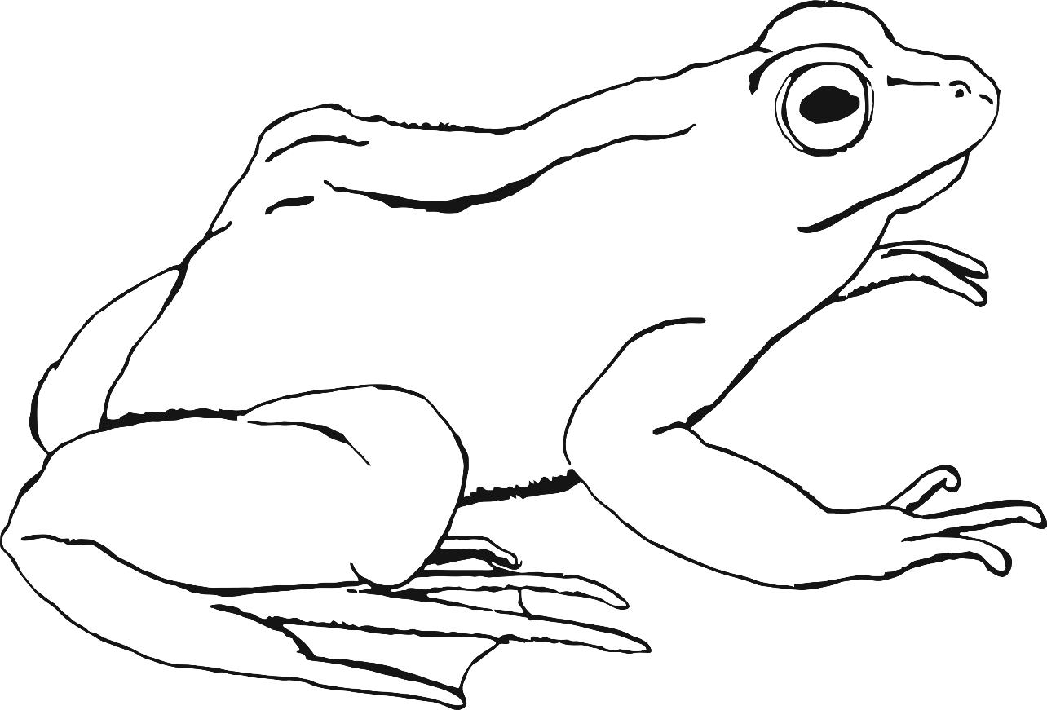

**Tadpole**

**Frog**

